**DESTINATION NAME: Amazon S3**

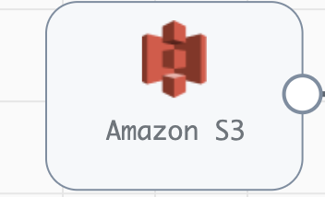

**Engine Type**: Data Collector

**Pipeline Name**: D_AmazonS3_Origin_S3_Dest_Pipeline_CredStr

**Description**: The **Amazon S3** destination writes data to Amazon S3.

We need to configure the **Amazon S3** in a following way.

Step 1: Click on the **Amazon S3** destination to configure the authentication method that the destination uses to connect.

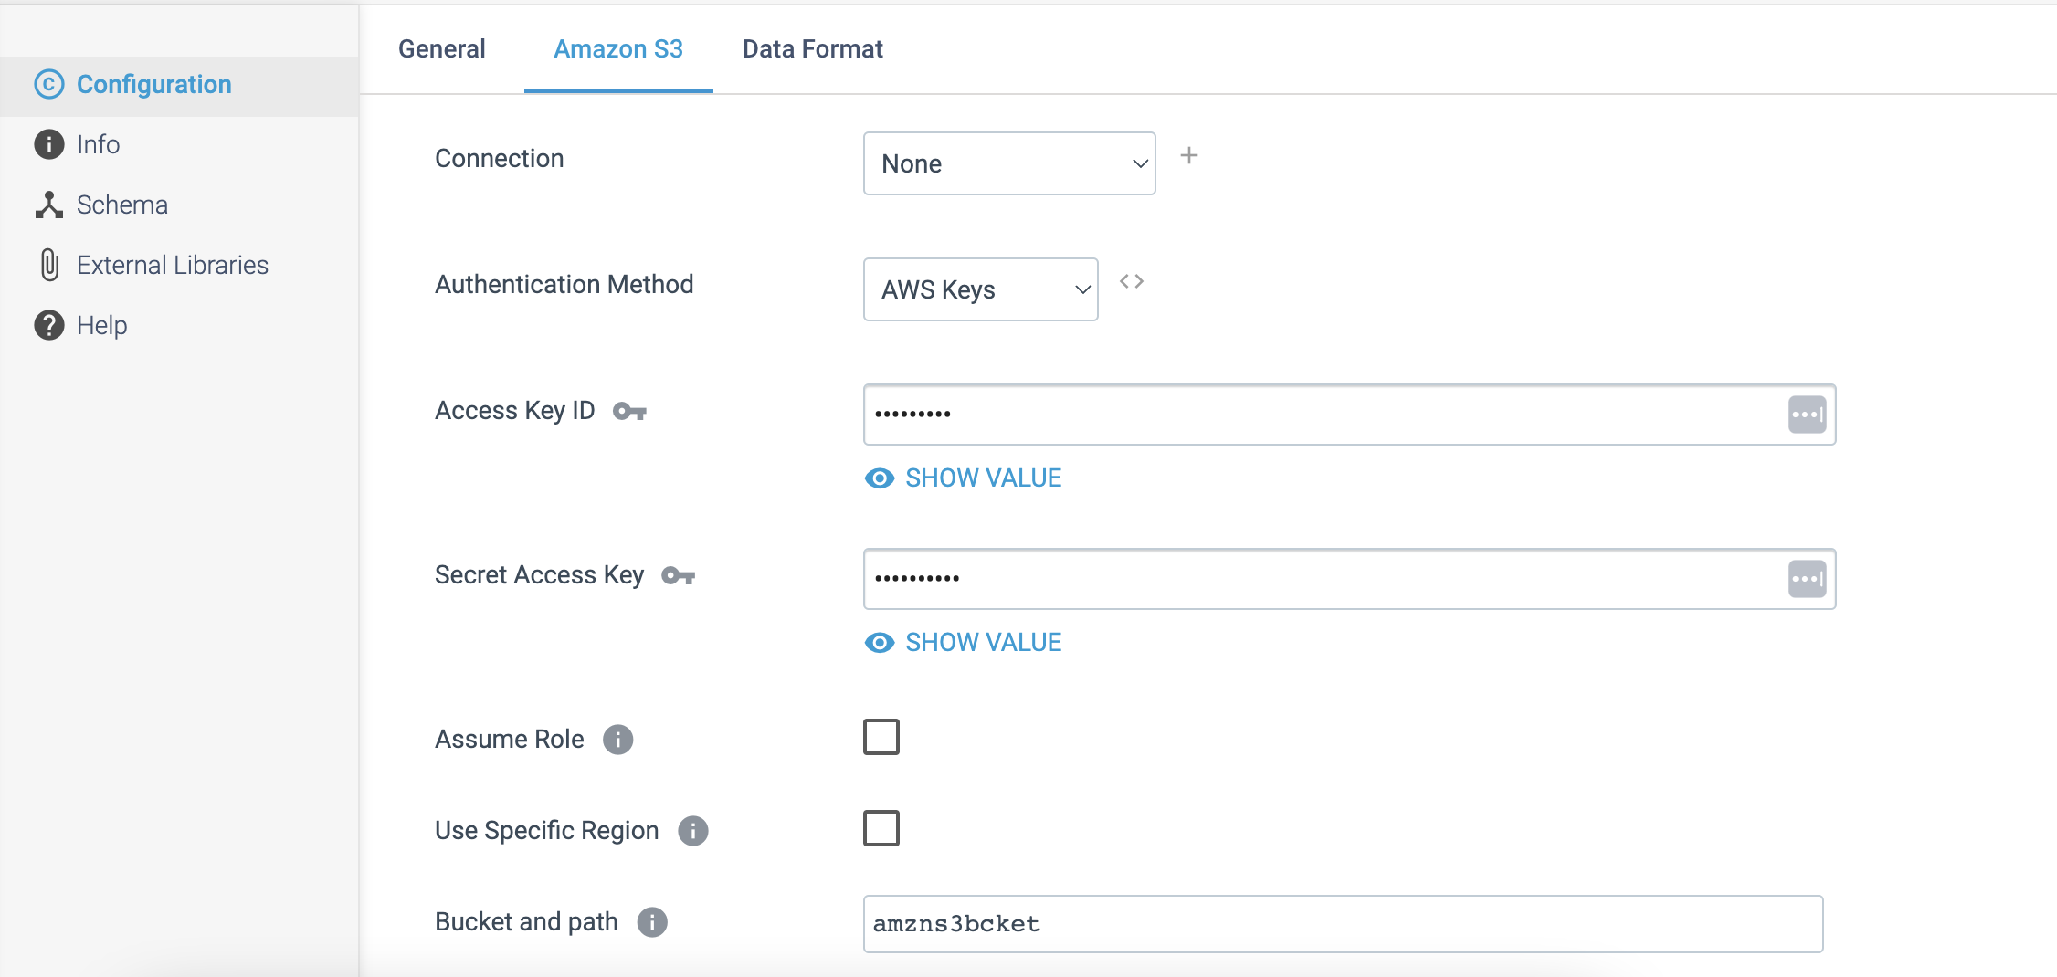

Step 2: Click on the **Data Format** tab to define the output format.

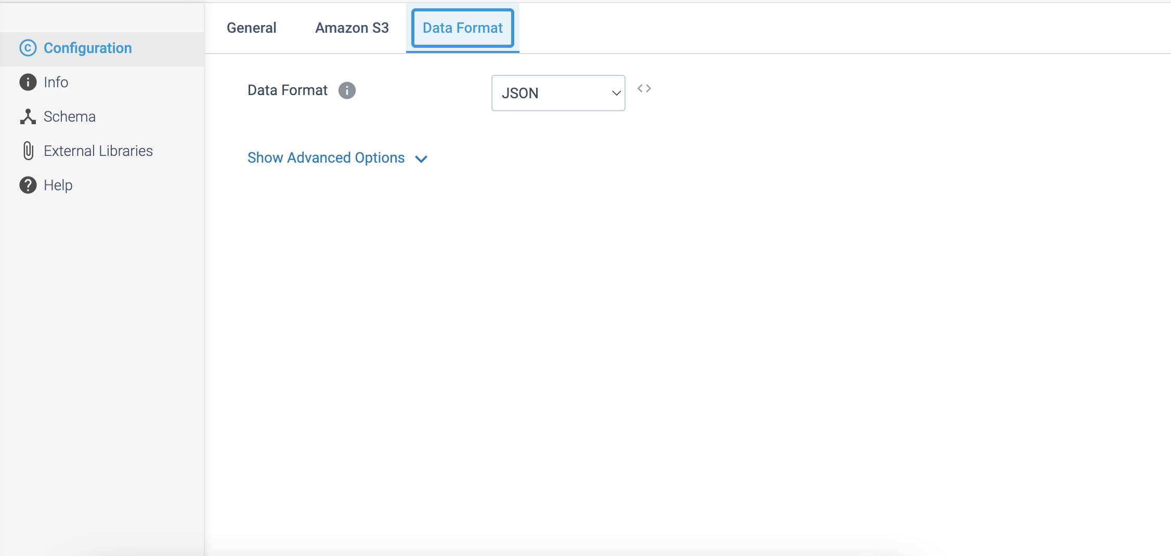

**DESTINATION NAME:** Azure Synapse SQL

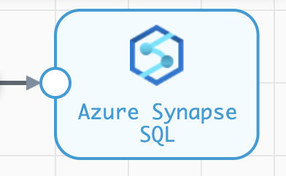

**Engine Type**: Data Collector

**Pipeline Name**: D_Azure_Blob_Orgn_AzureSQL_Dest_Pipeline_Cred

**Description**: The **Azure Synapse SQL** destination loads data into one or more tables in Microsoft Azure Synapse.

We need to configure the **Azure Synapse SQL** destination in a following way.

Step 1: Click on the **Azure Synapse SQL** destination to configure authentication information for the instance.

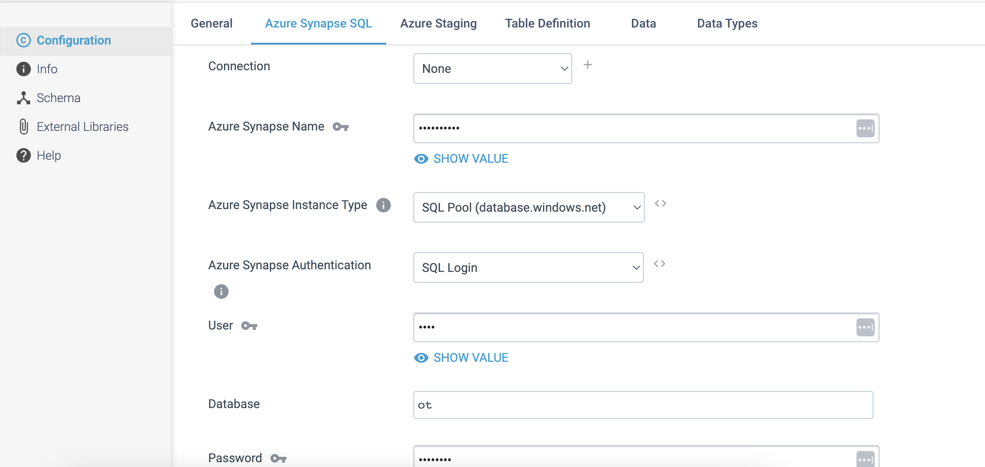

Step 2: Click on the **Azure staging** tab to define the below staging details.

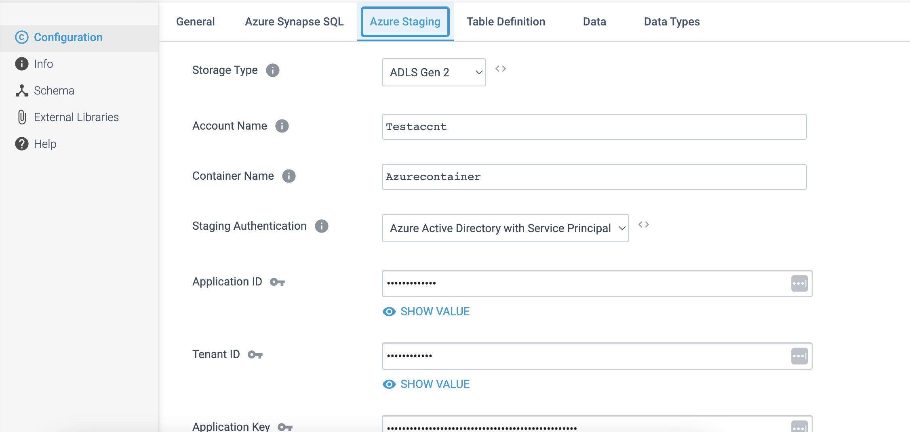

Step 3: Click on the **Table Definition** tab to configure the below table details.

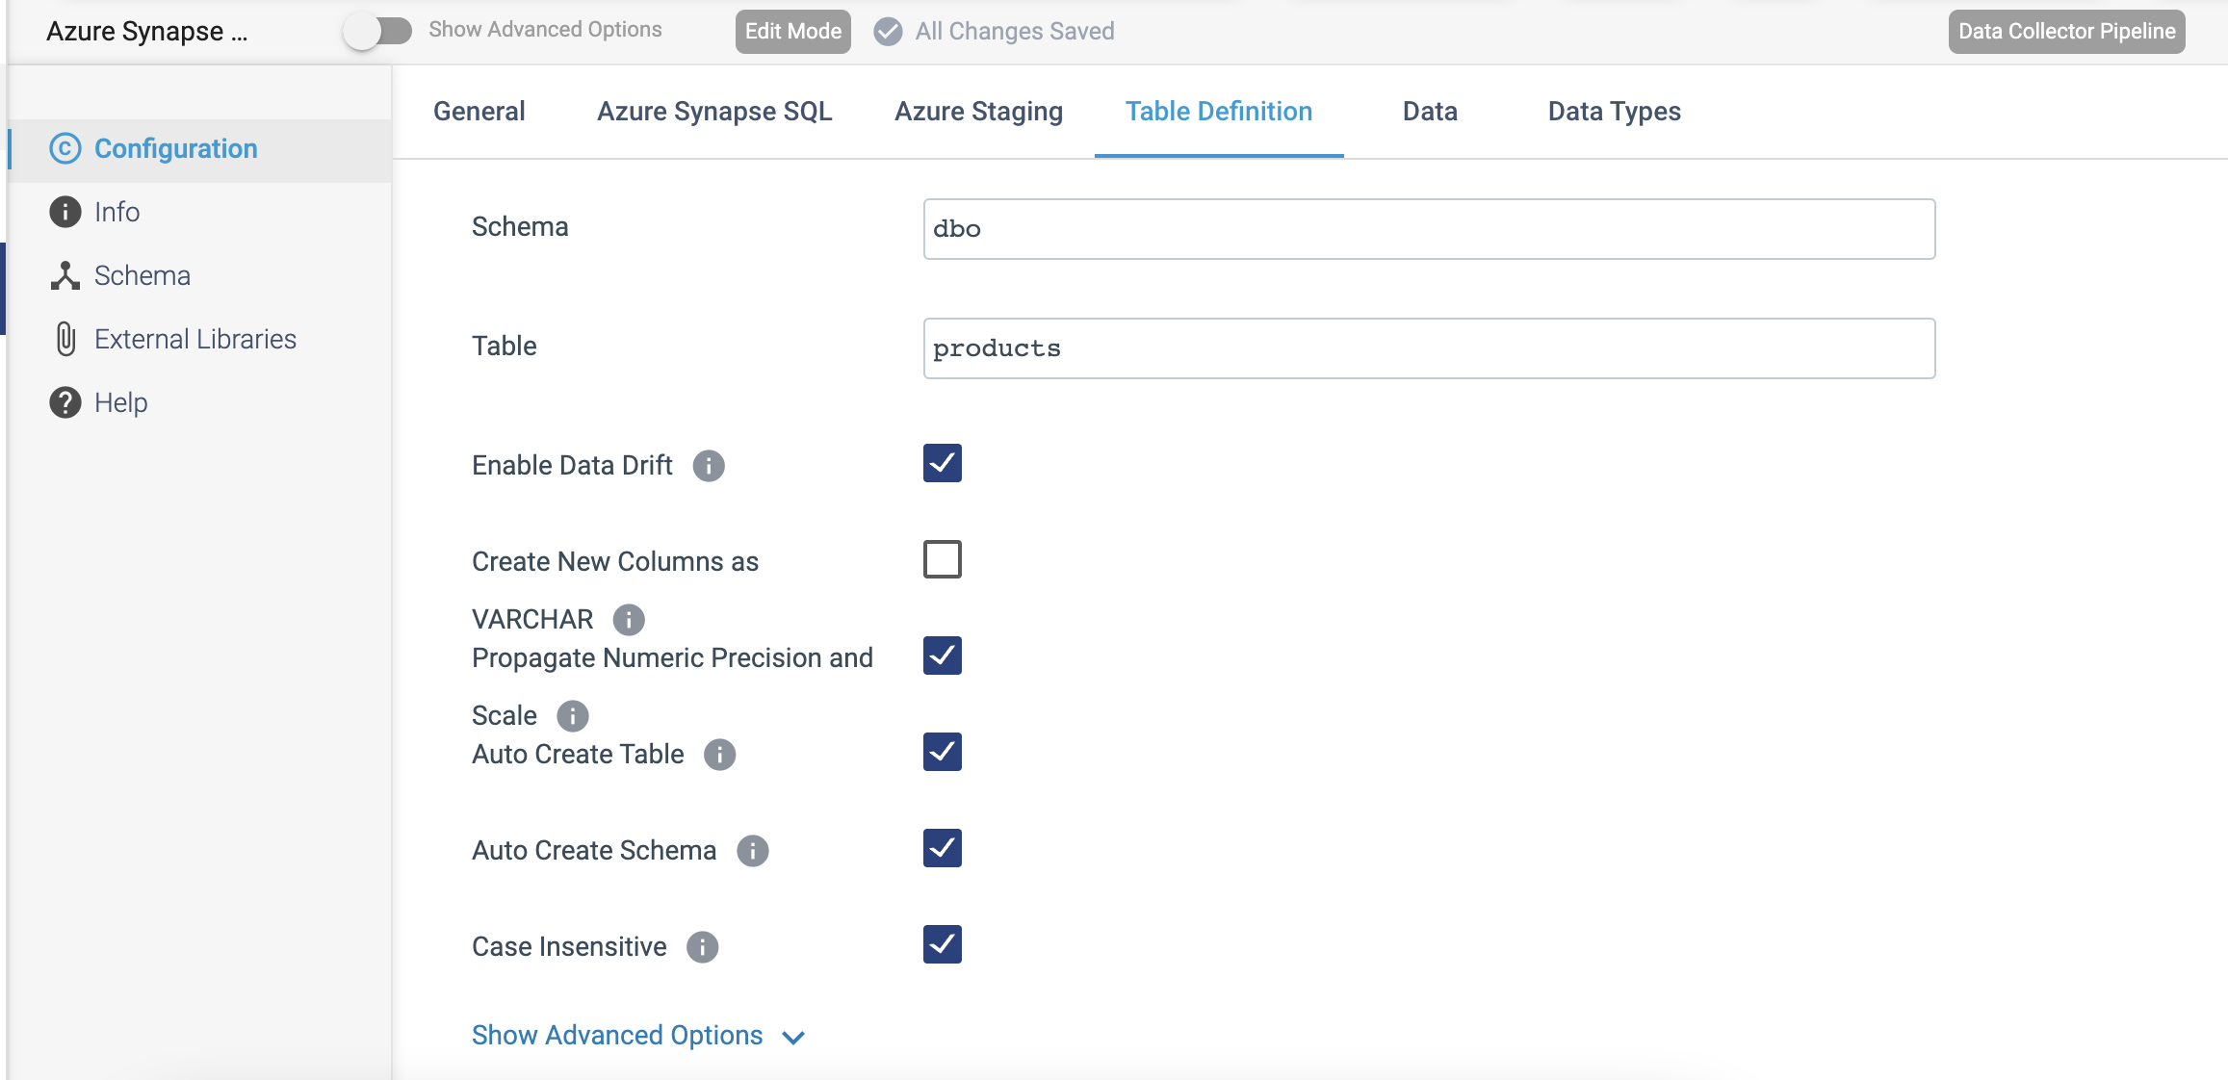

**DESTINATION NAME:** Azure IoT Hub Producer

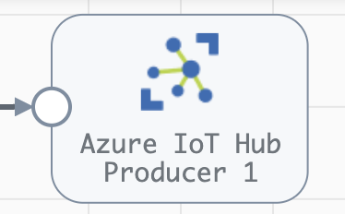

**Engine Type**: Data Collector

**Pipeline Name**: D_azure_IoT_Orgn_Hub_Dest_Pipeline_CredStr

**Description**: The **Azure IoT Hub** **Producer** destination writes data to Microsoft Azure IoT Hub.

We need to configure the **Azure IoT Hub** **Producer** destination in a following way.

Step 1: Click on the **Azure IoT Hub** **Producer** destination to configure the Azure IoT hub details.

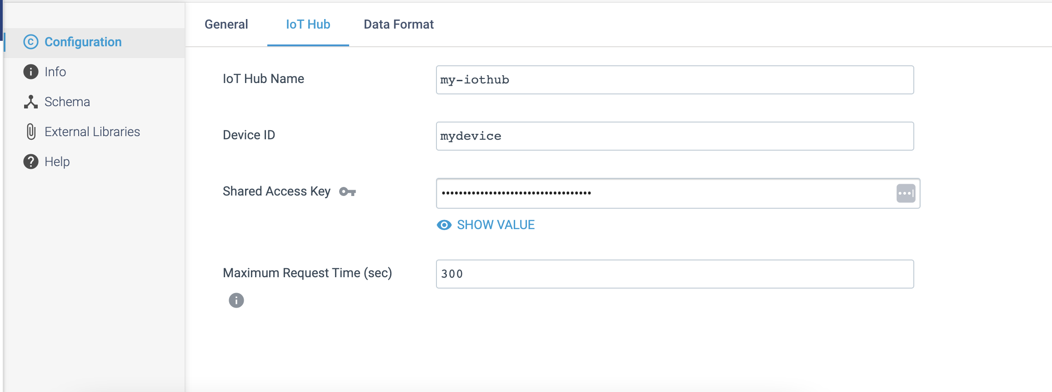

Step 2: Click on the **Data Format** tab to define the output format.

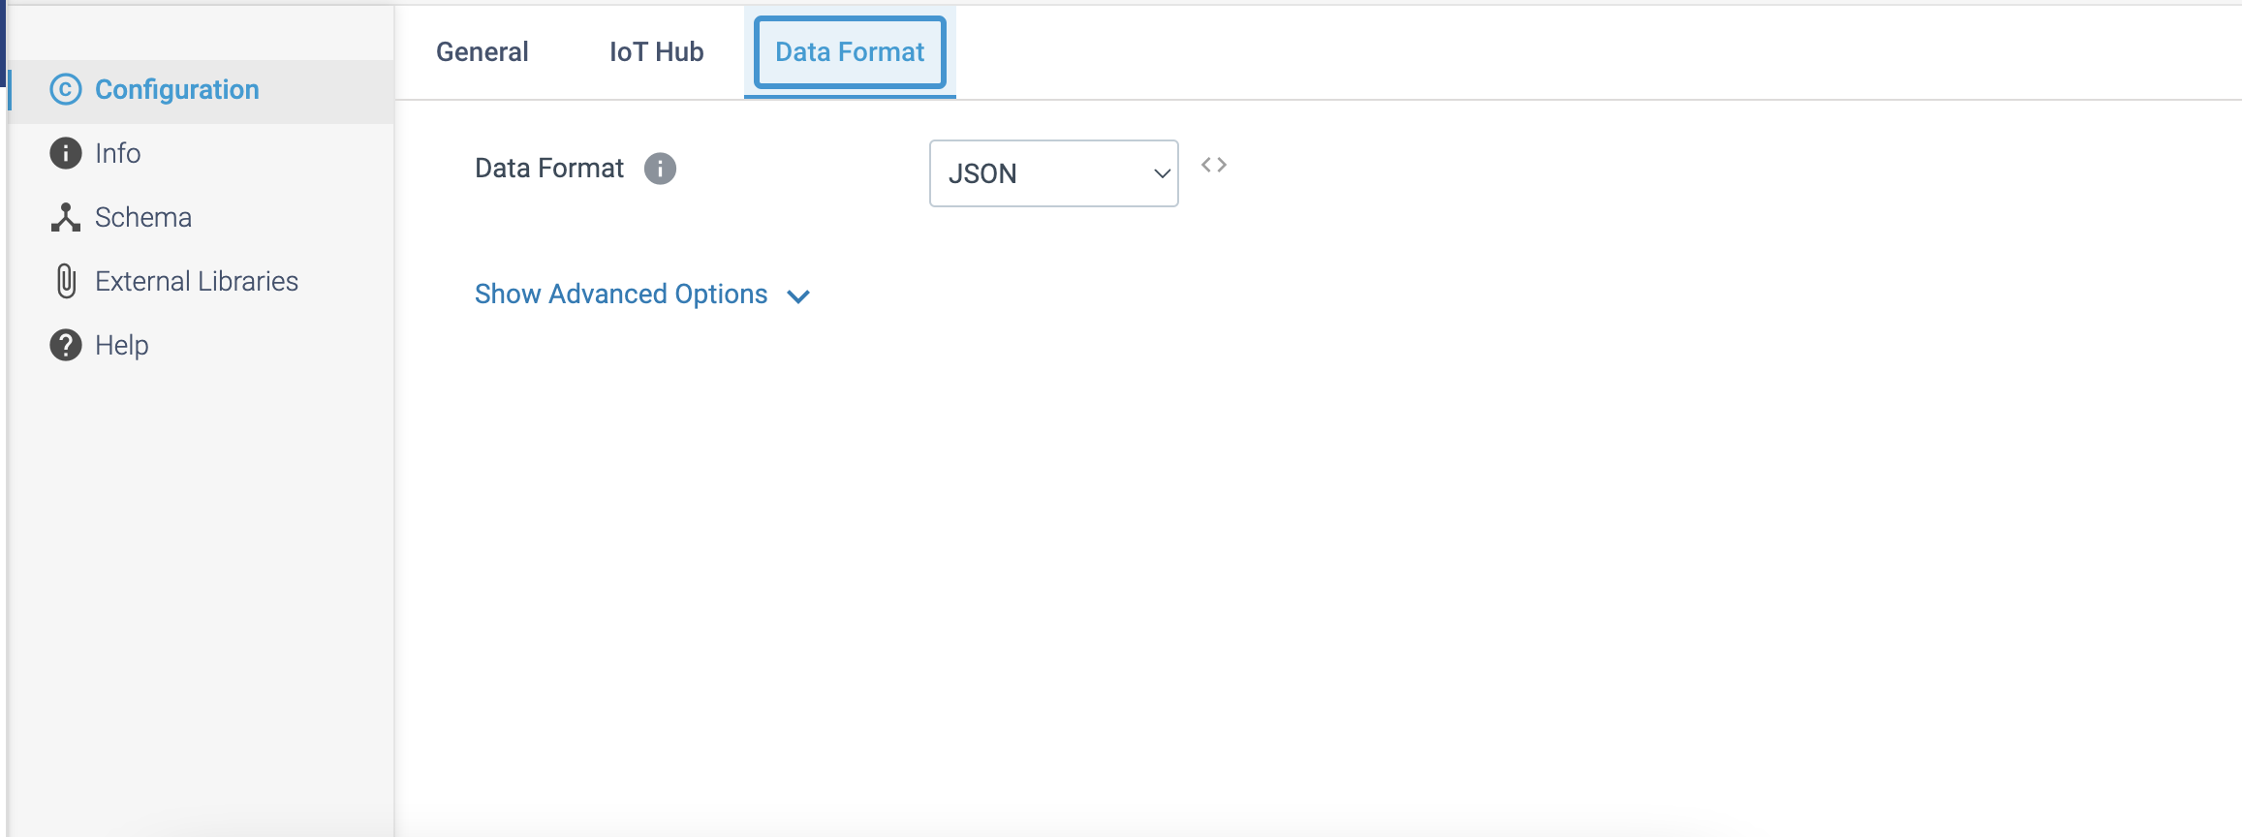

**DESTINATION NAME:** Azure Event Hub Producer

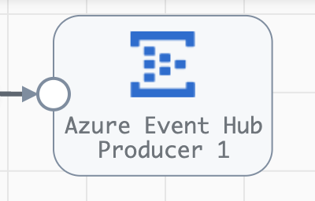

**Engine Type**: Data Collector

**Pipeline Name**: D_azure_IoT_Orgn_Event_Dest_Pipeline_CredStr

**Description**: The **Azure Event Hub Producer** destination writes data to Microsoft Azure Event Hub.

We need to configure the **Azure Event Hub Producer** destination in a following way.

Step 1: Click on the **Azure Event Hub Producer** destination to specify the Microsoft Azure namespace and event hub names.

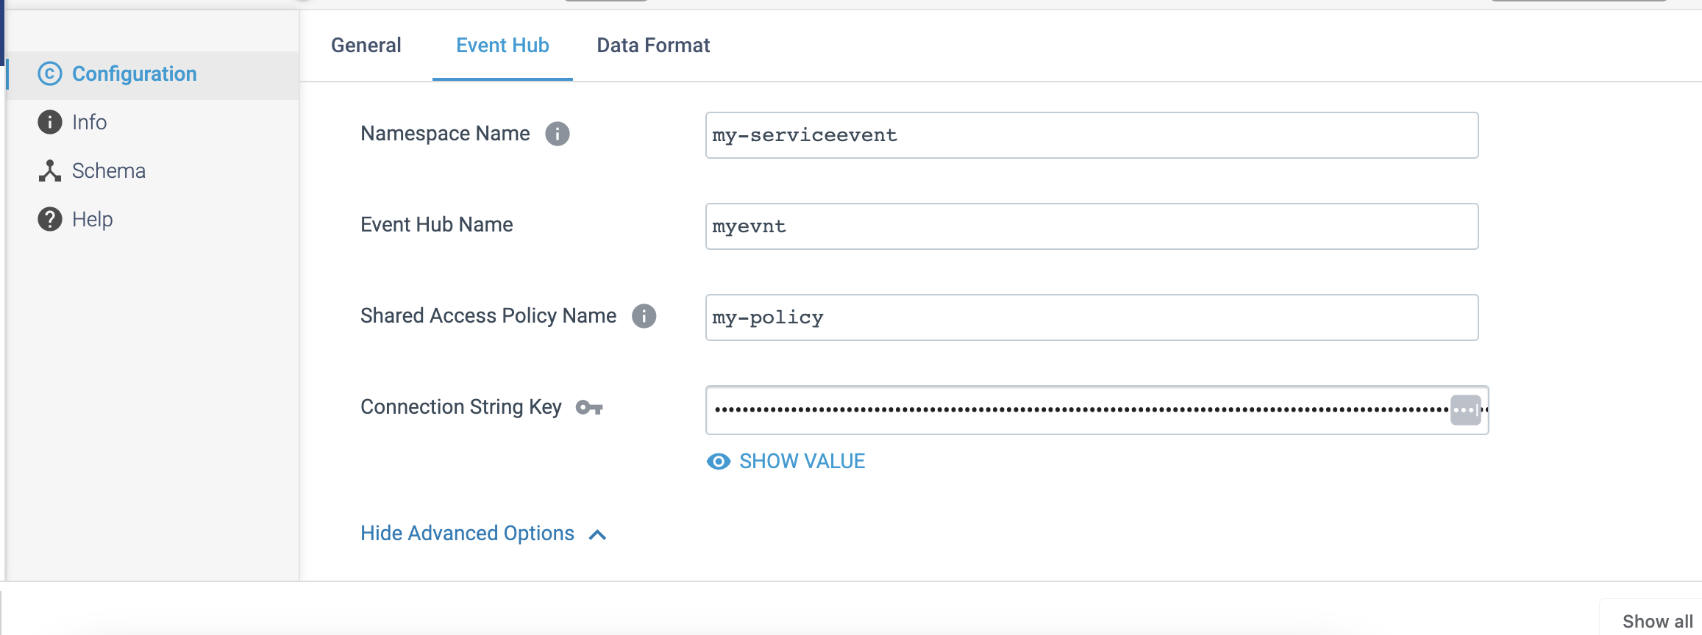

Step 2: Click on the **Data Format** tab to define the output format.

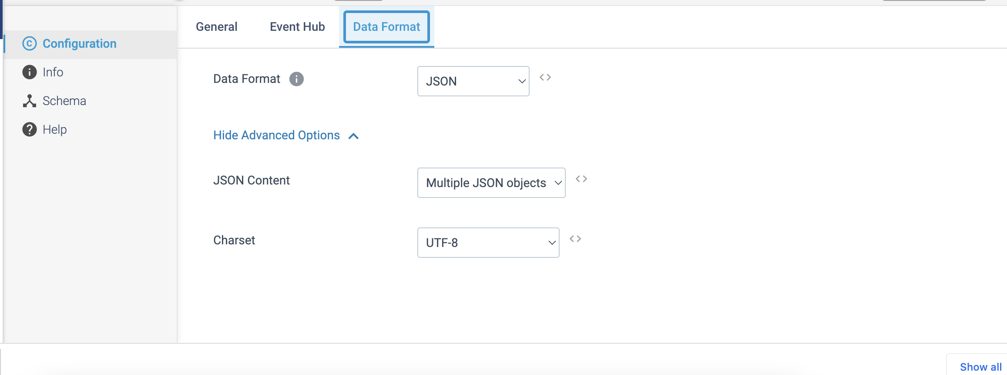

**DESTINATION NAME:** Azure Data Lake Storage Gen2

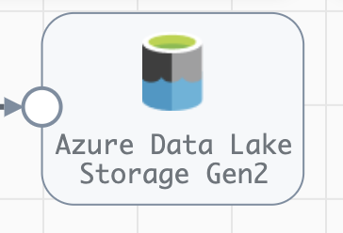

**Engine Type**: Data Collector

**Pipeline Name**: D_Postgrs_Orgn_Azre_LkeGen2_Dest_Pipelne_CredStr

**Description**: The **Azure Data Lake Storage Gen2** destination writes data to Microsoft Azure Data Lake Storage Gen2.

We need to configure the **Azure Data Lake Storage Gen2** destination in a following way.

Step 1: Click on the **Azure Data Lake Storage Gen2** destination to specify the authentication method to use and related properties.

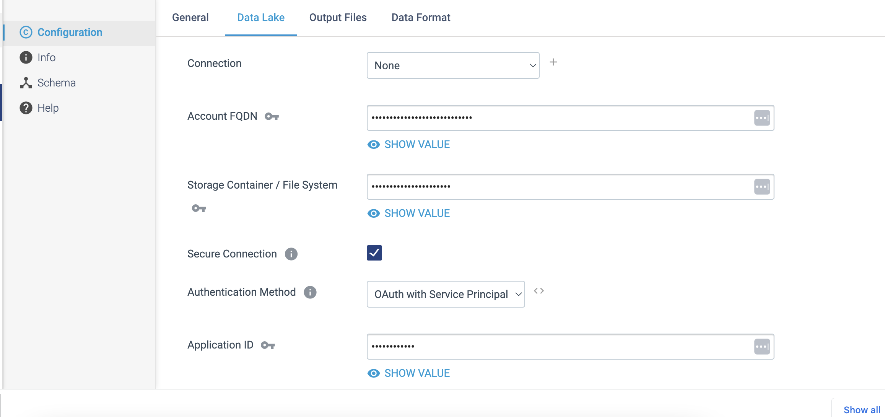

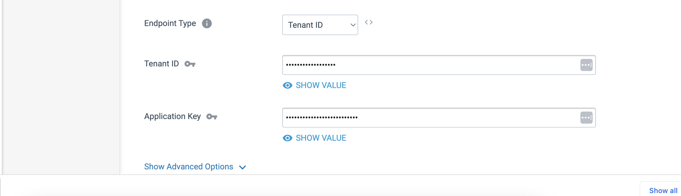

Step 2: Click on the **Output Files** tab to define a **directory template** and time basis to determine the output directories that the destination creates and the files where records are written.

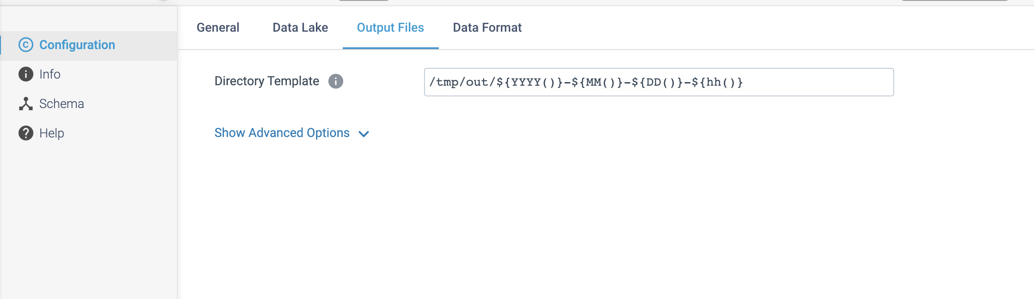

Step 3: Click on the **Data Format** tab to define the output format.

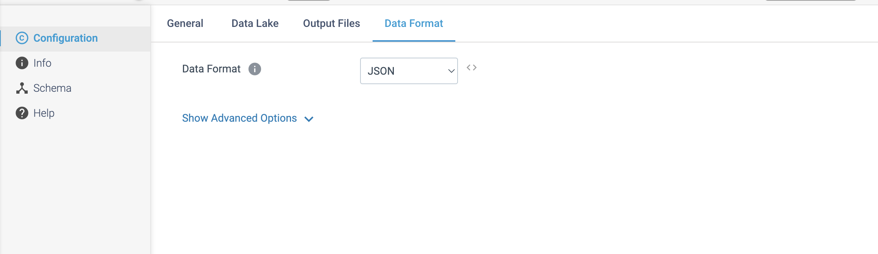

**DESTINATION NAME:** JDBC Producer

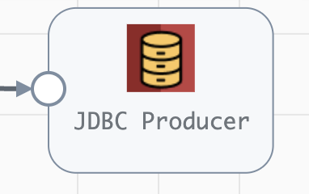

**Engine Type**: Data Collector

**Pipeline Name**: D_AmazonSQS_Origin_JDBC_Dest_Pipeline_CredStr

**Description**: The **JDBC Producer** destination uses a JDBC connection to write data to a database table. We can also use the JDBC Producer destination to write change capture data from a Microsoft SQL Server change log.

Step 1: Click on the **JDBC Producer** destination to specify connection information, table name, and optionally define field mappings.

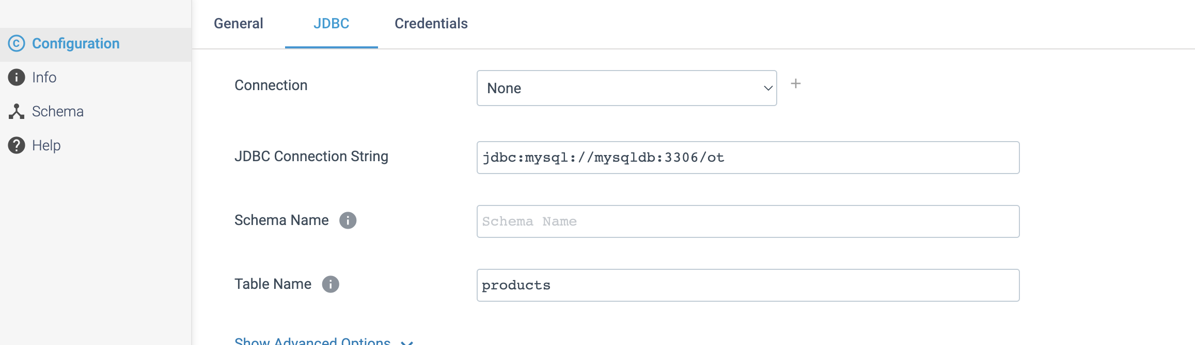

Step 2: Click on the **Credentials** tab to define the credentials.

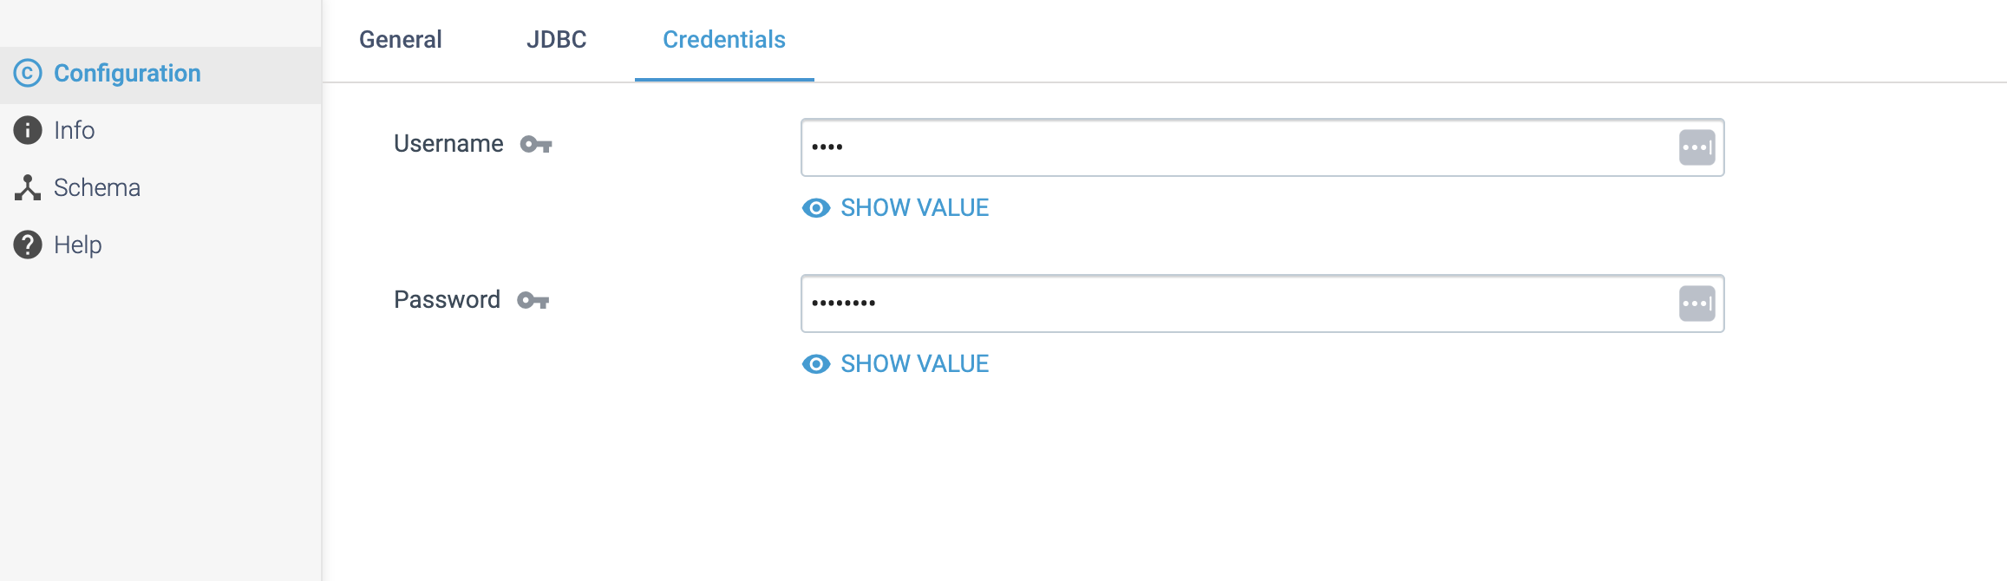

**DESTINATION NAME:** Couchbase

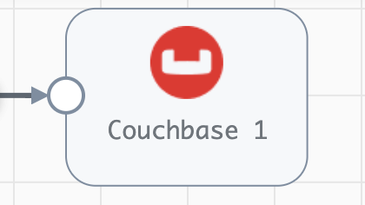

**Engine Type**: Data Collector

**Pipeline Name**: D_OPC_Client_orgn_Couchbse_Dest_Pipeline_URL_URI

**Description**: The **Couchbase** destination writes data to Couchbase Server. Couchbase Server is a distributed NoSQL document-oriented database.

We need to configure the **Couchbase** destination in a following way.

Step 1: Click on the **Couchbase** destination to enter connection information, such as the nodes and bucket to connect to, as well as timeout properties for the connection. Optionally, you can enable **TLS** for the connection. You also enter information to authenticate with **Couchbase** Server.

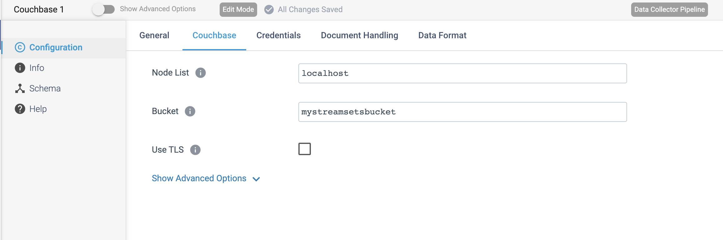

Step 2: Click on the **Credentials** tab to define the credentials.

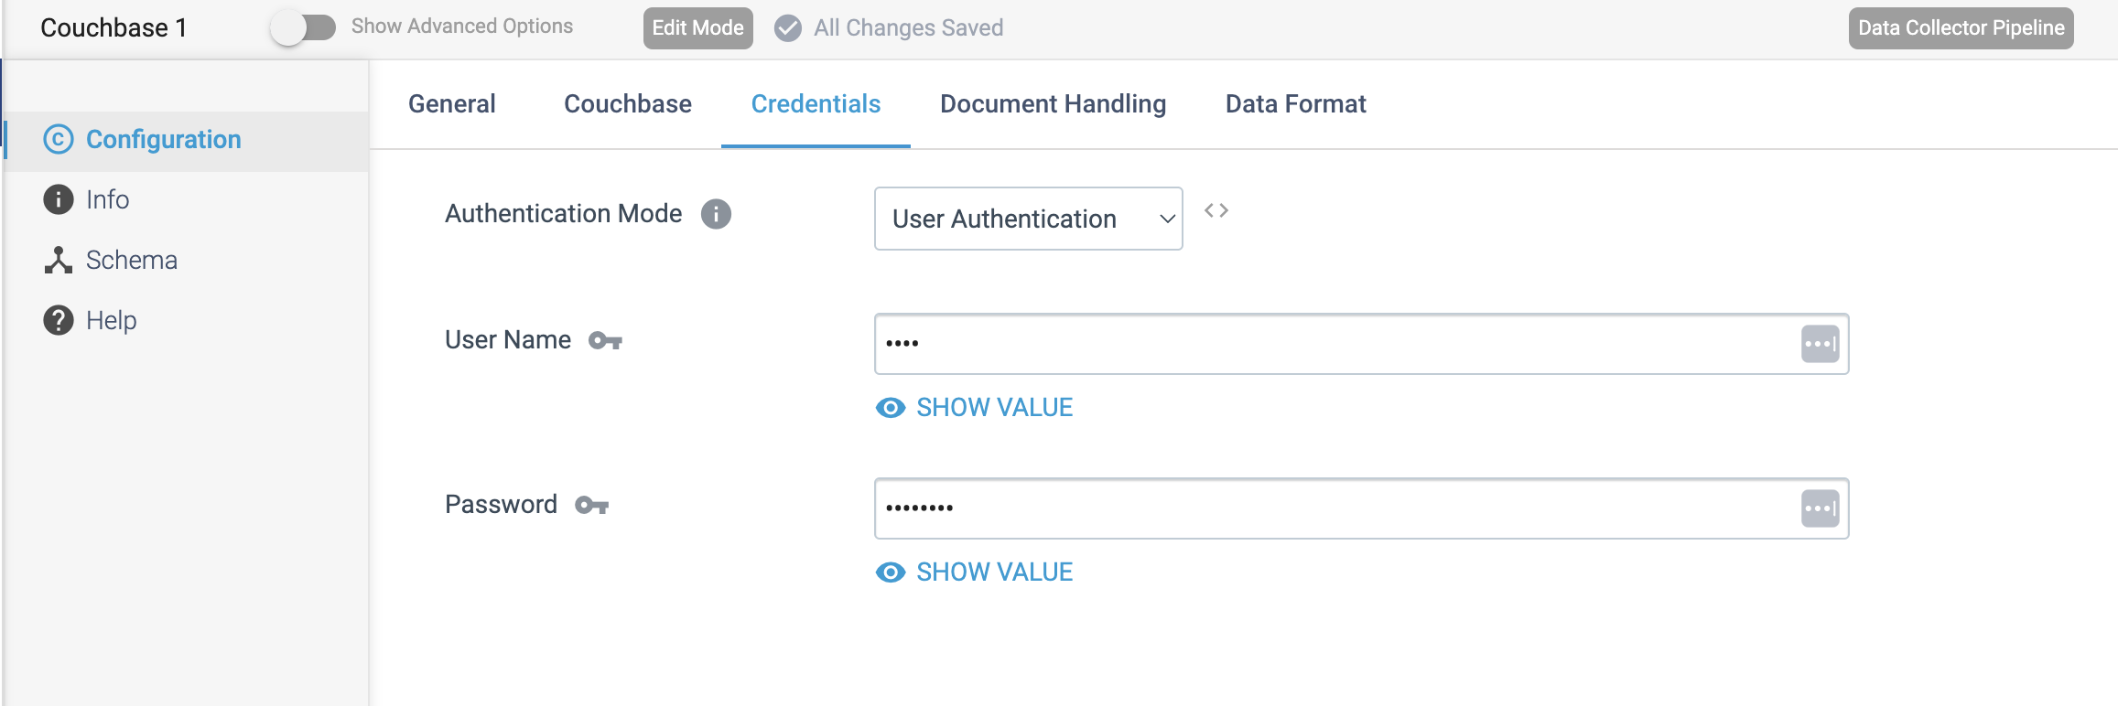

Step 3: Click on the **Document Handling** tab to define the below details.

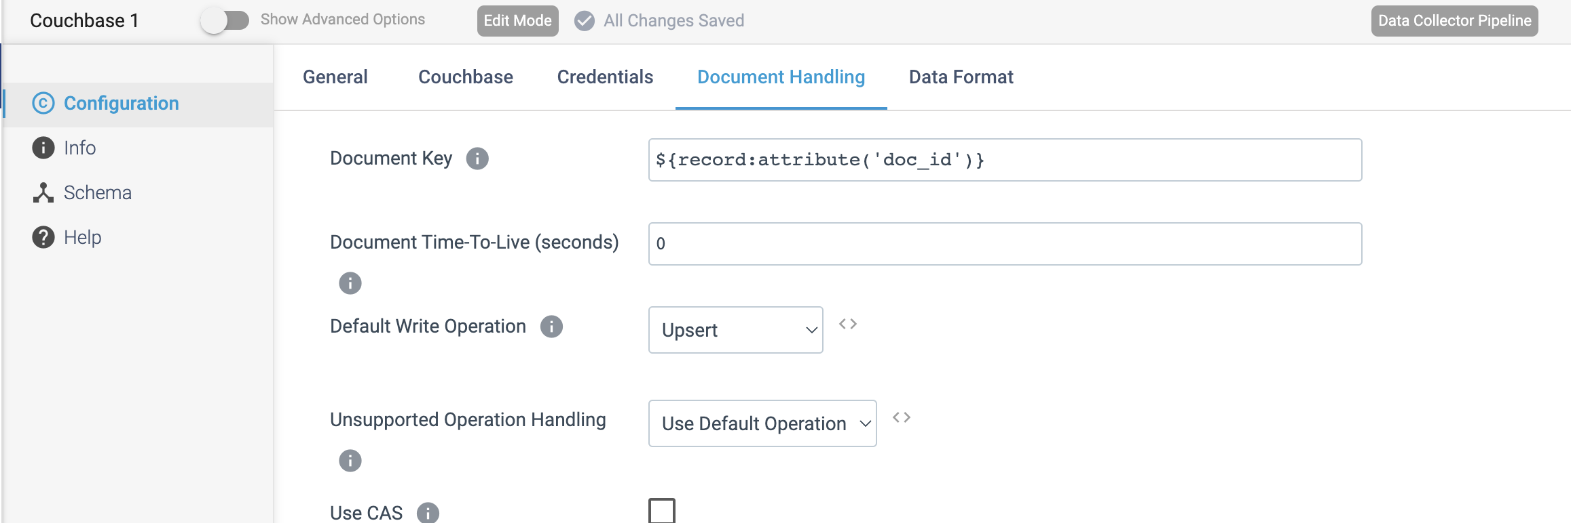

Step 4: Click on the **Data format** tab to define the output format.

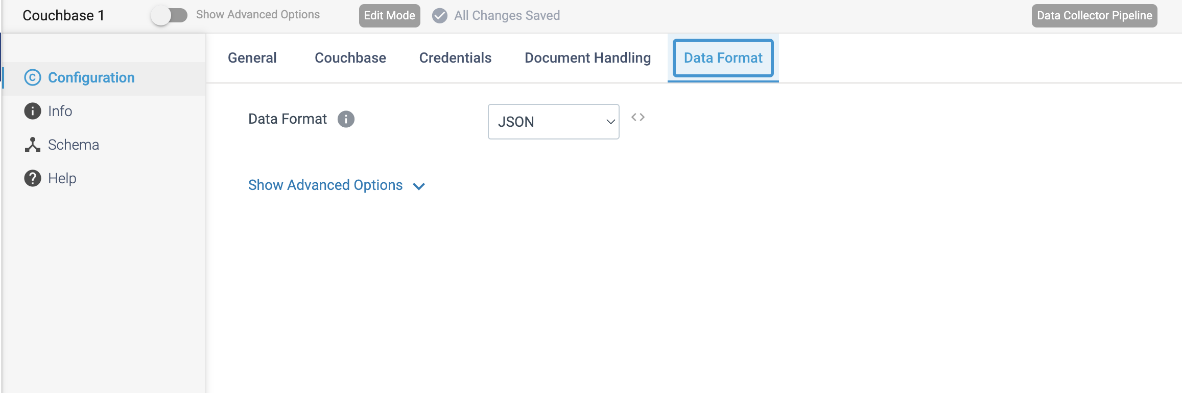

**DESTINATION NAME:** Cassandra

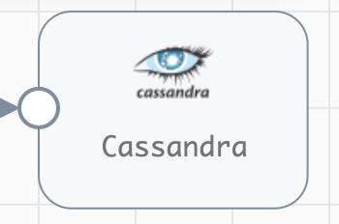

**Engine Type**: Data Collector

**Pipeline Name**: D_MongoAtlas_orgn_cssndra_Dest_pipeline_CredStr

**Description**: The **Cassandra** destination writes data to a Cassandra cluster.

We need to configure the **Cassandra** destination in a following way.

Step 1: Click on the **Cassandra** destination to define connection information and map incoming fields to columns in the **Cassandra** table. We can also use a **connection** to configure the destination.

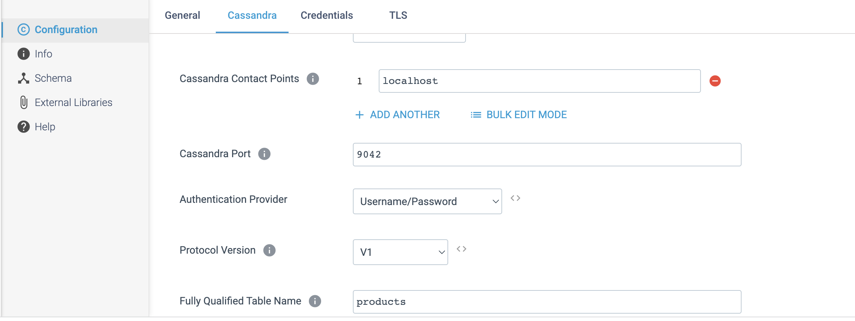

Step 2: Click on the **Credentials** tab to define the credentials.

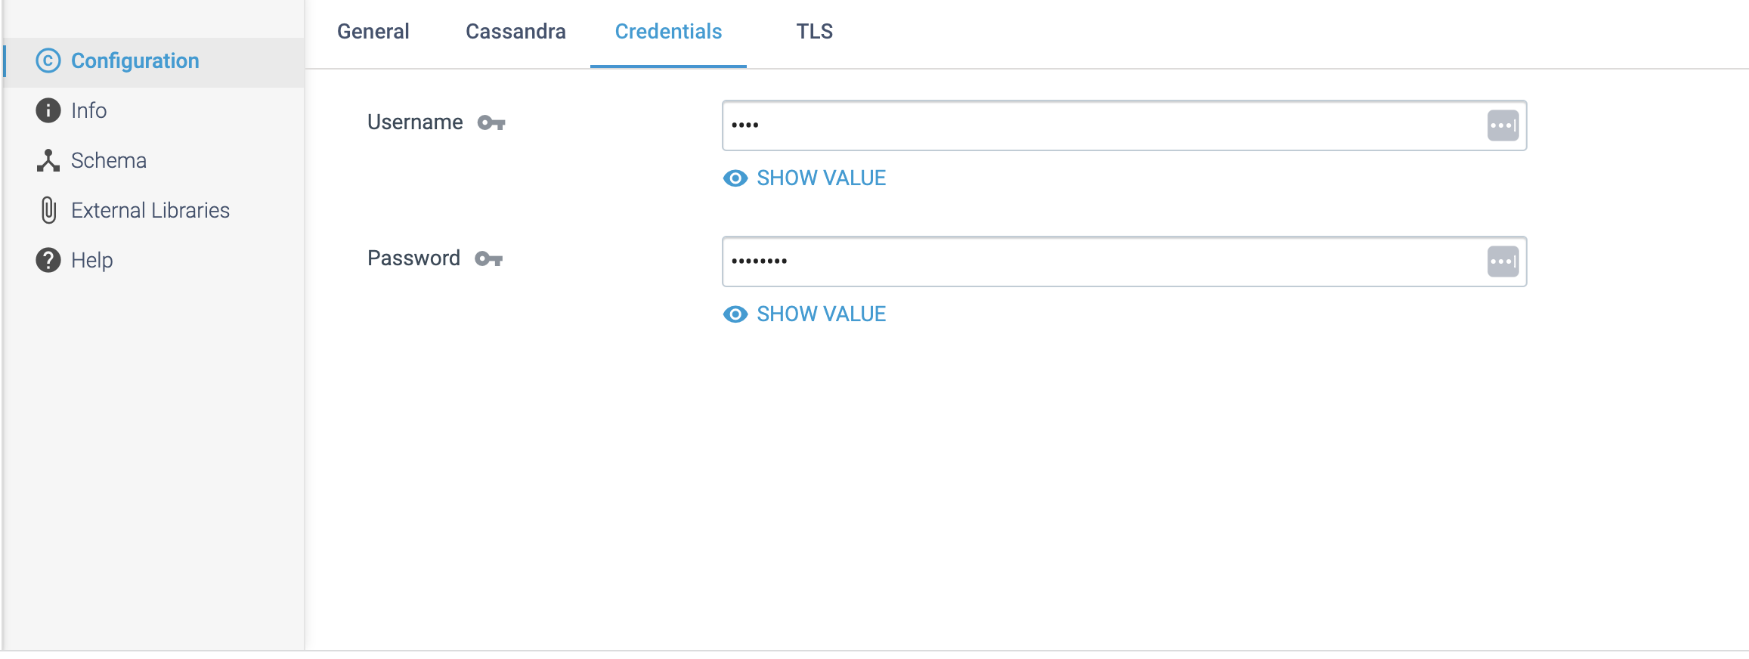

**DESTINATION NAME:** MongoDB

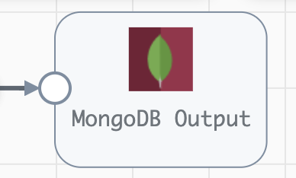

**Engine Type**: Data Collector

**Pipeline Name**: D_MongoDB_Orgn_Dest_Pipeline_Cred

**Description**: The **MongoDB** destination writes data to MongoDB.

We need to configure the **MongoDB** destination in a following way.

Step 1: Click on the **MongoDB** destination to define connection information, such as the connection string and MongoDB credentials. We can also use a connection to configure the destination.

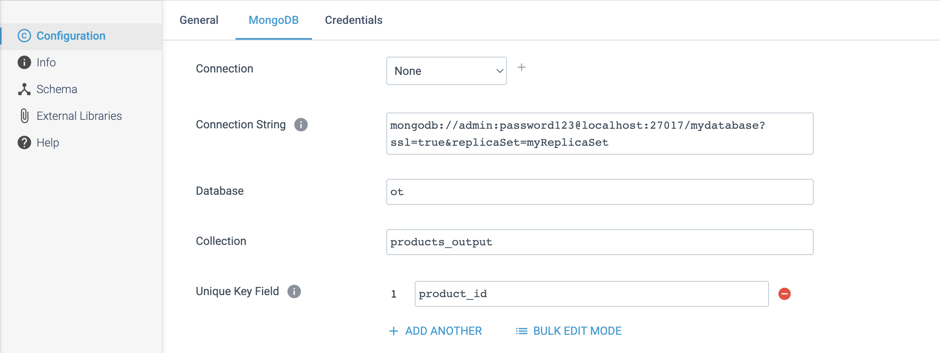

Step 2: Click on the **Credentials** tab to define the credentials.

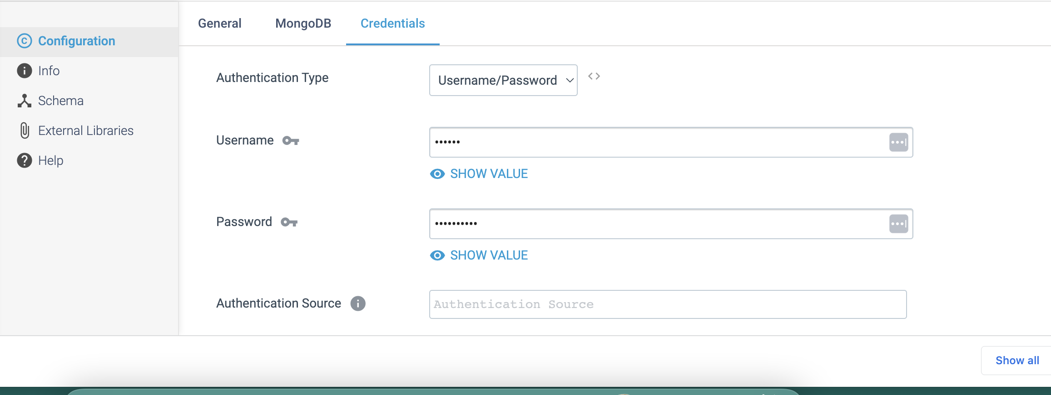

**DESTINATION NAME:** MongoDB Atlas

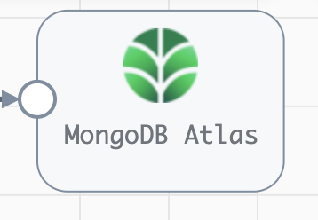

**Engine Type**: Data Collector

**Pipeline Name**: D_Mongolog_orgn_Atlas_Dest_pipeline_CredStr

**Description**: The **MongoDB Atlas** destination writes data to MongoDB Atlas and MongoDB Enterprise Server. The **MongoDB Atlas** destination can write CDC data if an operation is specified in the **CRUD** operation header attribute. When not specified, it treats all records as inserts. The destination can also perform **upserts** for update and replace records.

We need to configure the **MongoDB Atlas** destination in a following way.

Step 1: Click on the **MongoDB Atlas** destination to define connection information, such as the connection string and credentials to use.

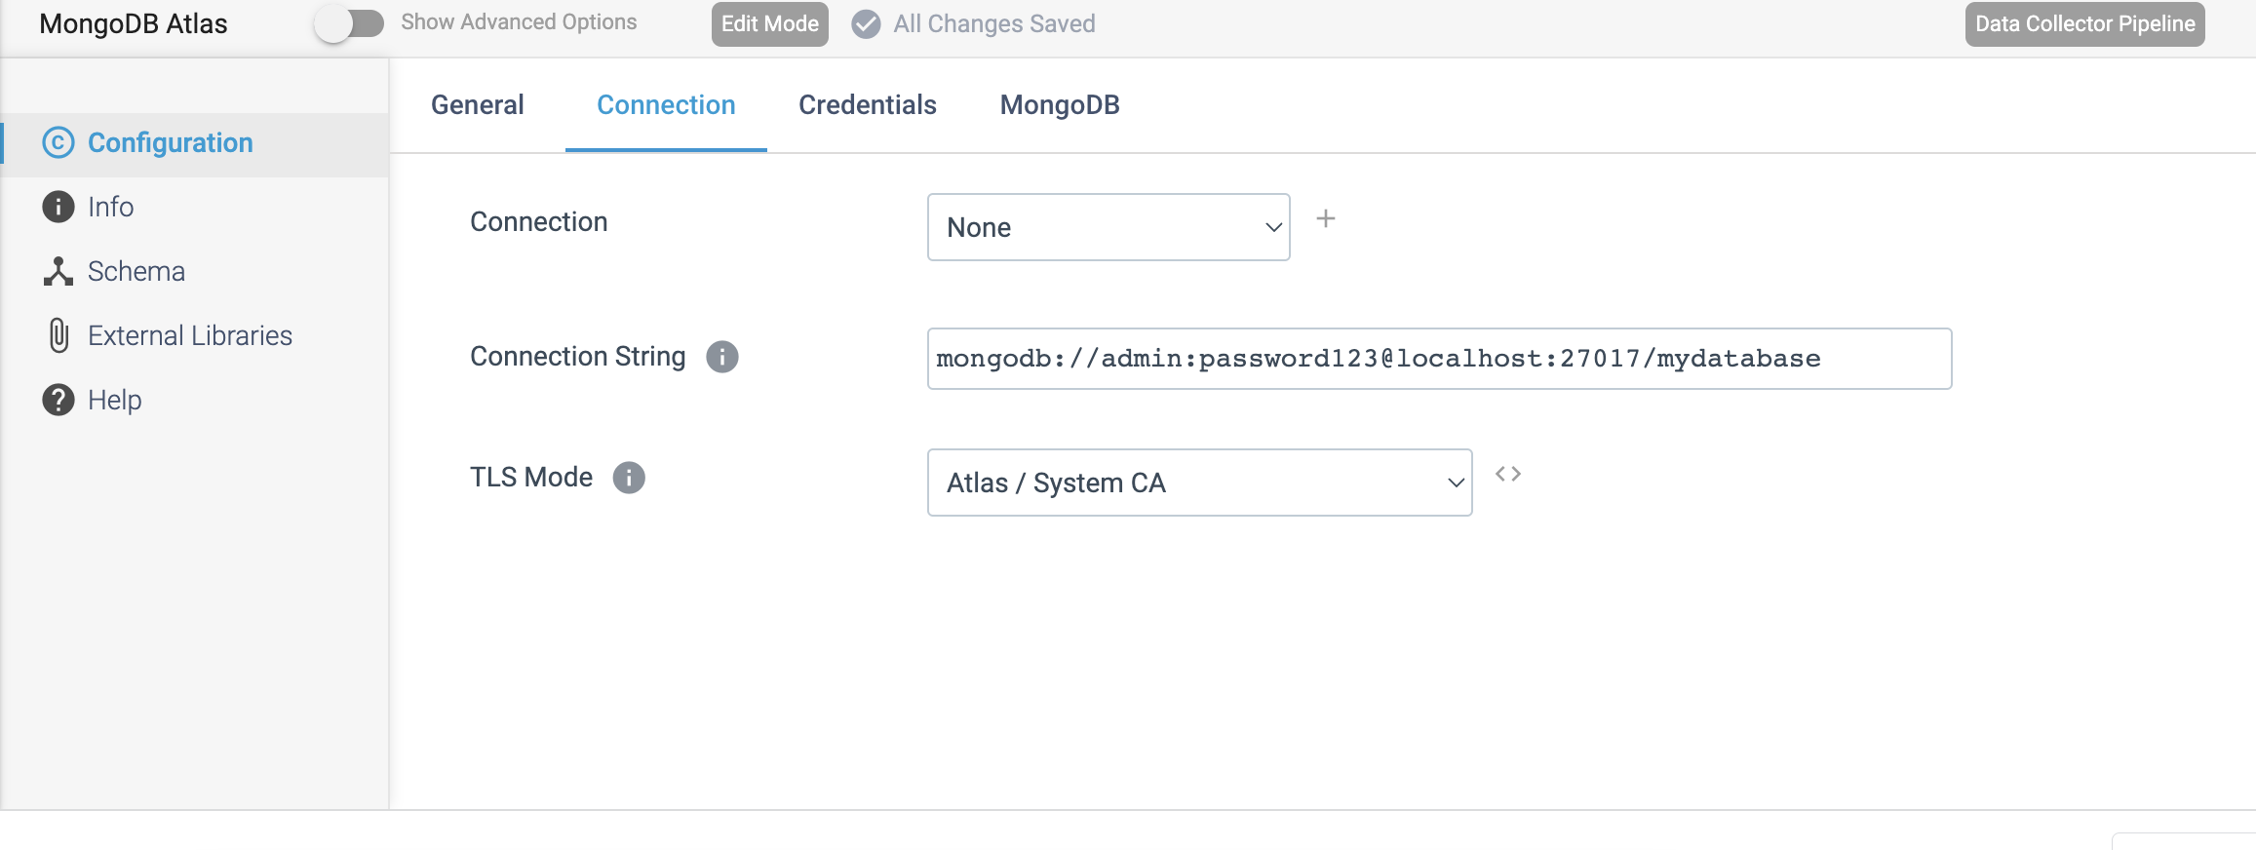

Step 2: Click on the **Credentials** tab to define the credentials.

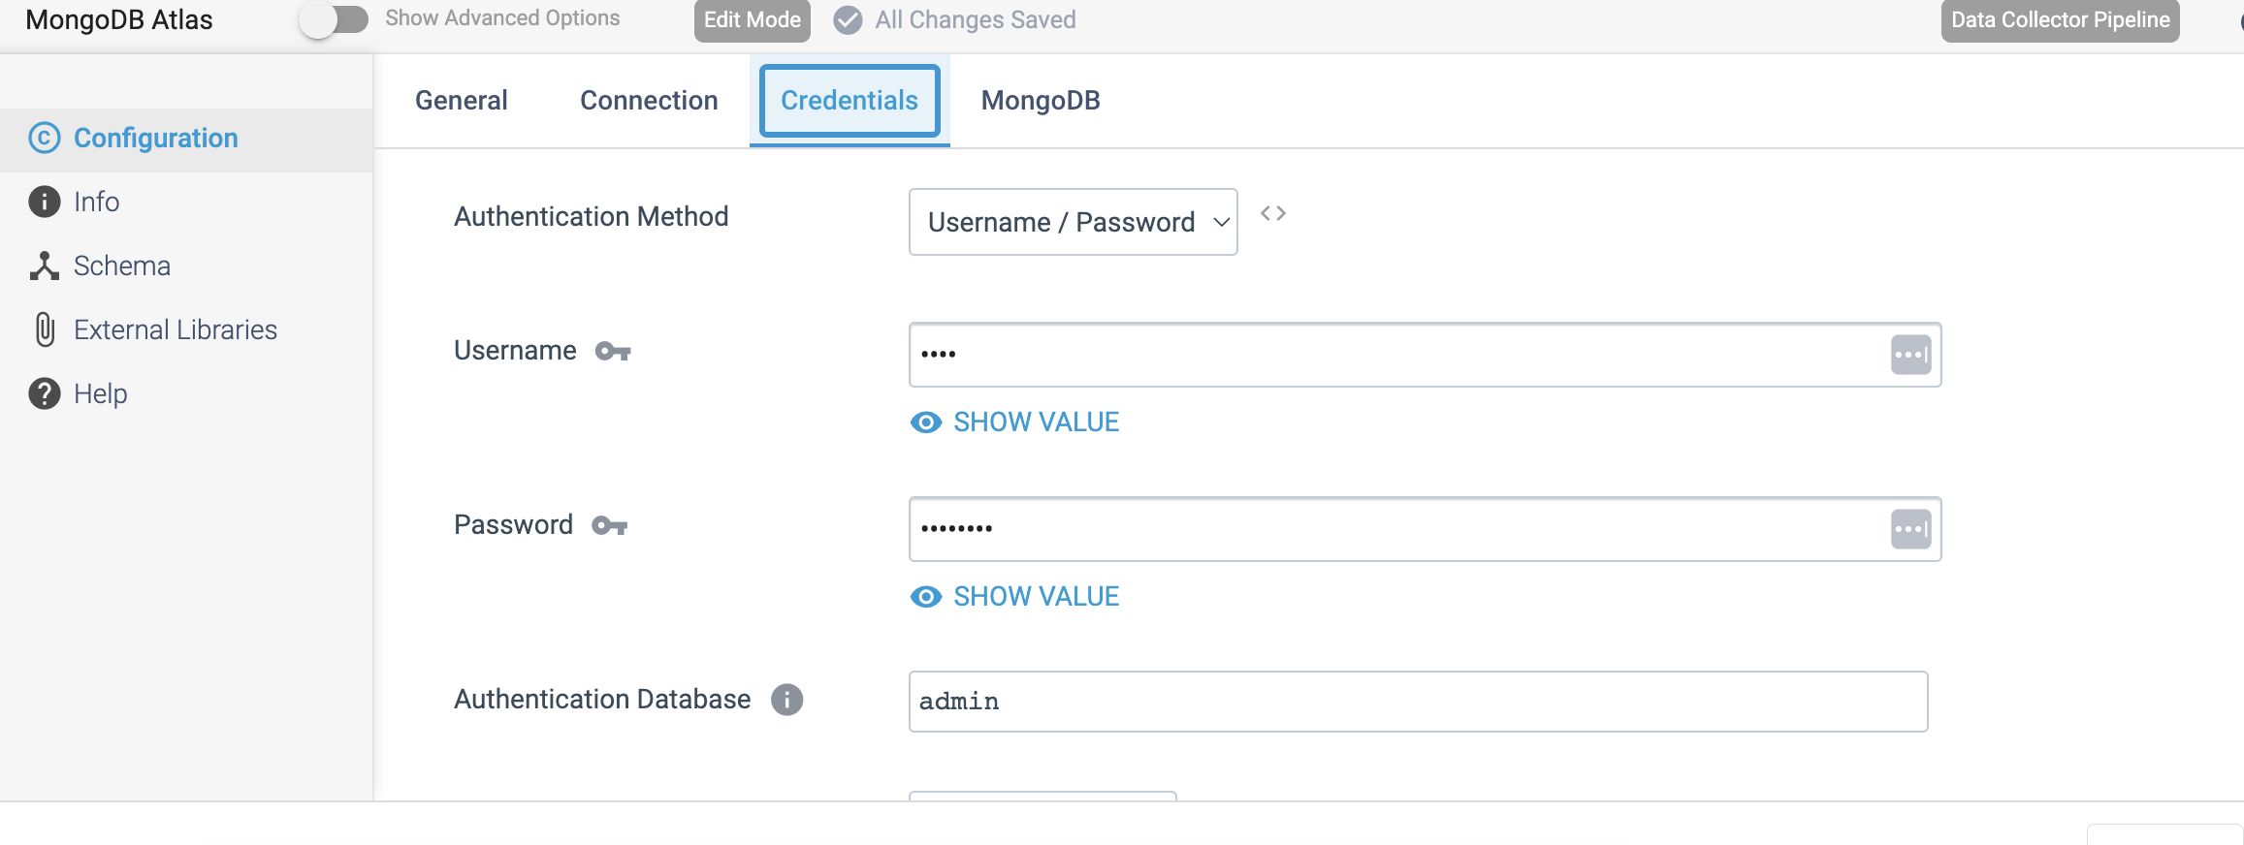

Step 3: Click on the **MongoDB** tab to configure the following properties.

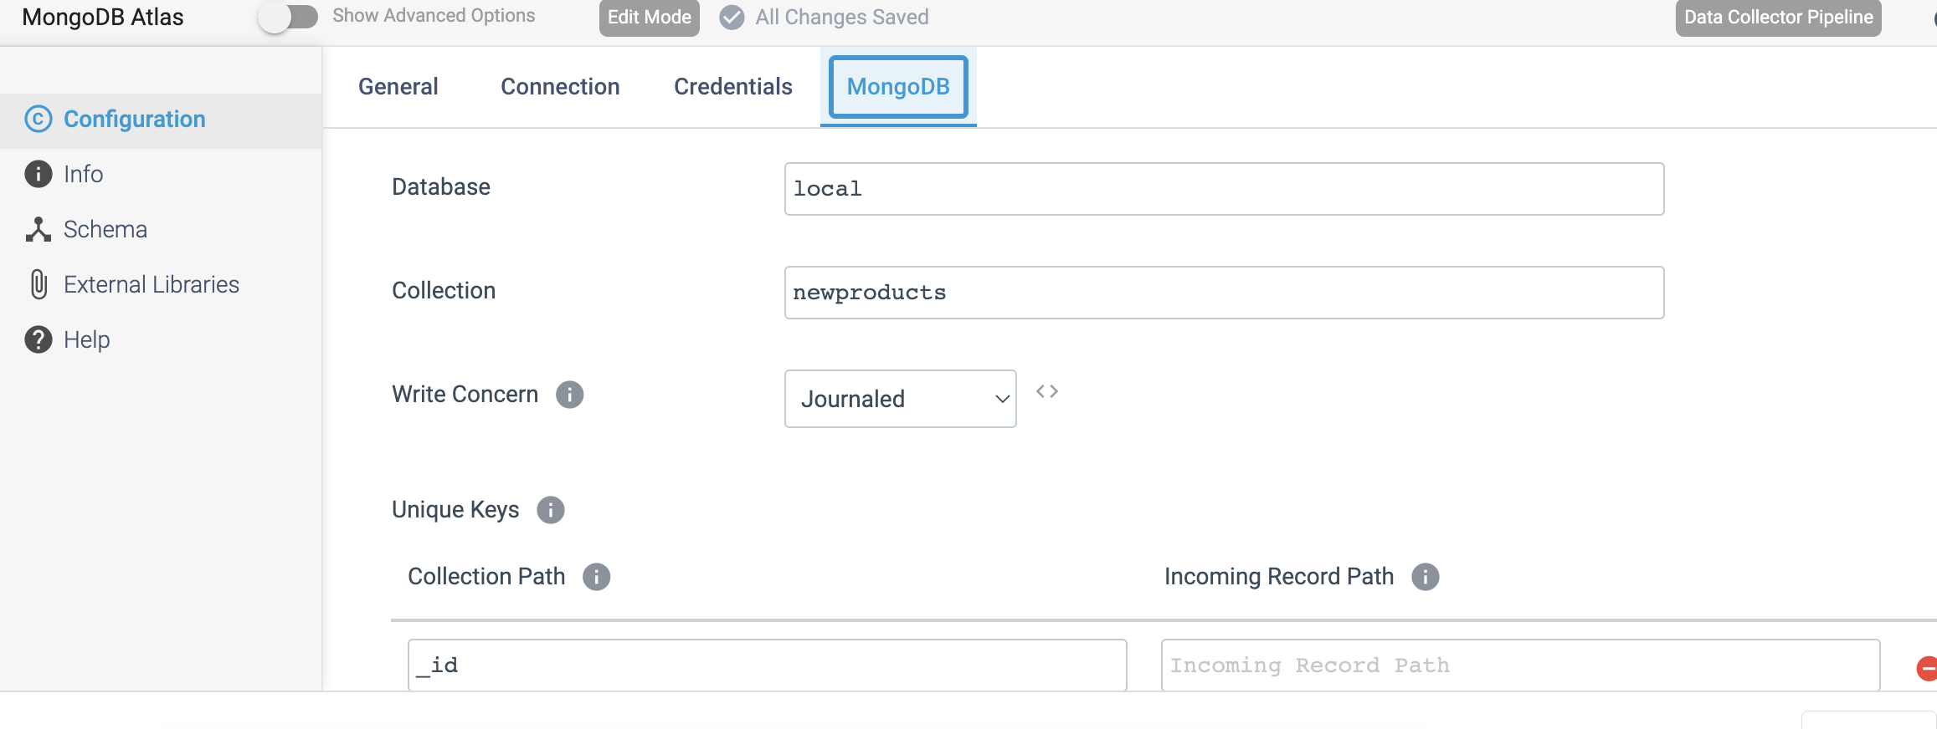

**DESTINATION NAME:** Elasticsearch

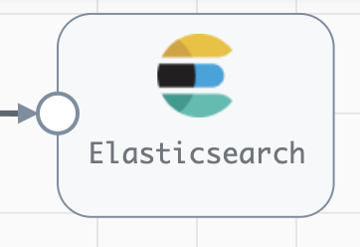

**Engine Type**: Data Collector

**Pipeline Name**: D_Elasticsrch_orgn_Dest_Pipeline_Cred_URL

**Description**: The **Elasticsearch** destination writes data to an Elasticsearch cluster, including Elastic Cloud clusters (formerly Found clusters) and Amazon Elasticsearch Service clusters.

We need to configure the **Elasticsearch** destination in a following way.

Step 1: Click on the **Elasticsearch** destination to configure the HTTP URLs used to connect to the Elasticsearch cluster and specify whether security is enabled on the cluster.

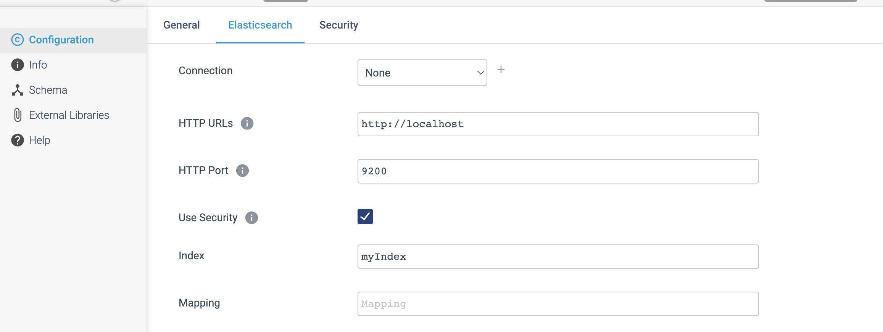

Step 2: Click on the **Security** tab to define the credentials.

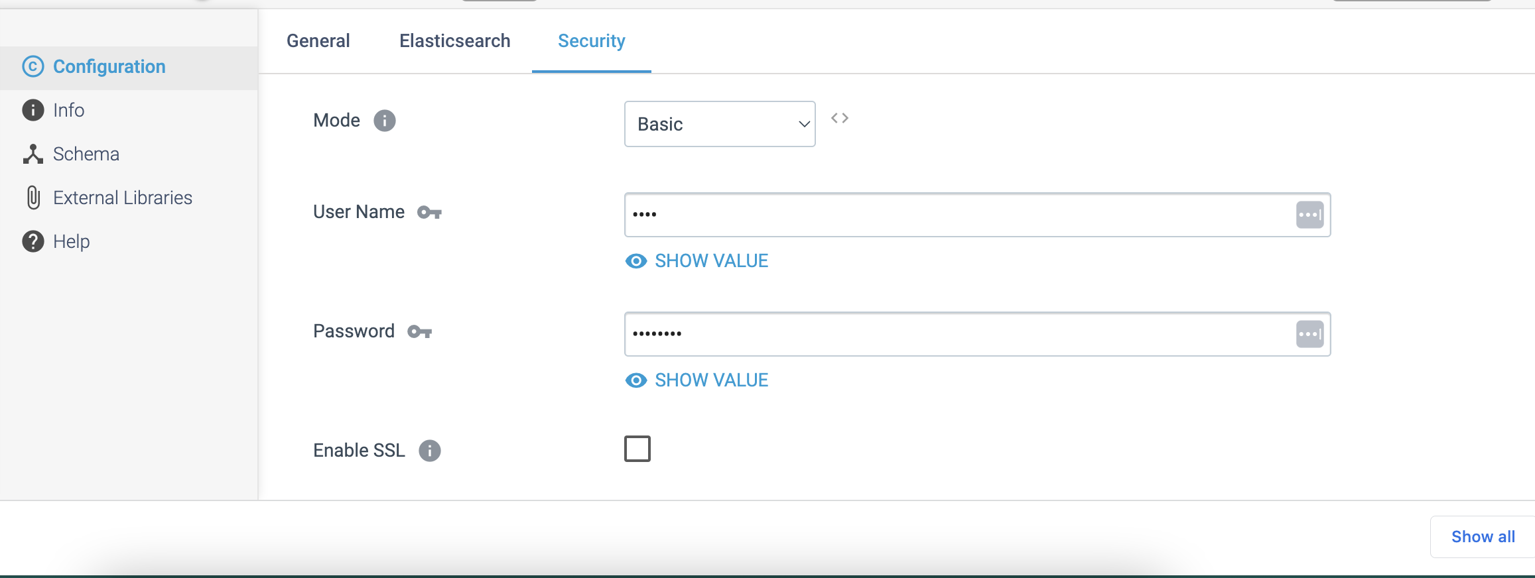

**DESTINATION NAME:** JMS Producer

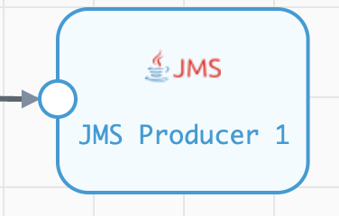

**Engine Type**: Data Collector

**Pipeline Name**: D_JMS_Orgn_Dest_Pipeline_CredURL

**Description**: The **JMS Producer** destination writes data to a Java Messaging Service (JMS). Before we use JMS Producer, install the drivers required for your JMS implementation.

We need to configure the **JMS Producer** destination in a following way.

Step 1: Click on the **JMS Producer** destination to configure how the destination connects to the JMS server and the JMS destination name.

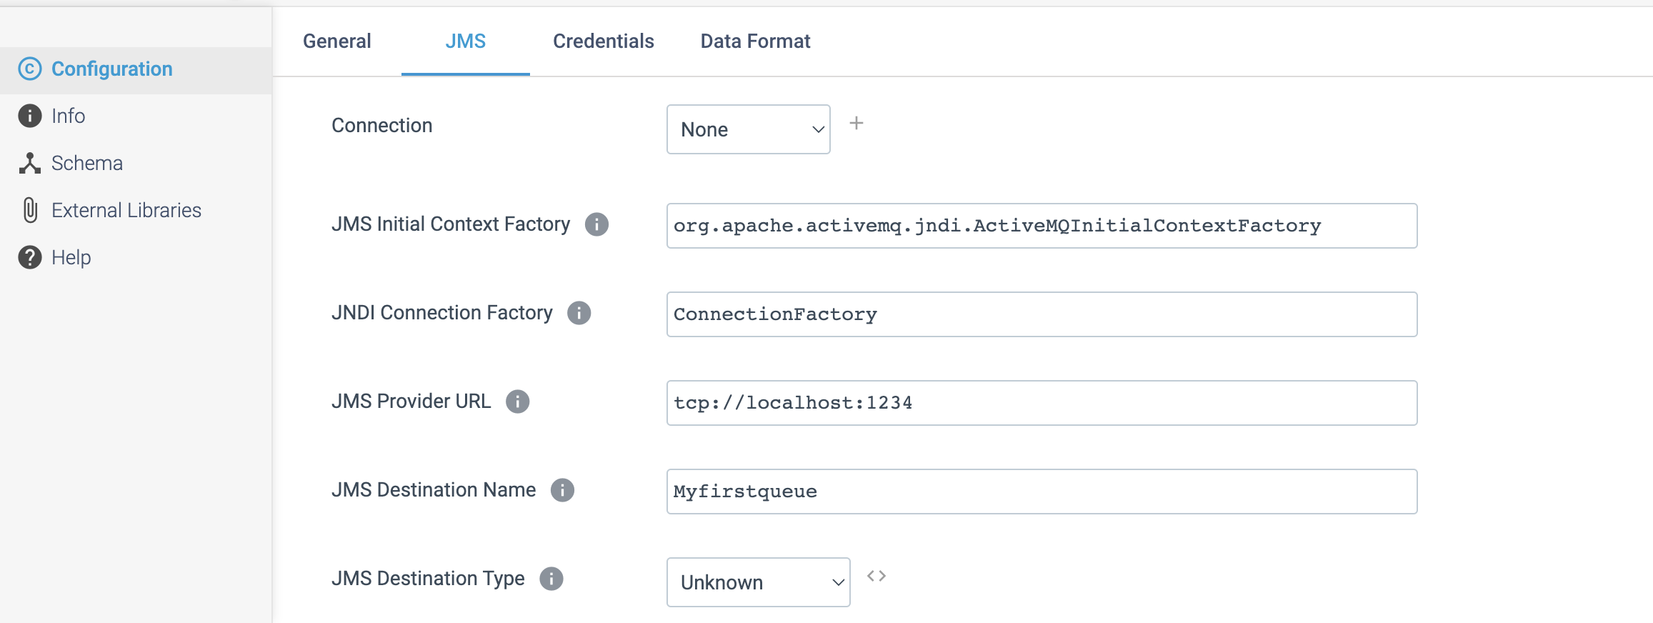

Step 2: Click on the **Credentials** tab to define the credentials.

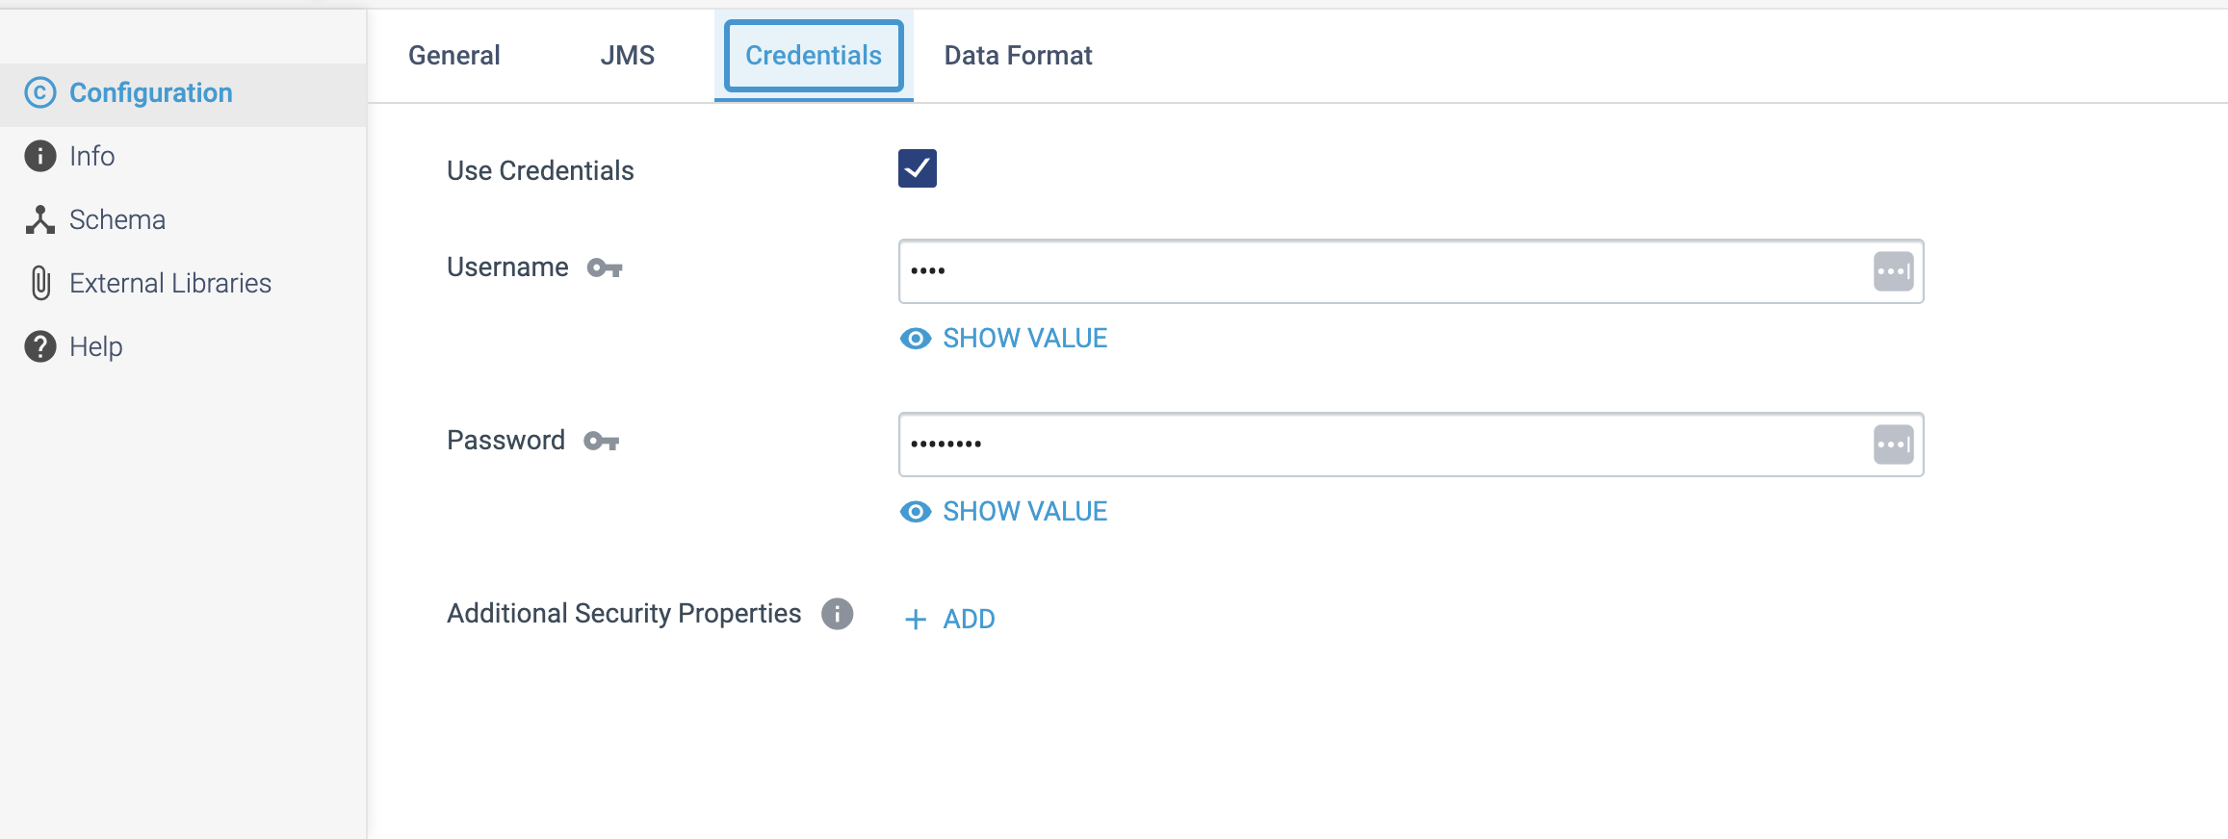

**DESTINATION NAME:** Kafka Producer

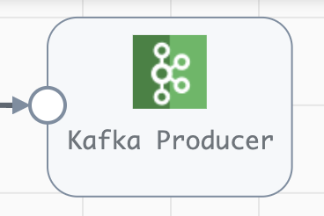

**Engine Type**: Data Collector

**Pipeline Name**: D_Kafka_Cons_Dest_Prod_Pipeline_URI

**Description**: The **Kafka Producer** destination writes data to a Kafka cluster. The destination can also send responses to a microservice origin when used in a microservice pipeline.

We need to configure the **Kafka Producer** destination in a following way.

Step 1: Click on the **Kafka Producer** destination to define connection information, the partition strategy, and data format to use. We can also configure Kafka Producer to determine the topic to write to at runtime.

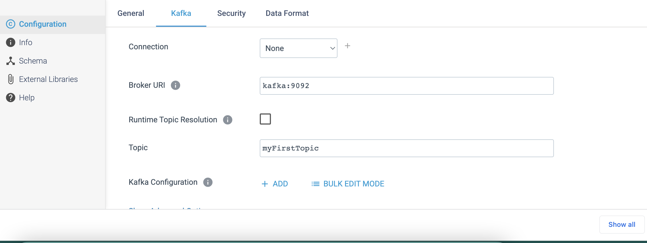

Step 2: Click on the **Security** tab to define the below any one of the credentials, if it requires.

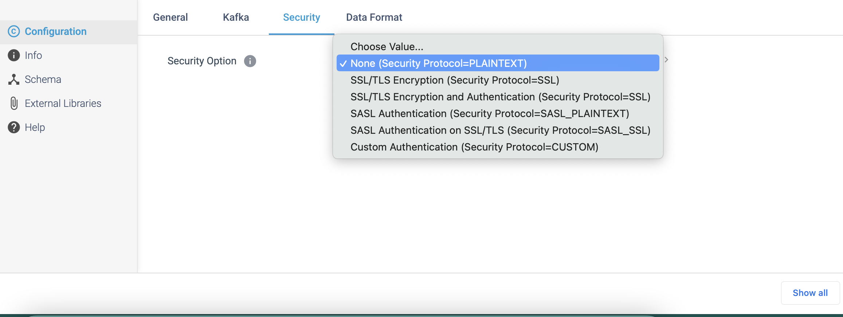

Step 3: Click on the Data Format tab to define the output format.

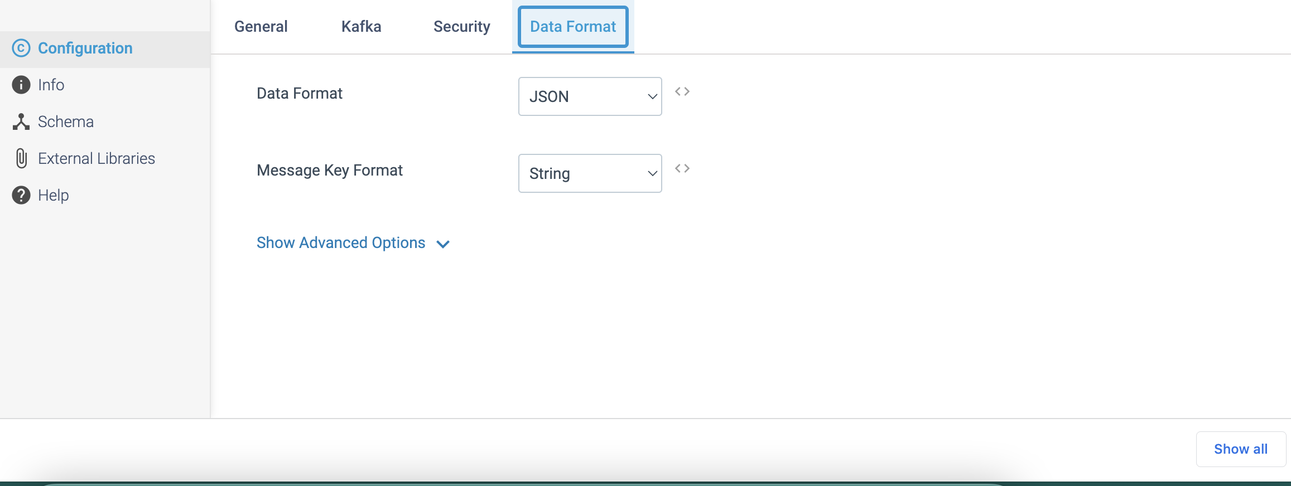

**DESTINATION NAME:** Kinesis Producer

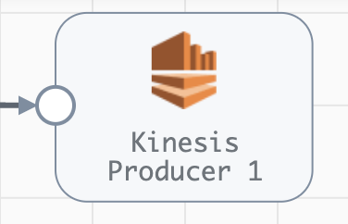

**Engine Type**: Data Collector

**Pipeline Name**: D_Kinesis_Orgn_Dest_Pipeline_Cred

**Description**: The **Kinesis Producer** destination writes data to Amazon Kinesis Streams. The destination can also send responses to a microservice origin when used in a microservice pipeline.

We need to configure the **Kinesis Producer** destination in a following way.

Step 1: Click on the **Kinesis Producer** destination to specify the Amazon Web Services connection information for our Kinesis cluster and the data format to use.

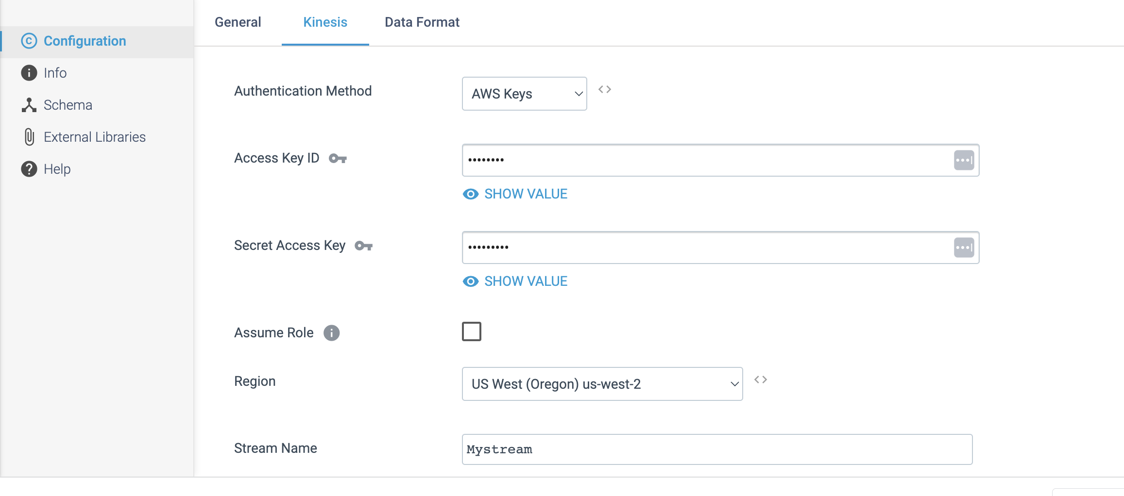

Step 2: Click on the **Data Format** tab to define the output format.

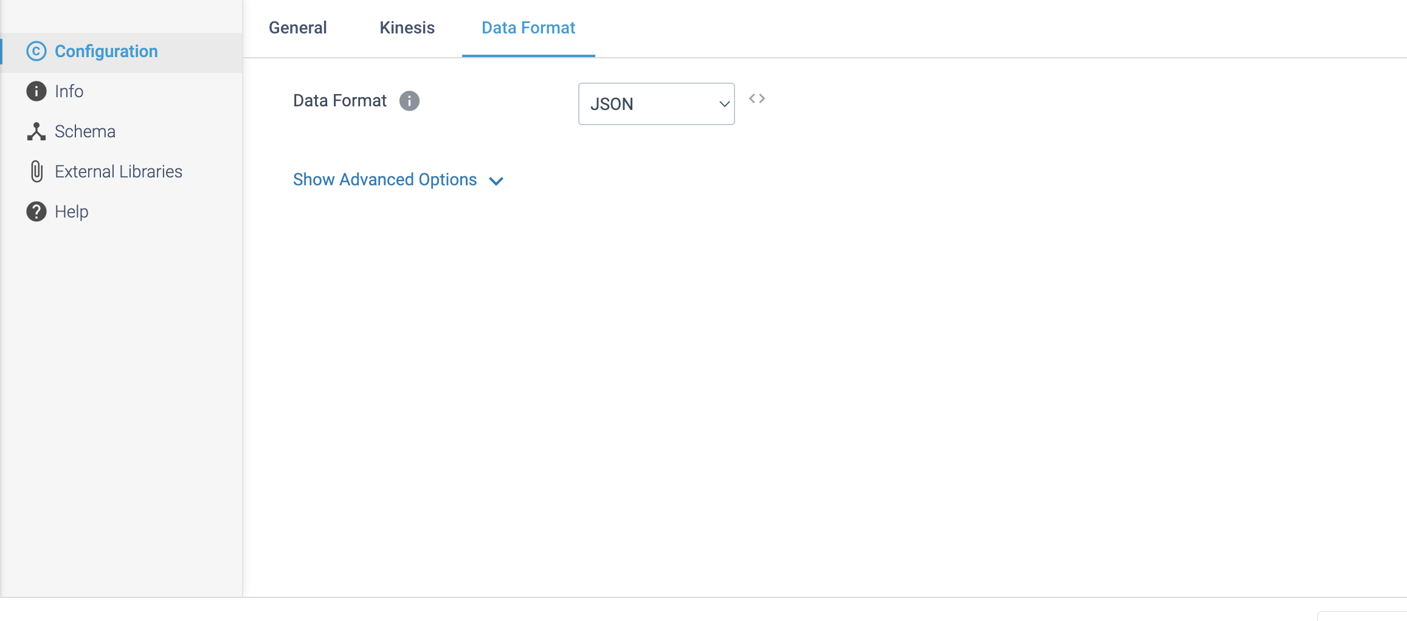

**DESTINATION NAME:** Kinesis Firehose

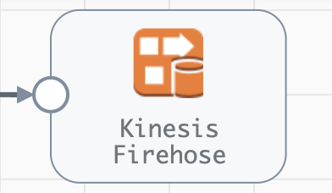

**Engine Type**: Data Collector

**Pipeline Name**: D_Kinesis_Orgn_Firehse_Dest_Pipeline_Cred

**Description**: The **Kinesis Firehose** destination writes data to an Amazon Kinesis Firehose delivery stream. Firehose automatically delivers the data to the **Amazon S3** bucket or **Amazon Redshift** table that you specify in the delivery stream.

We need to configure the **Kinesis Firehose** destination in a following way.

Step 1: Click on the **Kinesis Firehose** destination to specify an existing delivery stream to write to, AWS credentials and region, and the data format to use.

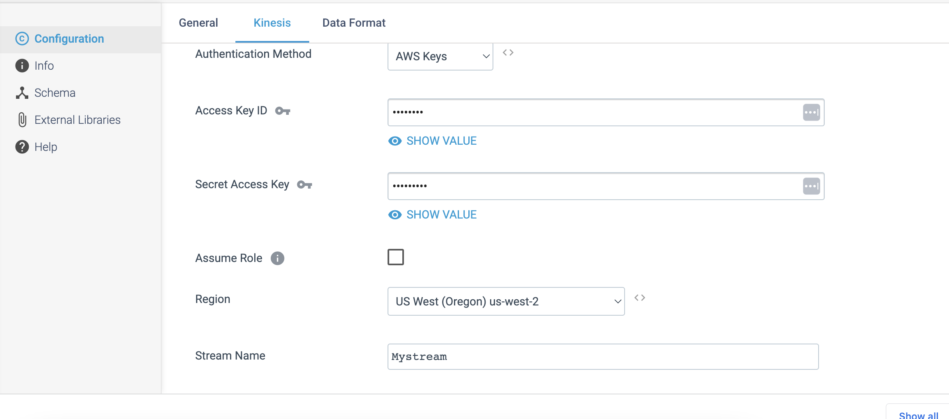

Step 2: Click on the **Data Format** tab to define the output format.

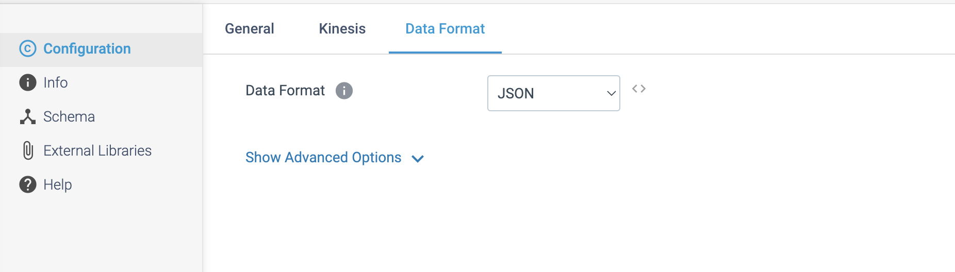

**DESTINATION NAME:** Snowflake File Uploader

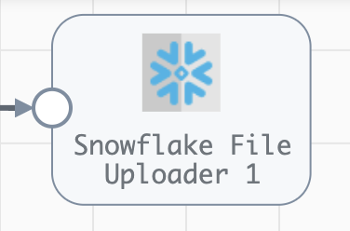

**Engine Type**: Data Collector

**Pipeline Name**: D_Oracle_snwflke_fileloadr_Pipeline_CredStr

**Description**: The **Snowflake File Uploader** destination writes whole files to an internal Snowflake stage. Use this destination with a whole file origin and the Snowflake executor.

We need to configure the **Snowflake File Uploader** destination in a following way.

Step 1: Click on the **Snowflake File Uploader** destination to specify Snowflake connection information, such as the Snowflake region and user account. We can optionally specify an organization name to use. We can also use a connection to configure the destination.

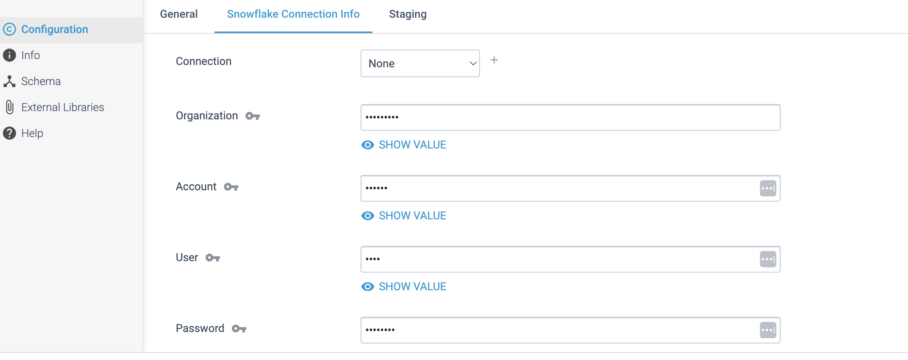

Step 2: Click on the **Staging** tab to define staging information, such as the database, schema, and name of the internal Snowflake stage to write to, as well as the number of threads to use. We can configure the destination to create the internal Snowflake stage, then specify the file format for the stage and related properties.

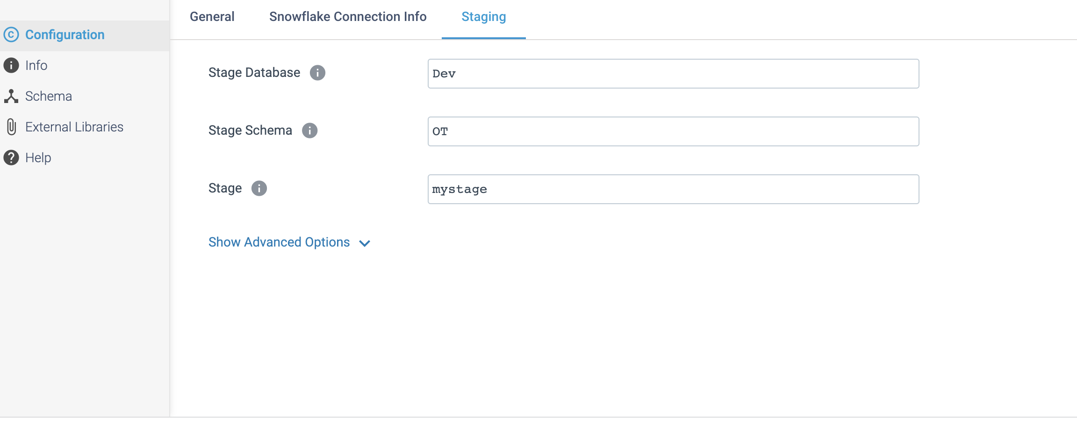

**DESTINATION NAME:** Snowflake

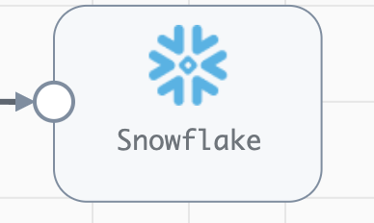

**Engine Type**: Data Collector

**Pipeline Name**: D_Oracle_snowflake_Pipeline_CredStr

**Description**: The **Snowflake** destination writes data to one or more tables in a Snowflake database. We can use the **Snowflake** destination to write to any accessible Snowflake database, including those hosted on Amazon S3, Google Cloud Storage, Microsoft Azure, and private Snowflake installations.

We need to configure the **Snowflake** destination in a following way.

Step1: Click on the **Snowflake** destination to specify the Snowflake region, account and connection information and the number of connections to use to write to Snowflake. We can specify an organization name to use and define additional Snowflake connection properties, as needed. We can also use a connection to configure the destination.

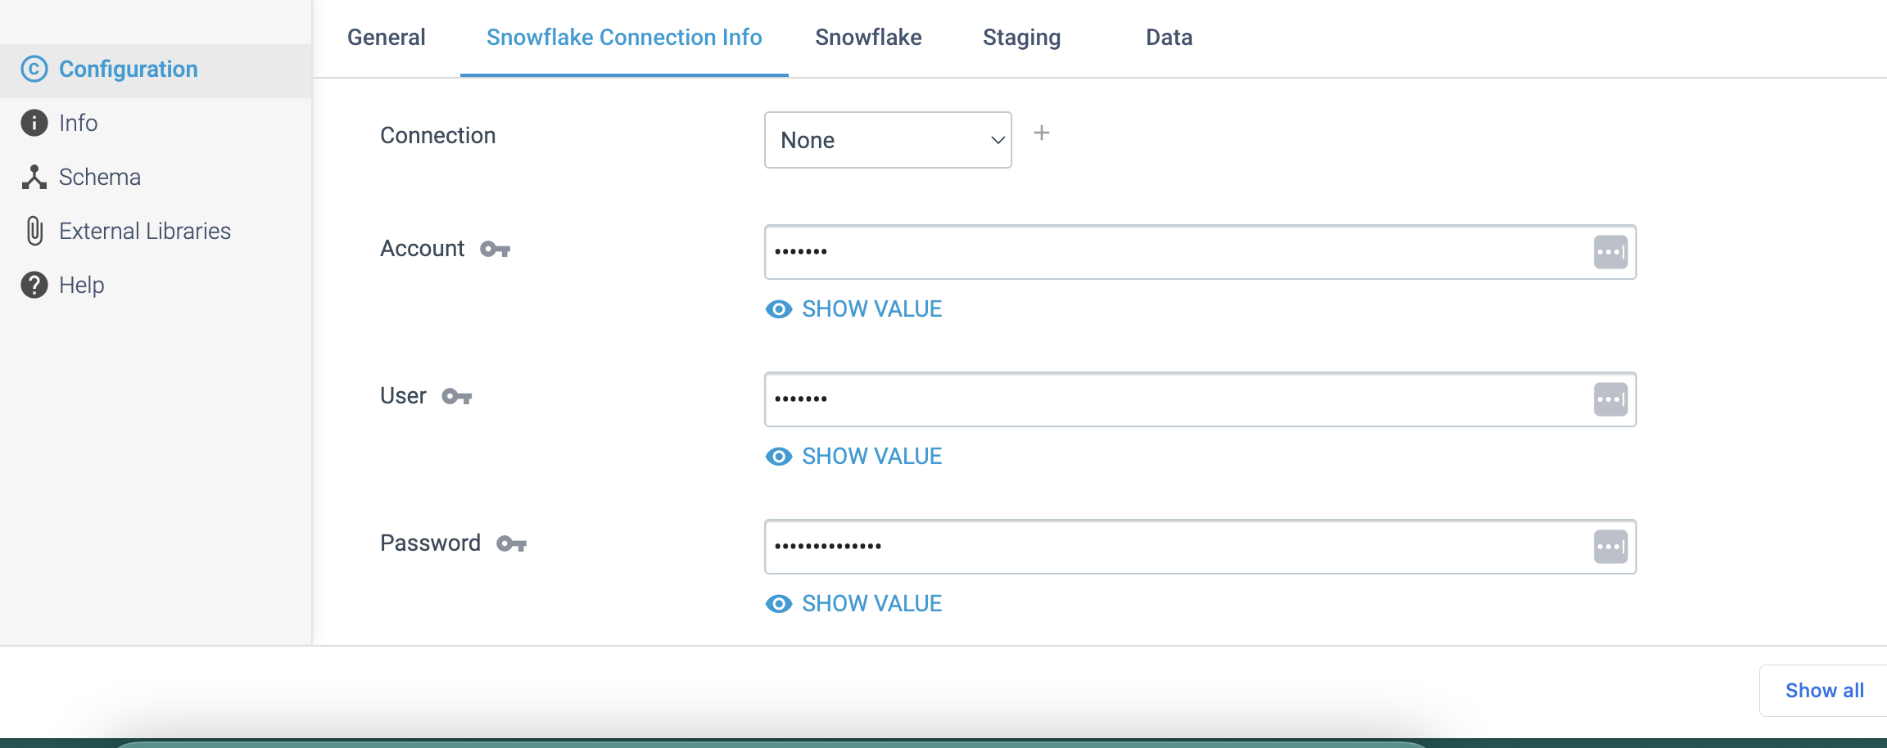

Step 2: Click on the **Snowflake** tab to configure the Snowflake warehouse, database, schema, and the tables to use. You specify load method, error handling, and staging details, and optionally define advanced properties for Amazon S3 or Microsoft Azure.

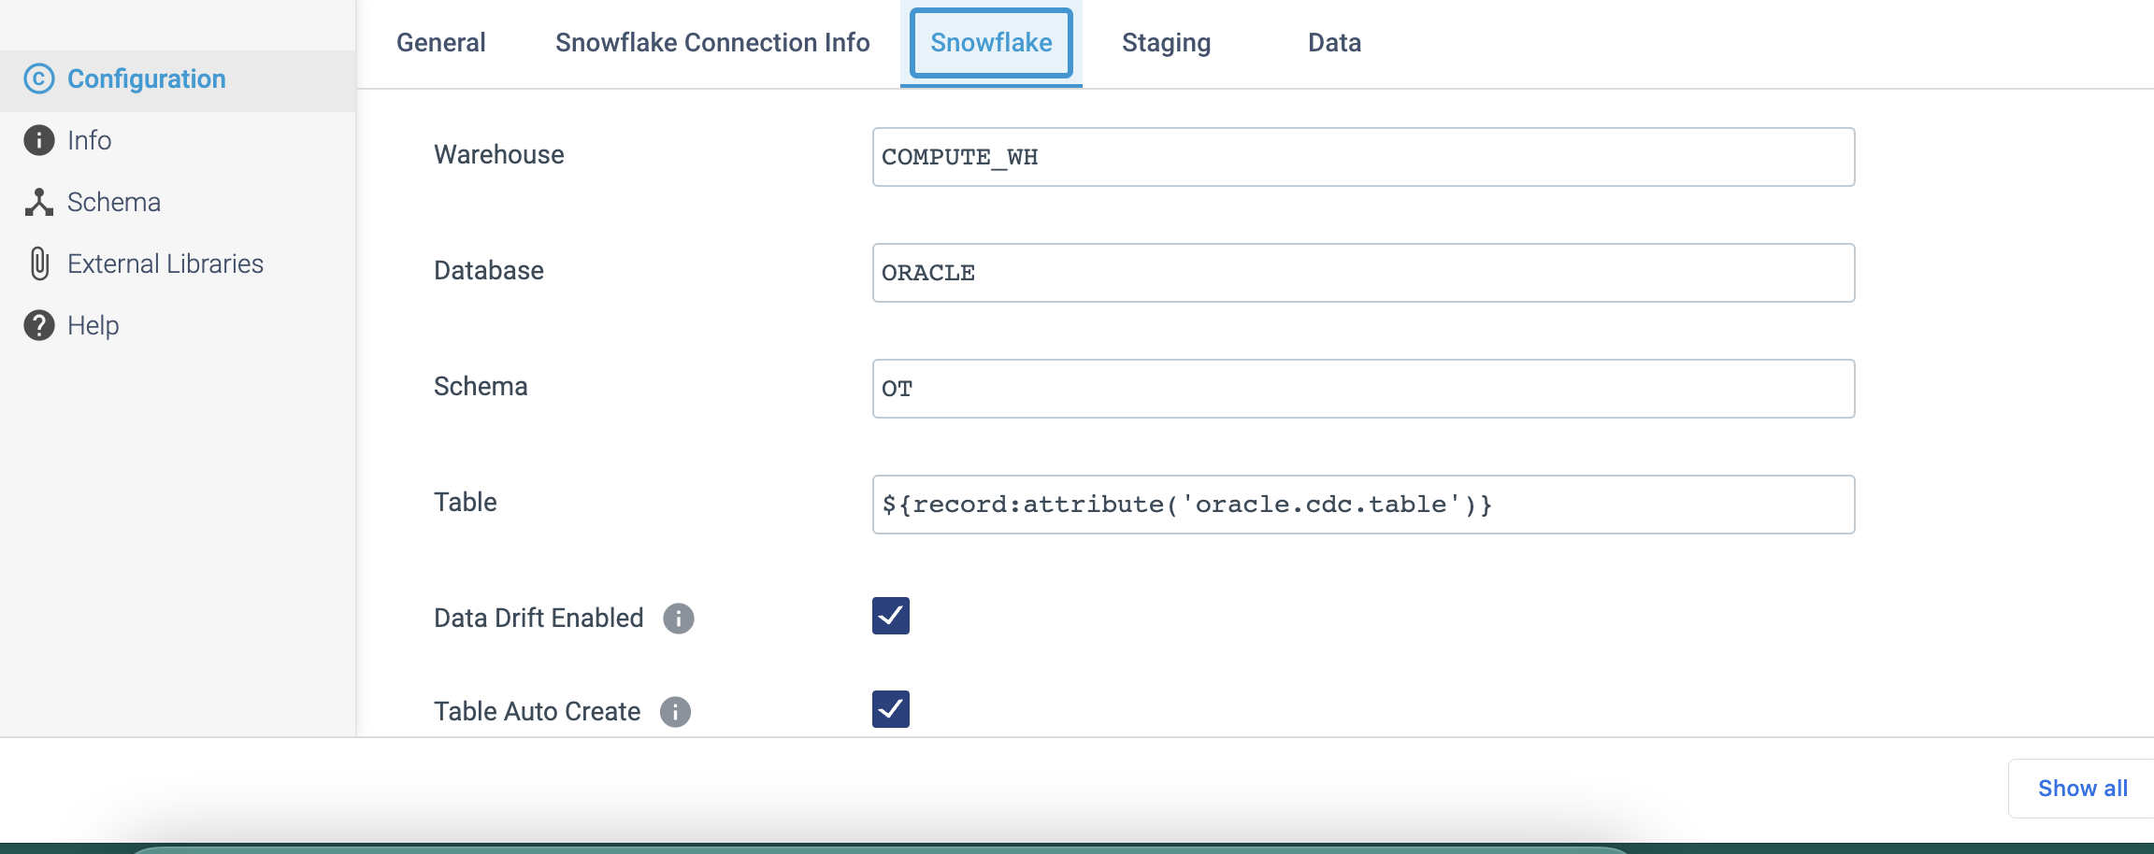

Step 3: Click on the Staging tab to configure the following properties.

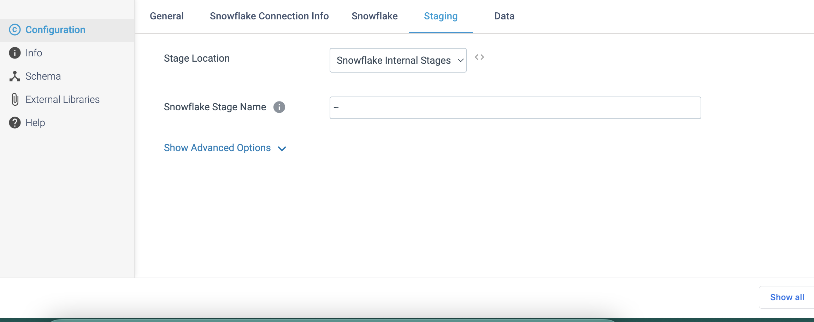

Step 4: Click on the **Data** tab to define the following properties.

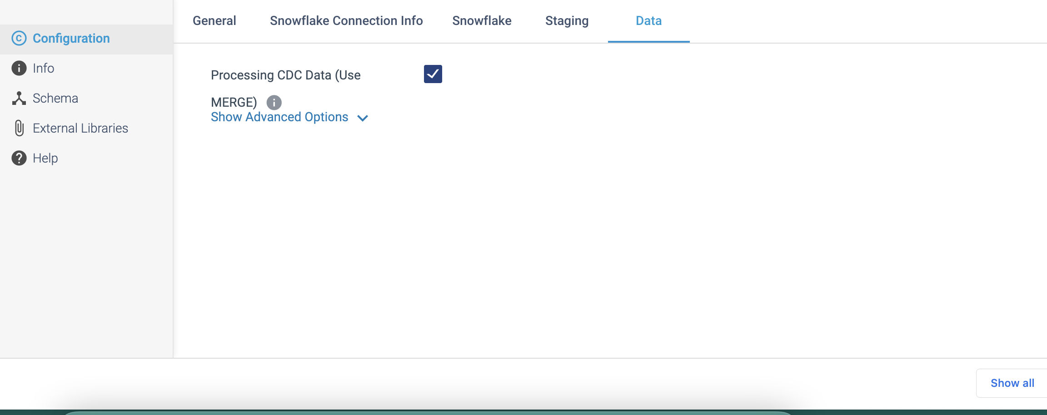

**DESTINATION NAME:** Salesforce Bulk API 2.0 1

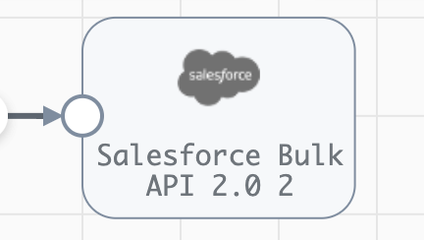

**Engine Type**: Data Collector

**Pipeline Name**: D_Salesfrcebulk_orgn_Dest_Pipeline_Cred

**Description**: The **Salesforce Bulk API 2.0** destination writes data to Salesforce objects using **Salesforce Bulk API 2.0**. To write to Salesforce with the SOAP or Bulk API, use the Salesforce destination.

We need to configure the **Salesforce Bulk API 2.0** destination in a following way.

Step 1: Click on the **Salesforce Bulk API 2.0** destination to define connection information, including the API version and authentication type to use. You can also use a connection to configure the destination.

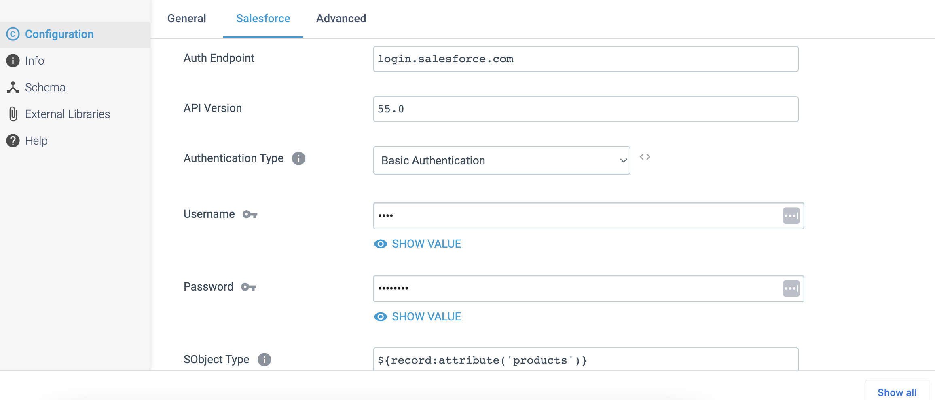

Step 2: Click on the **Advanced** tab to optionally use an HTTP proxy to connect to Salesforce. When enabled in Salesforce, We can configure the destination to use mutual authentication to connect.

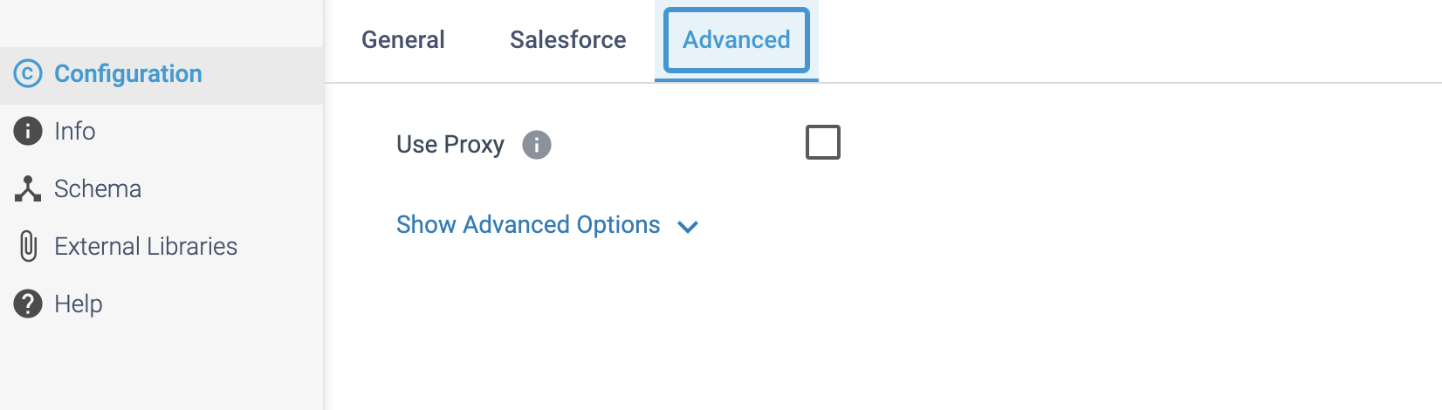

**DESTINATION NAME:** Salesforce

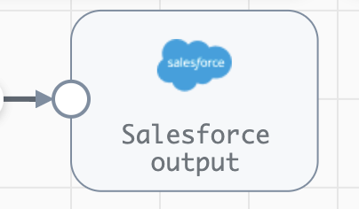

**Engine Type**: Data Collector

**Pipeline Name**: D_Salesfrce_orgn_Dest_Pipeline_Cred

**Description**: The **Salesforce** destination writes data to Salesforce objects with the SOAP or Bulk API.

We need to configure the **Salesforce** destination in a following way.

Step 1: Click on the **Salesforce** destination to define connection information, including the authentication type, and the API type and version to use to connect to Salesforce. You can also use a connection to configure the destination.

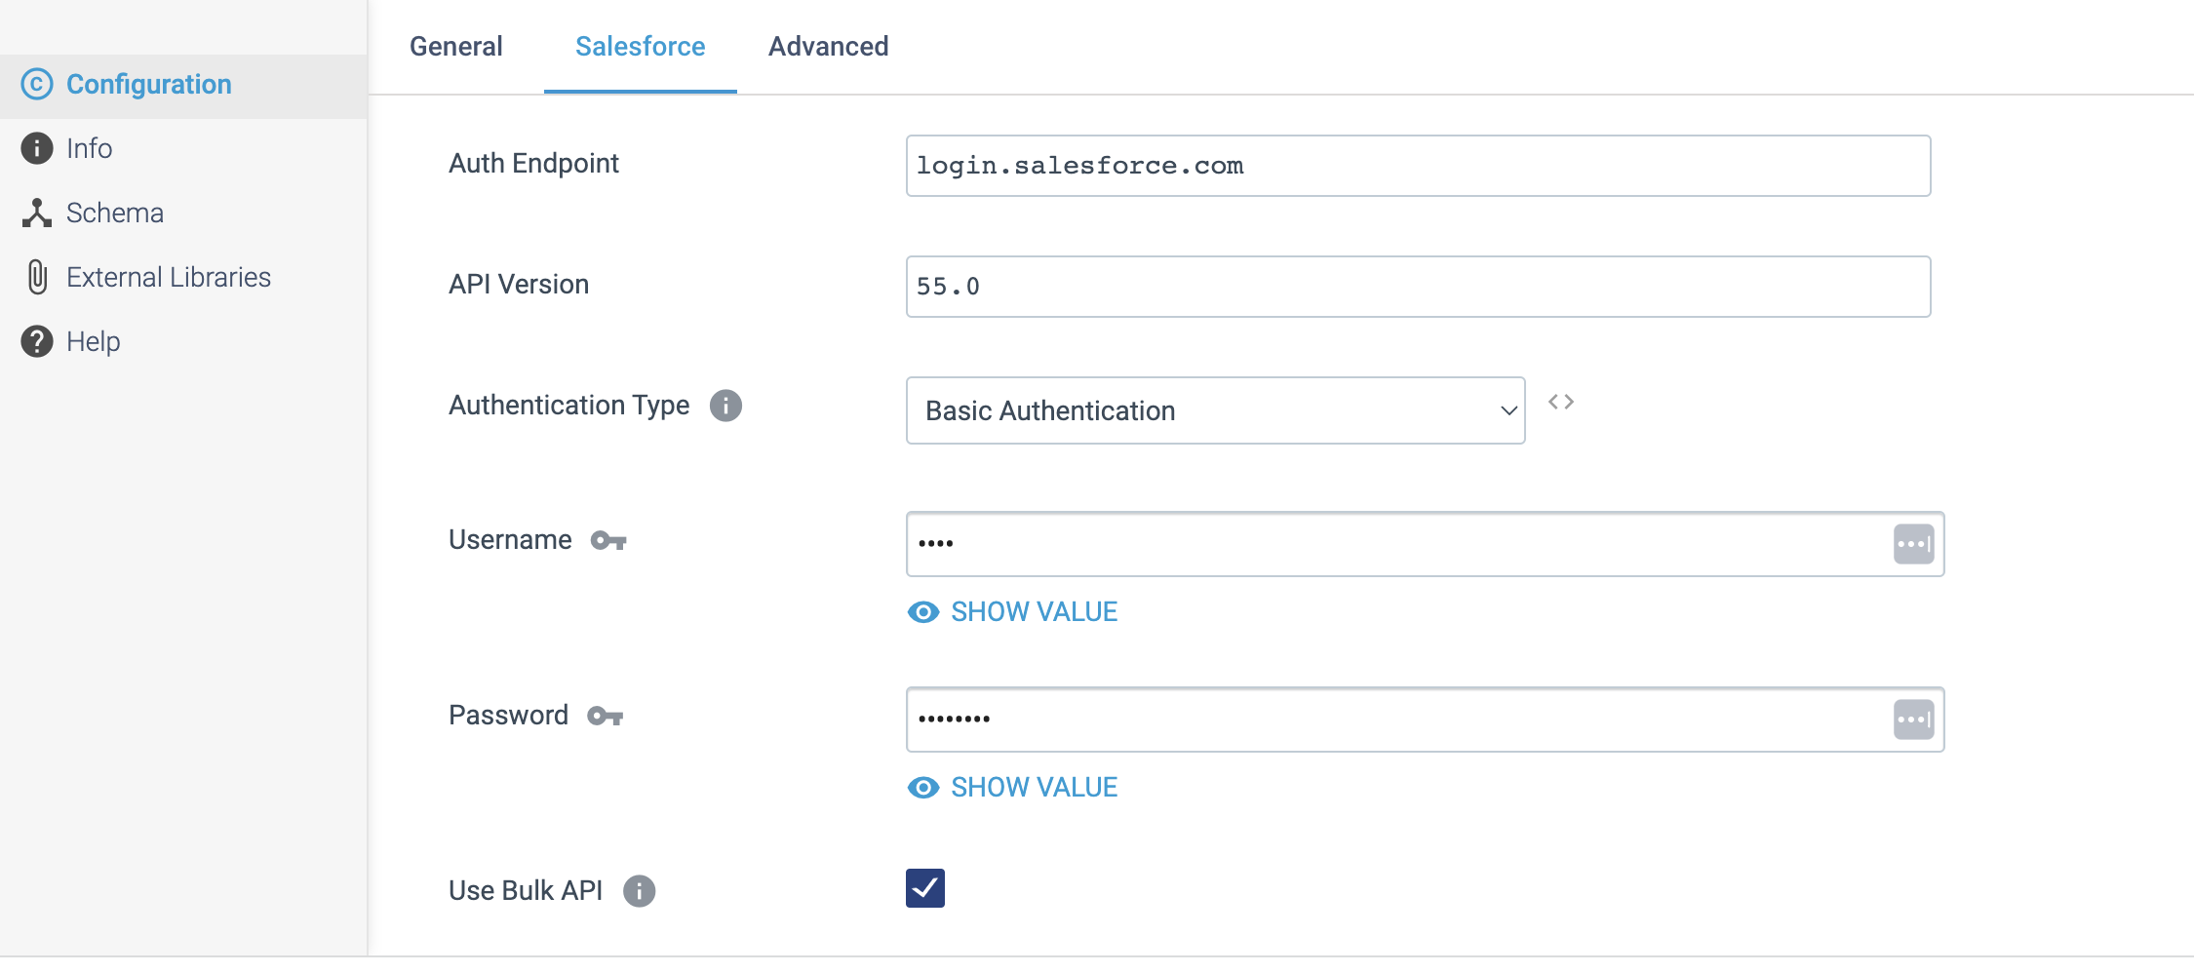

Step 2: Click on the **Advanced** tab to optionally use an HTTP proxy to connect to Salesforce. When enabled in Salesforce, you can configure the destination to use mutual authentication to connect.

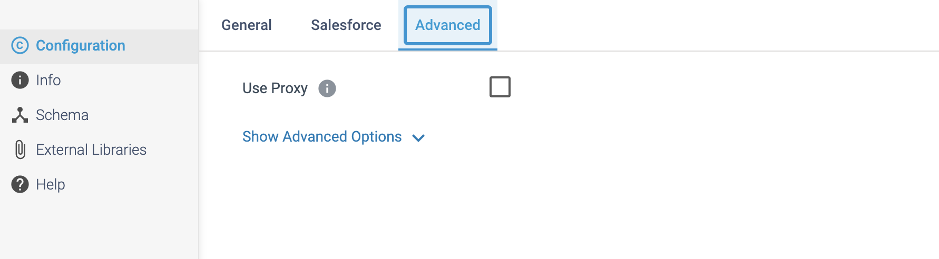

**DESTINATION NAME:** SFTP/FTP/FTPS Client

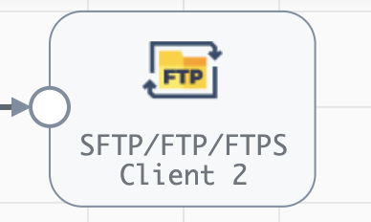

**Engine Type**: Data Collector

**Pipeline Name**: D_SFTP_orgn_Dest_Pipeline_Cred_URL

**Description**: The **SFTP/FTP/FTPS Client** destination writes whole files to a URL using the Secure File Transfer Protocol (SFTP), File Transfer Protocol (FTP), or FTP Secure (FTPS) protocol.

We need to configure the **SFTP/FTP/FTPS Client** destination in a following way.

Step 1: Click on the **SFTP/FTP/FTPS Client** destination to specify the protocol to use and the URL where the destination writes files on the remote server. You can also use a connection to configure the destination.

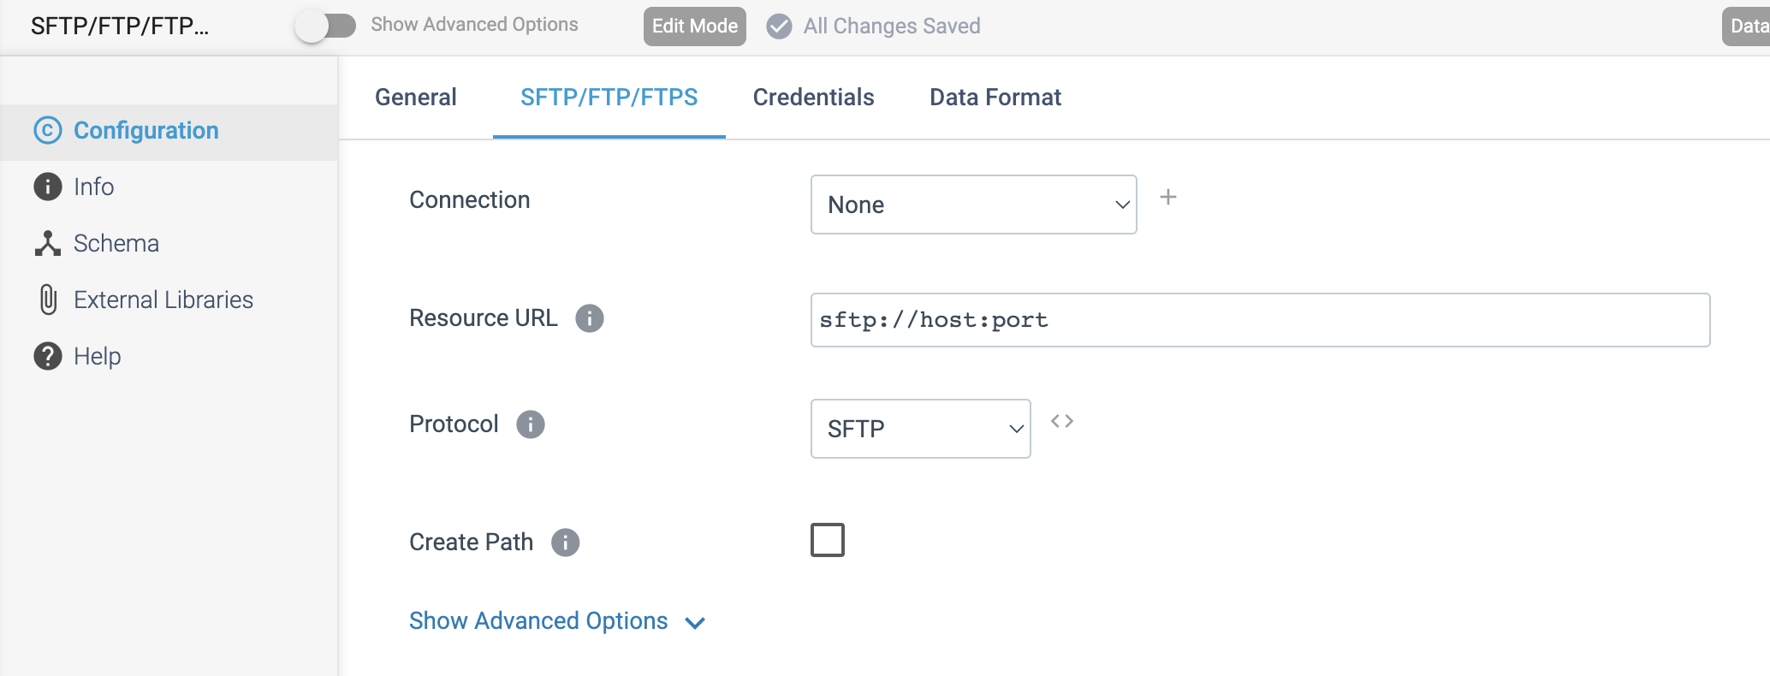

Step 2: Click on the **Credentials** tab to define the required credentials.

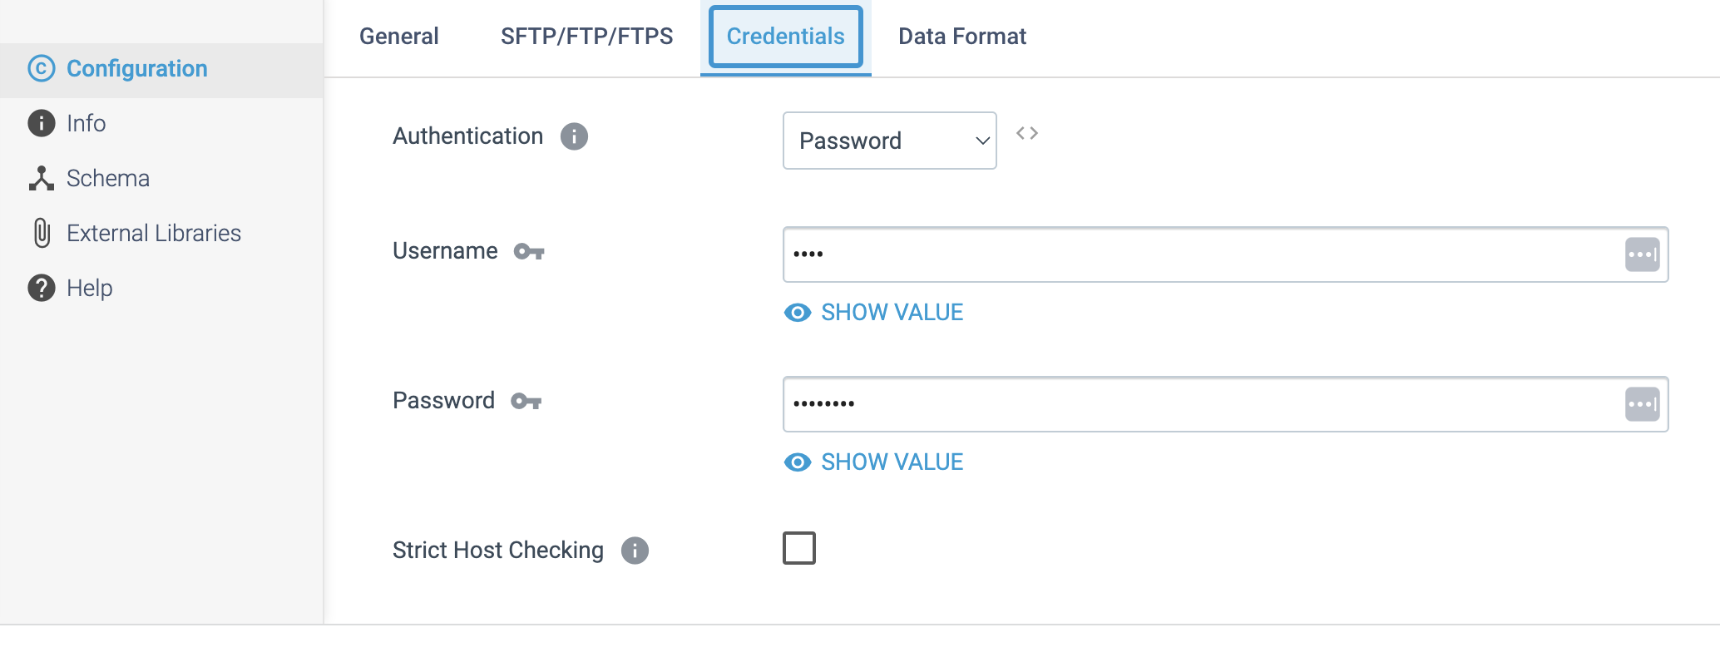

Step 3: Click on the **Data Format** tab to define the output format.

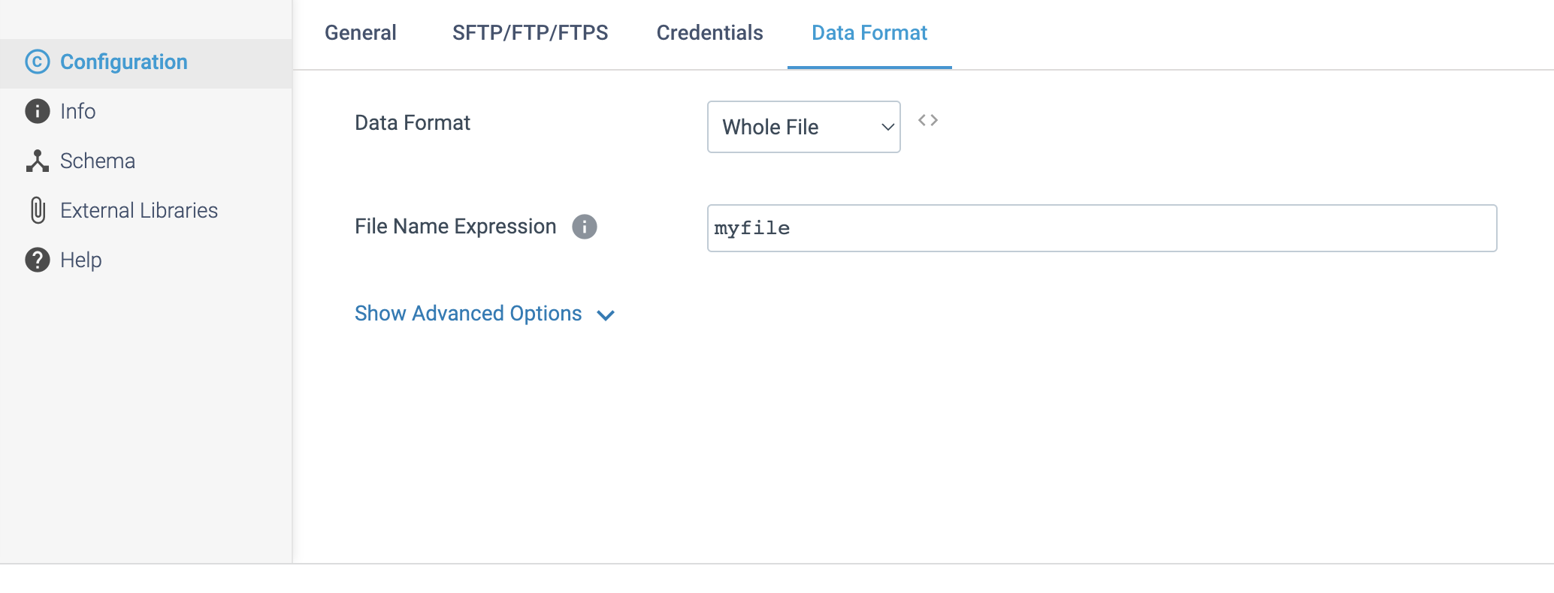

**DESTINATION NAME:** SingleStore

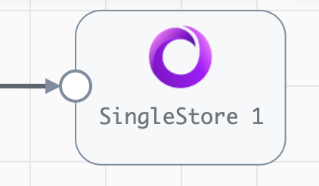

**Engine Type**: Data Collector

**Pipeline Name**: D_Sqlsrvr_Cons_orgn_Snglestre_Dest_Pipeline_CredStr

**Description**: The **SingleStore** destination uses a JDBC connection to write data to a SingleStore database table.

We need to configure the **SingleStore** destination in a following way.

Step 1: Click on the **SingleStore** destination to specify connection information, a table name, and other properties that the driver requires. You can also use a connection to configure the destination.

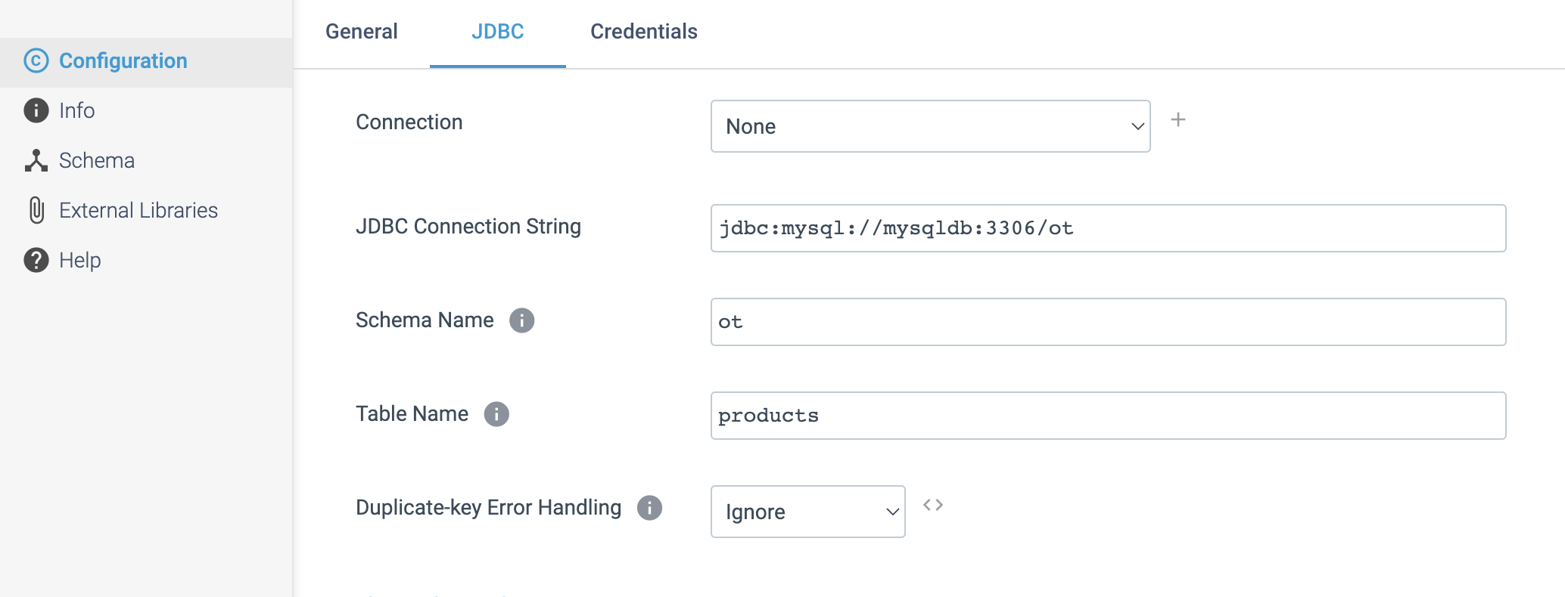

Step 2: Click on the Credentials tab to define the credentials.

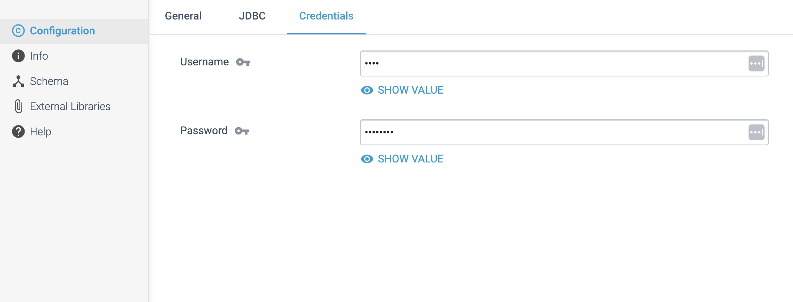

**DESTINATION NAME:** RabbitMQ Producer

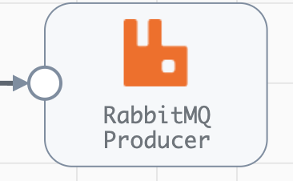

**Engine Type**: Data Collector

**Pipeline Name**: D_RabbitMQ_Orgn_Dest_Pipeline_Cred

**Description**: **RabbitMQ Producer** destinationwrites AMQP messages to a single RabbitMQ queue.

We need to configure the **RabbitMQ Producer** destination in a following way.

Step 1: Click on the **RabbitMQ Producer** destination to specify the information needed to connect to RabbitMQ client. We can also use a connection to configure the destination.

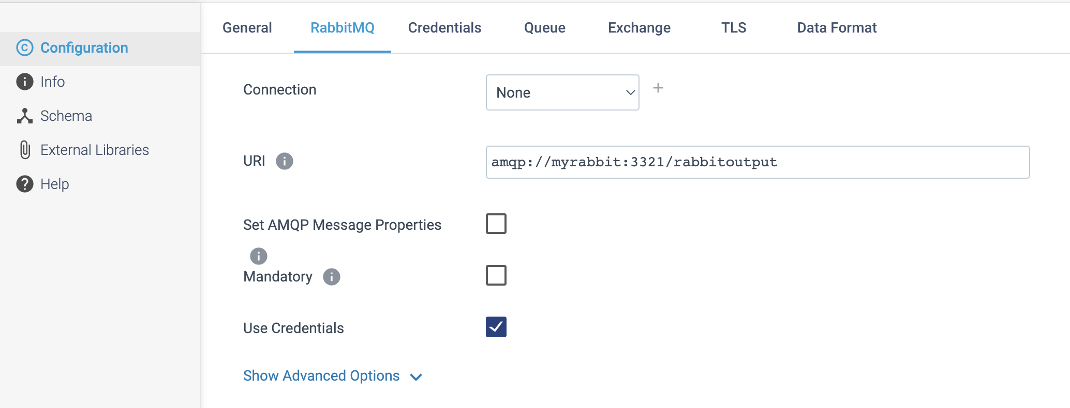

Step 2: Click on the **Credentials** tab to define the credentials.

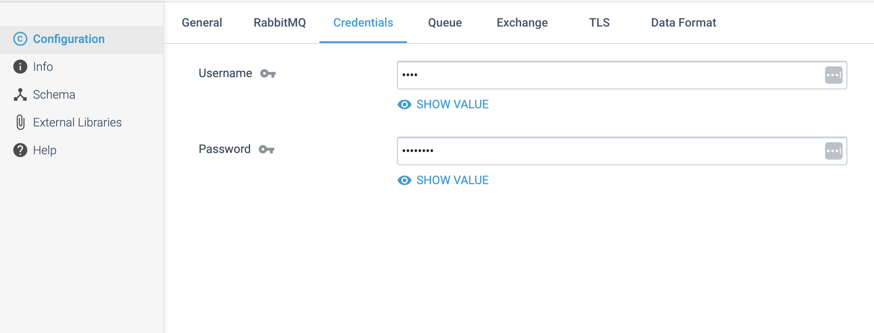

Step 3: Click on **Queue** tab to define a queue and the bindings to use.

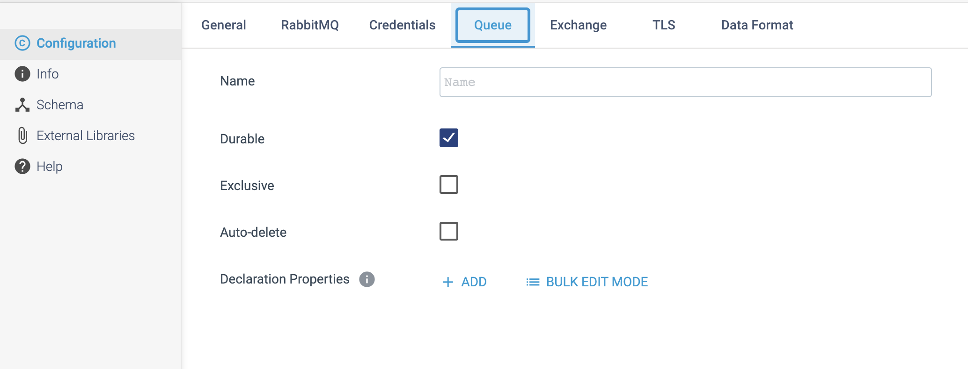

Step 4: Click on the **Exchange** tab to use multiple bindings to write messages to one or more exchanges.

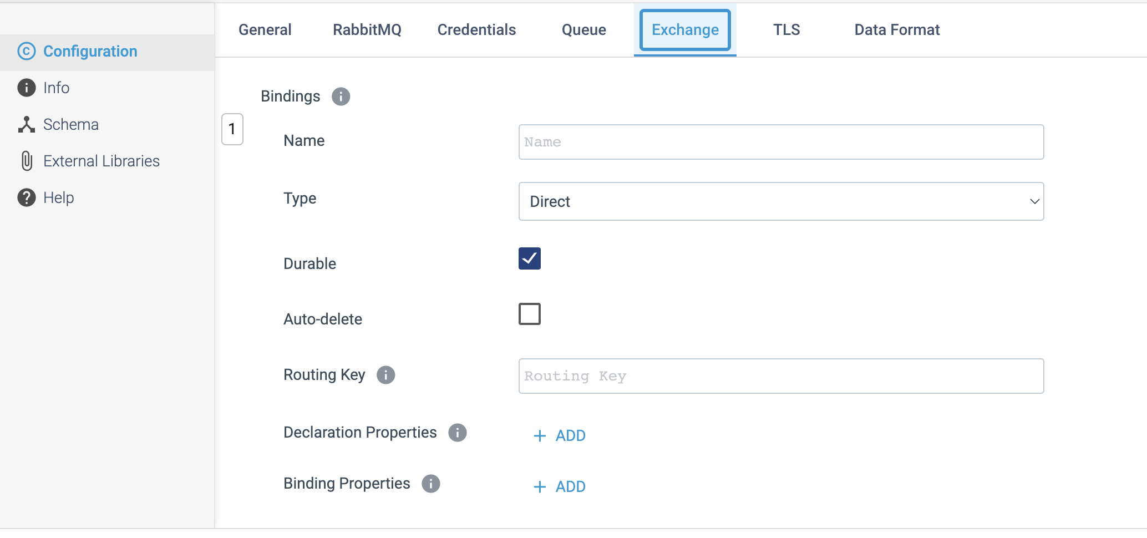

Step 5: Click on the **TLS** tab to configure SSL/TLS properties, including default transport protocols and cipher suites. You can optionally configure AMQP message properties.

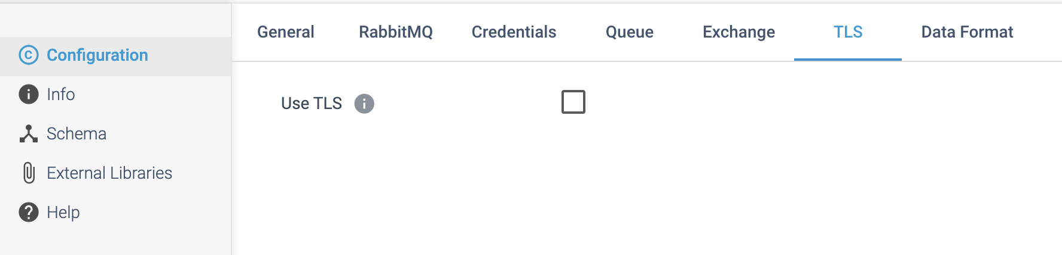

Step 6: Click on the **Data Format** tab to define the output format.

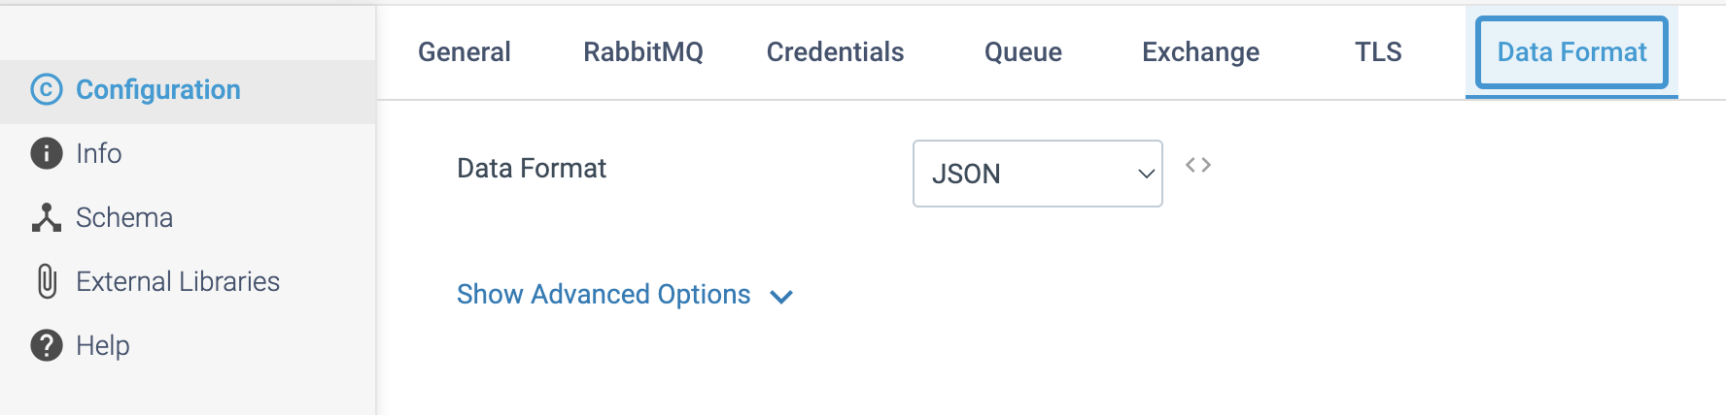

**DESTINATION NAME:** Redis

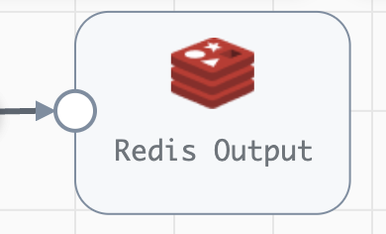

**Engine Type**: Data Collector

**Pipeline Name**: D_Redis_orgn_Dest_Pipeline_URI

**Description**: The **Redis** destination writes data to Redis.

We need to configure the **Redis** destination in a following way.

Step 1: Click on the **Redis** destination to specify the mode that the destination uses to process records. You configure properties to connect to Redis, including the URI of the Redis server. You can also use a connection to configure the destination.

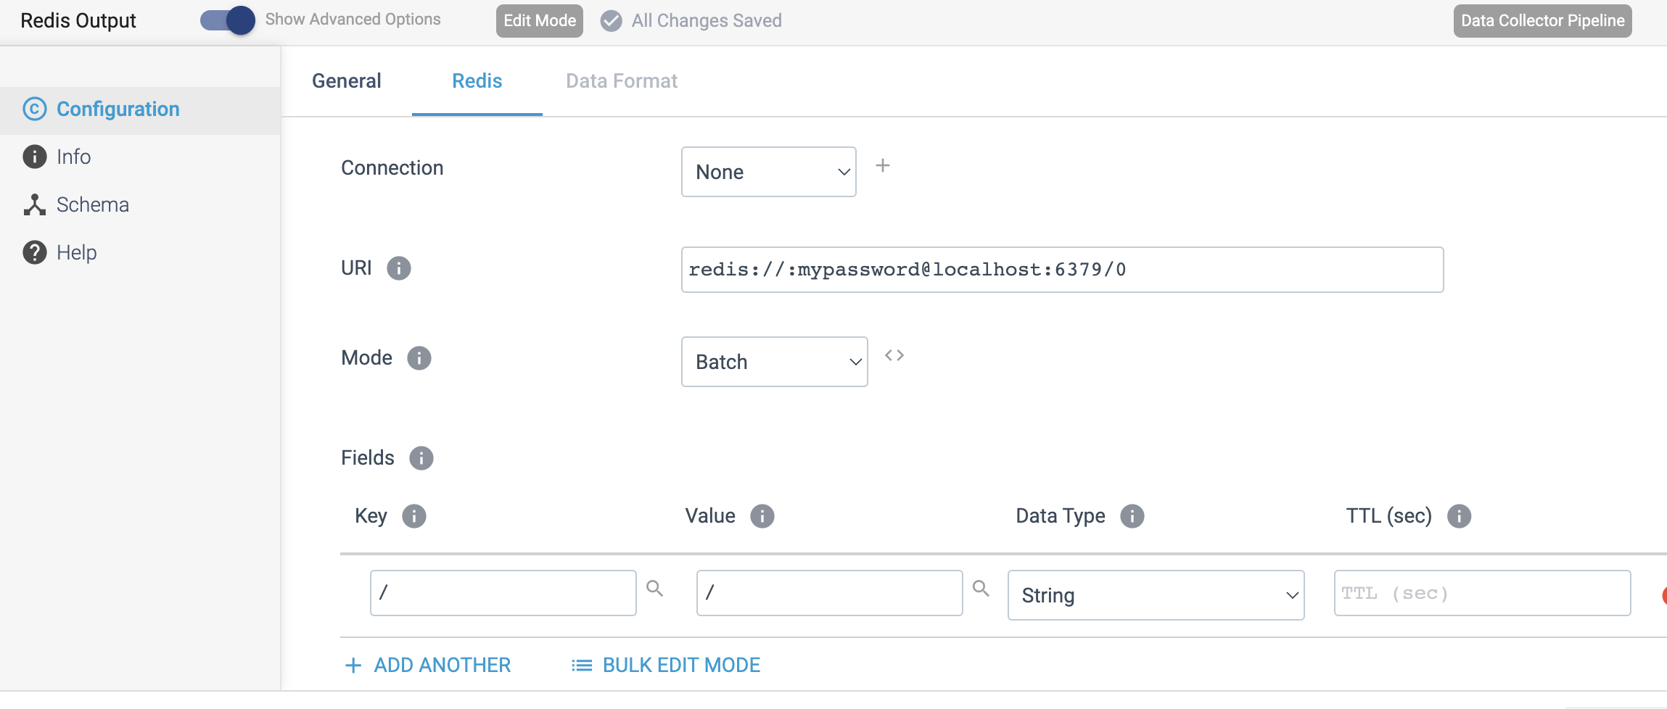

The Redis destination writes data to Redis using one of the following modes:

**Batch mode**

In **batch mode,** the destination writes data to Redis key-value pairs. You configure each key-value pair by selecting the incoming fields to use as the key and the value. You also select the data type of the Redis value. You can configure the destination to write to multiple key-value pairs.

**Publish mode**

In **publish mode,** the destination publishes data as messages to a Redis channel. You specify the channel to use and the data format of the messages. The publish mode pushes each record as one message to the specified Redis channel.

Step 2: Click on the **Data Forma**t tab to define the output format by selecting the Mode as **Publish Mode** in previous **Redis** tab.

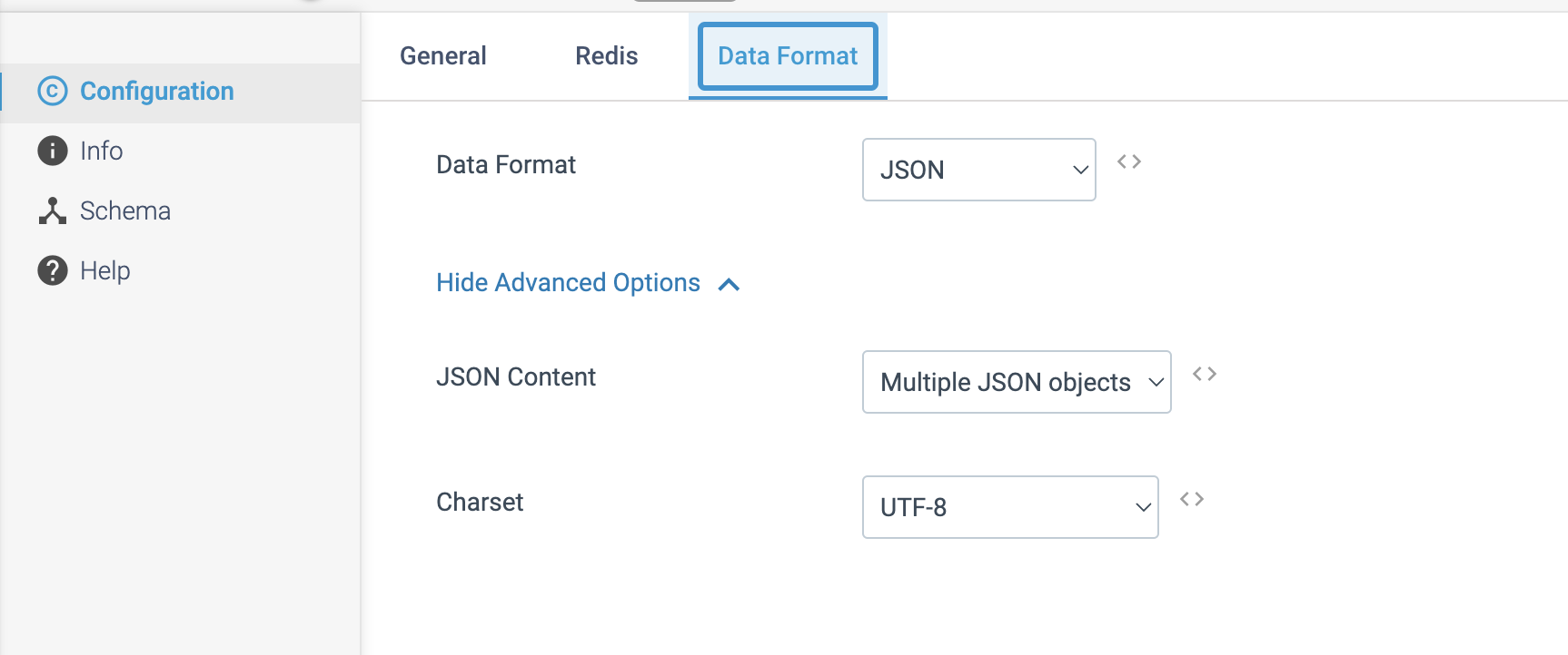

**DESTINATION NAME:** InfluxDB 2.x 1

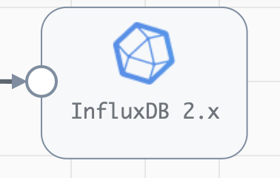

**Engine Type**: Data Collector

**Pipeline Name**: D_azureIoT_orgn_Influx2.x1_orgn_Dest_Pipeline_CredStr_URL

**Description**: The **InfluxDB 2.x d**estination writes data to an **InfluxDB 2.x** database. To write to an InfluxDB 0.9 - 1.x database, use the InfluxDB destination.

We need to configure the **InfluxDB 2.x** destination in following way.

Step 1: Click on the **InfluxDB 2.x** destination to define connection information including an API token, and the organization and bucket to use. You can have the destination create the bucket if it does not exist. You can also use a connection to configure the destination.

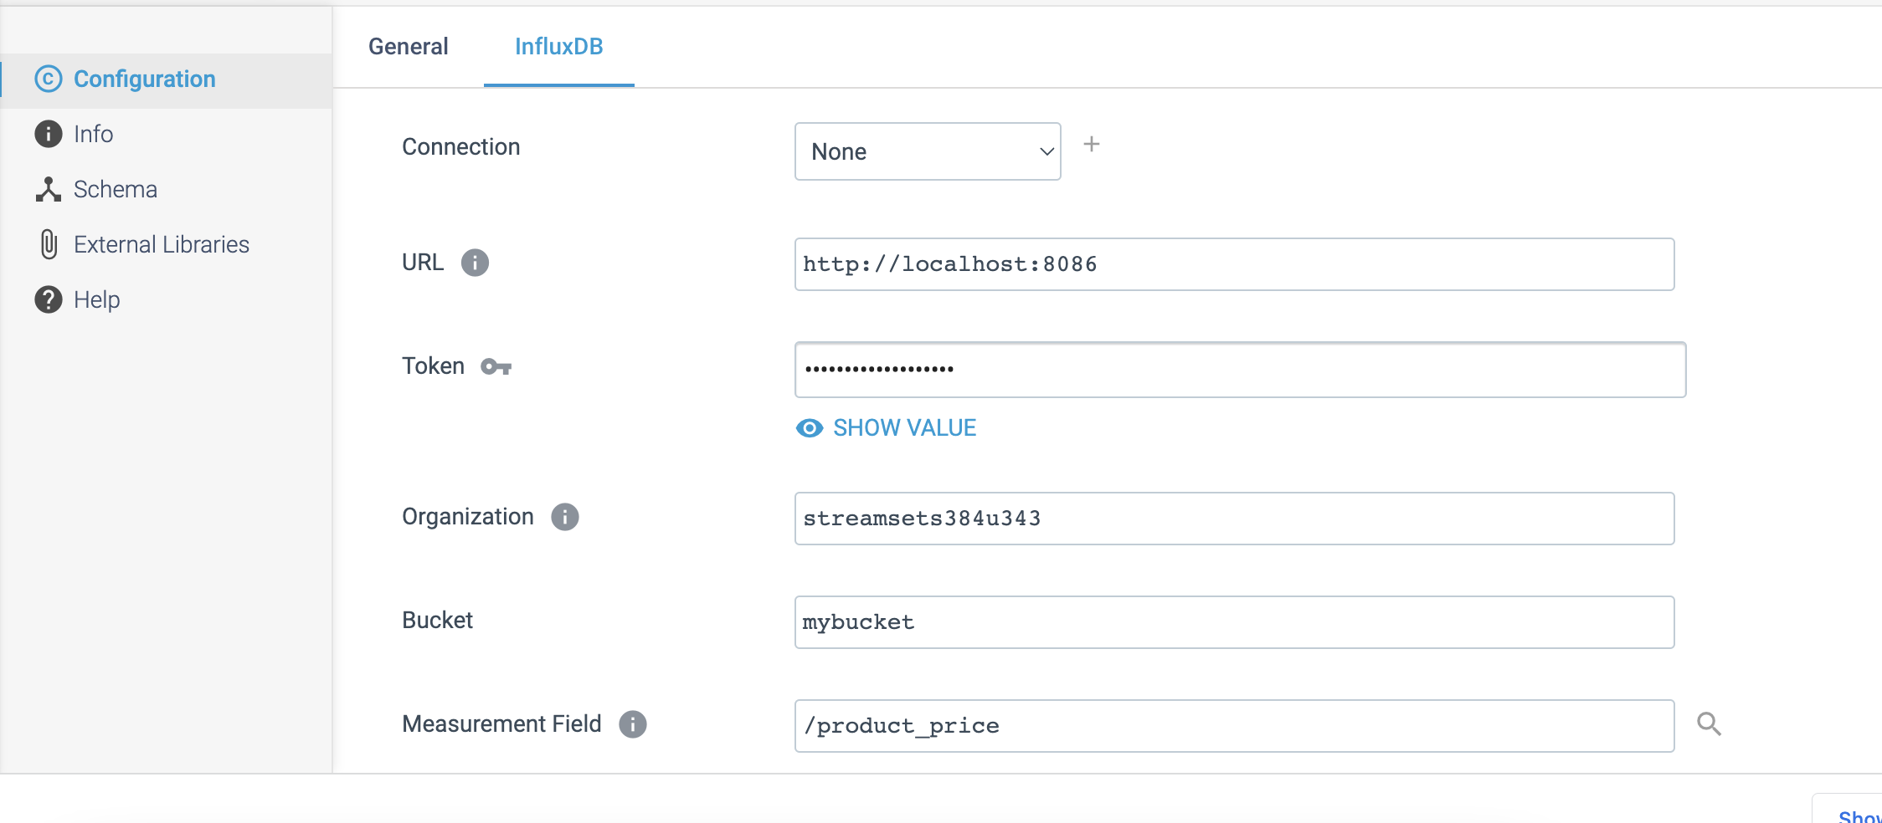

**DESTINATION NAME:** InfluxDB

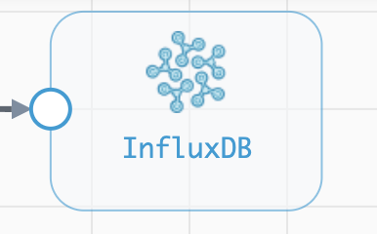

**Engine Type**: Data Collector

**Pipeline Name**: D_azureIoT_orgn_Influx_orgn_Dest_Pipeline_CredStr_URL

**Description**: The InfluxDB destination writes data to InfluxDB 0.9 - 1.x. To write to InfluxDB 2.x, use the InfluxDB 2.x destination.

We need to configure the **InfluxDB** destination in a following way.

Step 1: Click on the **InfluxDB** destination to define connection information, the retention policy, and the fields to use as tags on points. If InfluxDB is set up on a cluster, we can define the write consistency level. You can also use a connection to configure the destination.

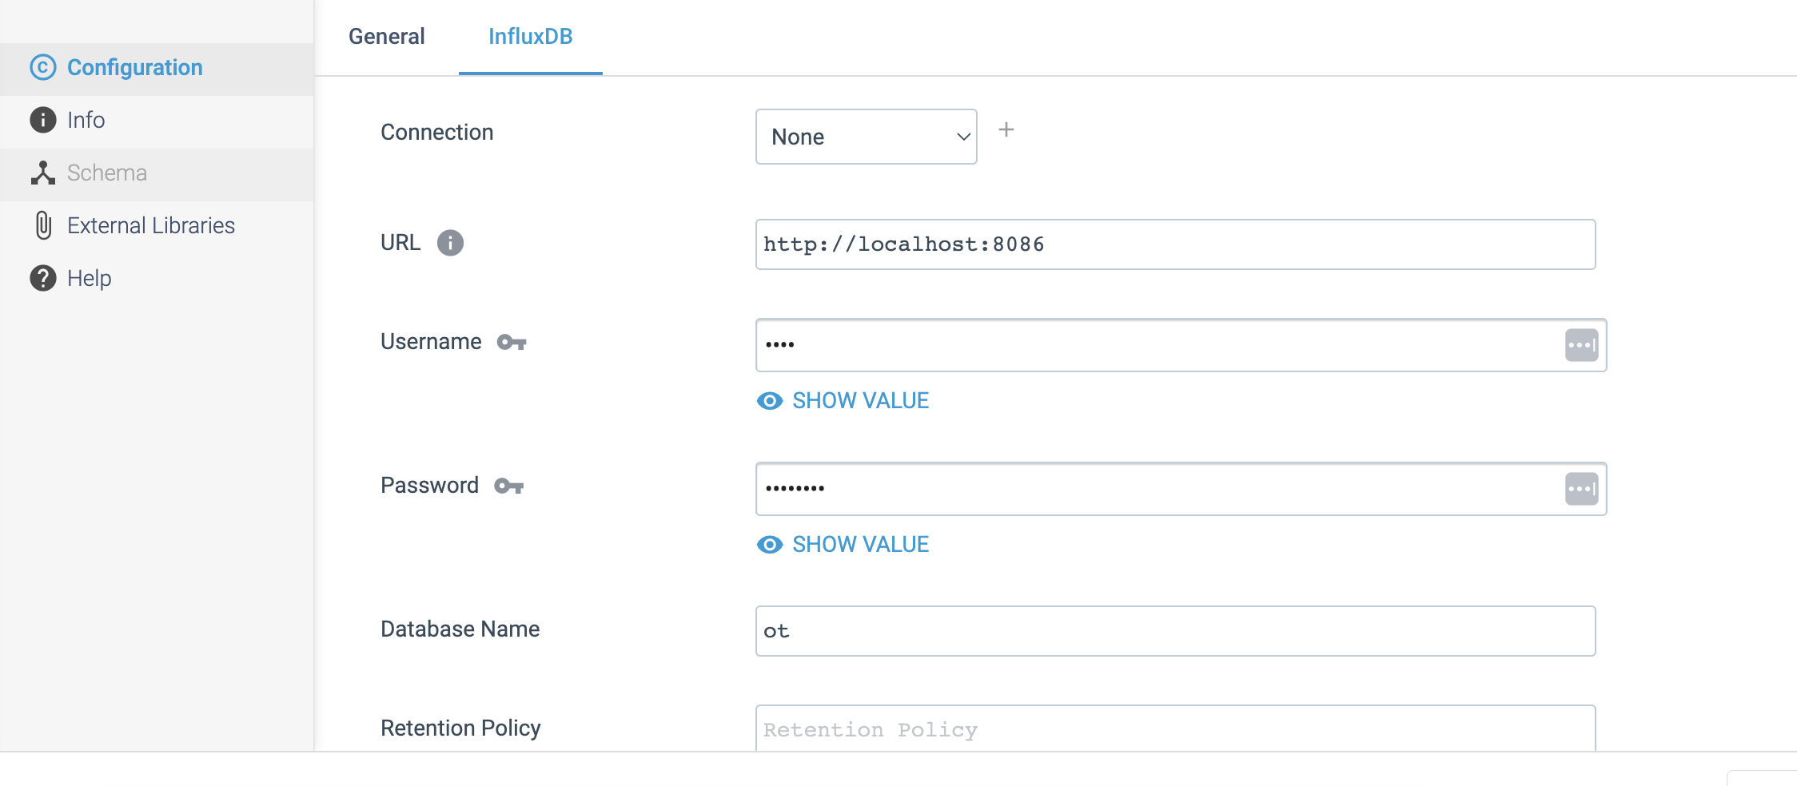

**DESTINATION NAME:** Hive Metastore

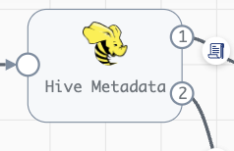

**Engine Type**: Data Collector

**Pipeline Name**: D_JDBC_Orgn_Dest_Pipeline_Cred_All

**Description**: The **Hive Metastore** destination works with the Hive Metadata processor and the Hadoop FS or MapR FS destination as part of the Drift Synchronization Solution for Hive.

We need to configure the **Hive Metastore** destination in a following way.

Step 1: Click on the **Hive Metastore** destination to define the connection information for Hive, the location of the Hive and Hadoop configuration files and optionally specify additional required properties. We can also use a connection to configure the destination.

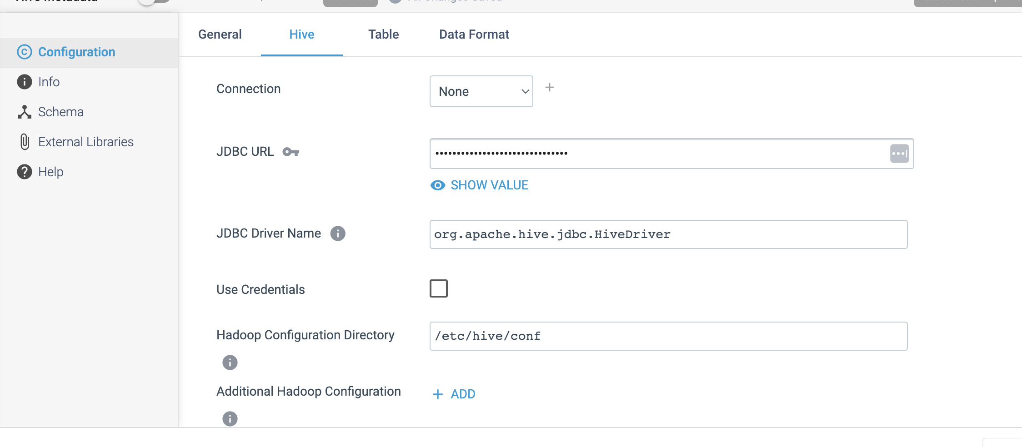

Step 2: Click on the **Table** tab to define the database name, table name and partition column names.

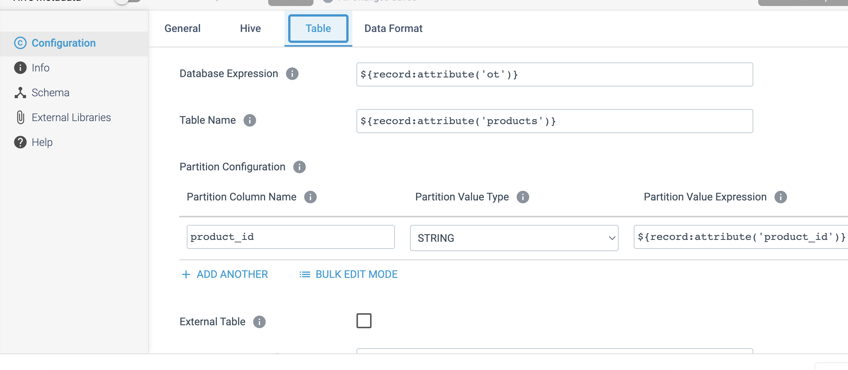

Step 3: Click on the **Data Format** tab to define the output format.

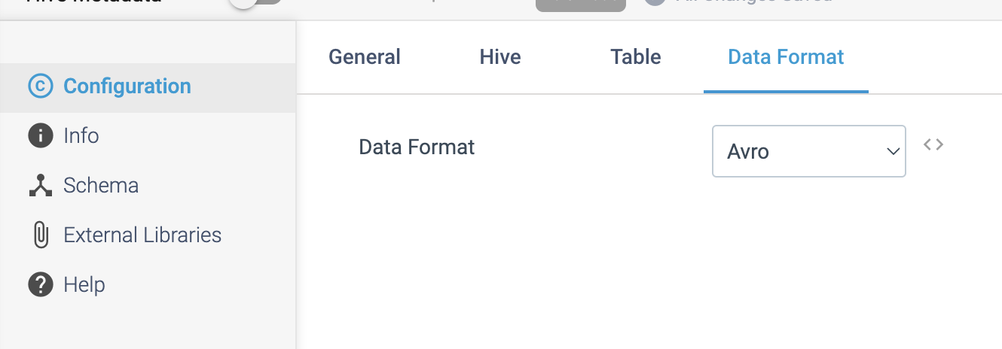

**DESTINATION NAME:** Tableau CRM

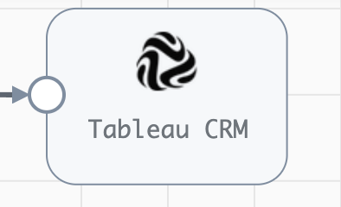

**Engine Type**: Data Collector

**Pipeline Name**: D_OracleBulk_orgn_CRM_Dest_Pipeline_CredStr

**Description**: The **Tableau CRM** destination writes data to Salesforce Tableau CRM. The destination connects to **Tableau CRM** to upload external data to a dataset.

We need to configure the **Tableau CRM** destination in a following way.

Step 1: Click on the **Tableau CRM** destination to define connection information, including the API version and authentication type that the destination uses to connect to **Tableau CRM**. You can also use a connection to configure the destination.

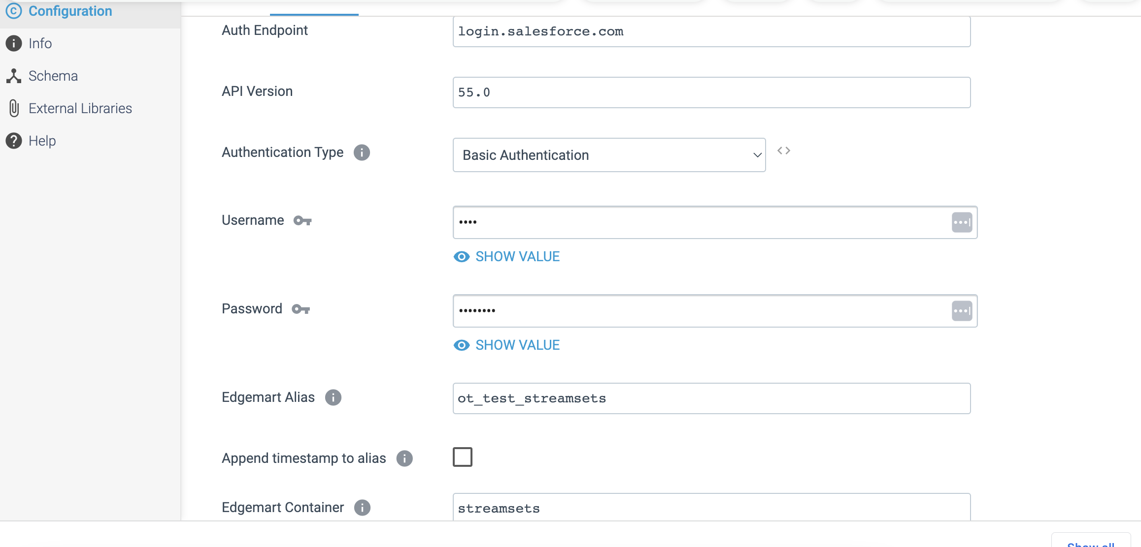

Step 2: Click on the **Advanced** tab to optionally use an HTTP proxy to connect to Salesforce Tableau CRM. When enabled in Salesforce, you can configure the destination to use mutual authentication to connect.

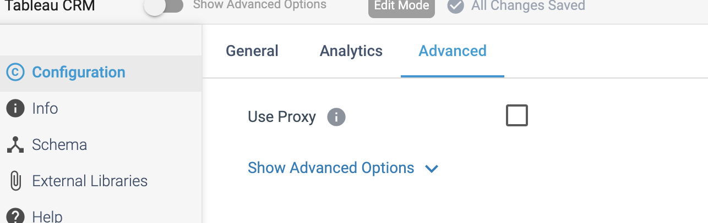

**DESTINATION NAME:** HTTP Client

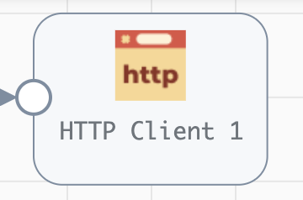

**Engine Type**: Data Collector

**Pipeline Name**: D_SFTP_orgn_Http_Dest_Pipeline_Cred_URL

**Description**: The HTTP Client destination writes data to an HTTP endpoint. The destination sends requests to an HTTP resource URL.

We need to configure the **HTTP Client** destination in a following way.

Step 1: Click on the **HTTP Client** destination to define the resource URL, optional headers, and method to use for the requests. You configure the destination to generate one request for each record or to generate a single request containing all records in the batch.

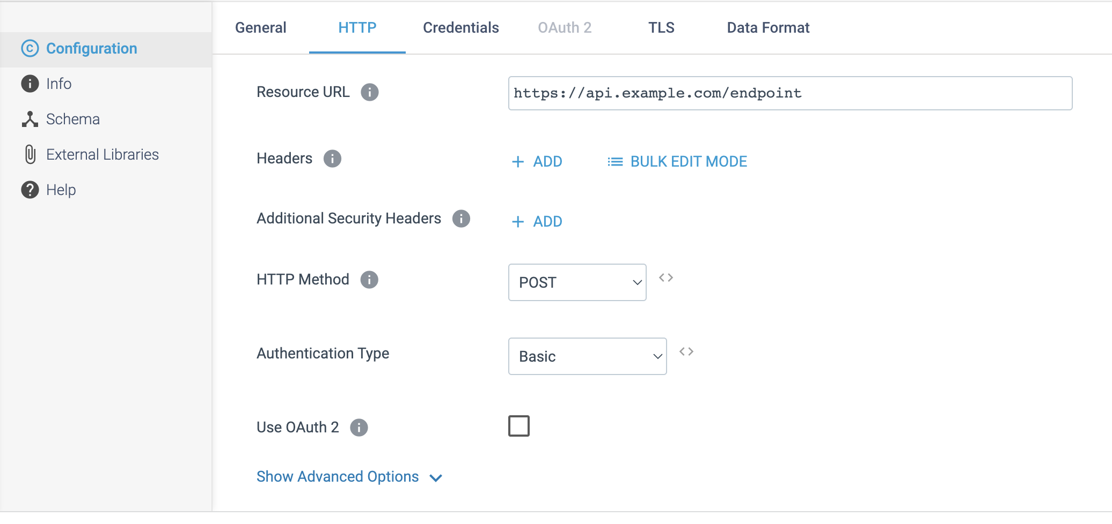

Step 2: Click on the **Credentials** tab to define the credentials.

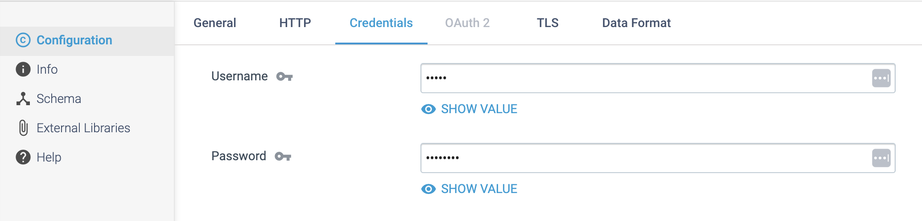

Step 3: Click on the **TLS** tab to optionally use an HTTP proxy and configure SSL/TLS properties. You can also configure the destination to use the OAuth 2 protocol to connect to an HTTP service.

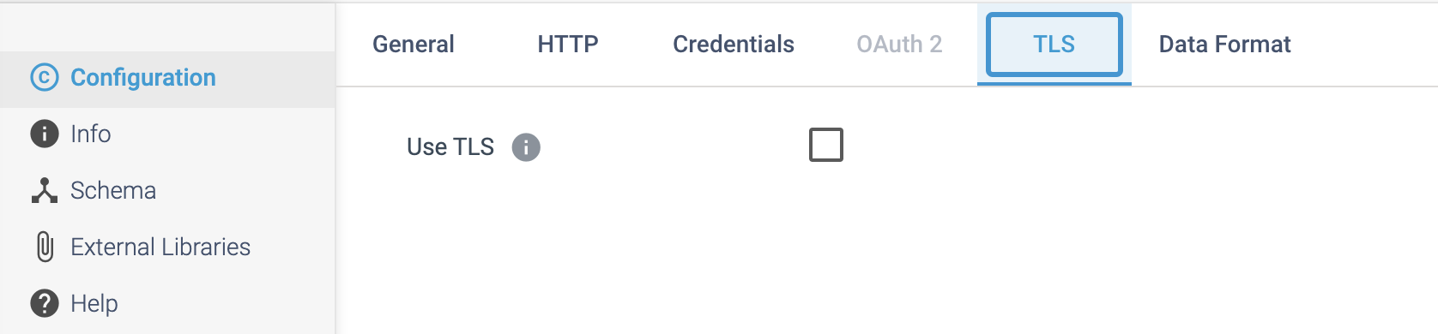

Step 4: Click on the **Data Format** tab to define the output format.

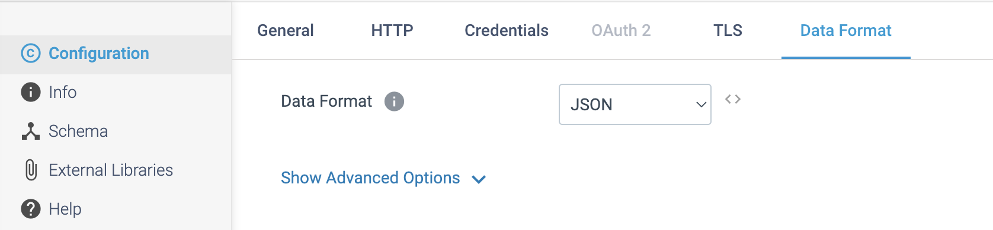

**DESTINATION NAME:** Splunk

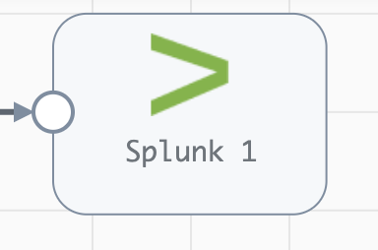

**Engine Type**: Data Collector

**Pipeline Name**: D_SQLChngeTrckng_Orgn_Splnk_Dest_Pipeline_CredStr

**Description**: The **Splunk** destination writes data to Splunk using the Splunk HTTP Event Collector (HEC).

We need to configure the **Splunk** destination in a following way.

Step 1: Click on the **Splunk** destination to supply the Splunk API endpoint and the HEC authentication token. We can configure the timeout, request transfer encoding, and authentication type. We can configure the destination to use the Gzip or Snappy compression format to write the data.

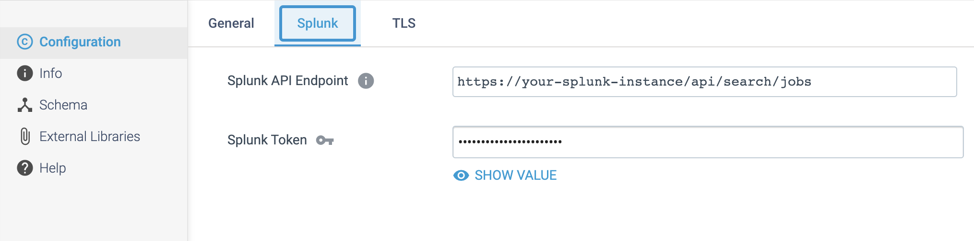

Step 2: Click on the **TLS** tab to optionally use an HTTP proxy and configure SSL/TLS properties.

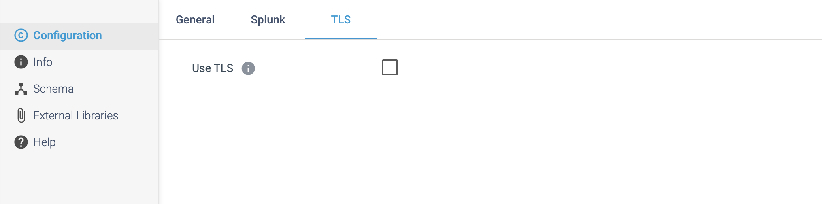

**DESTINATION NAME:** MQTT Publisher

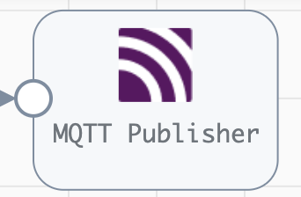

**Engine Type**: Data Collector

**Pipeline Name**: D_MQTT_Subs_Orgn_Pub_Dest_Pipeline_CredURL

**Description**: The **MQTT Publisher** destination publishes messages to a topic on an MQTT broker. The destination functions as an MQTT client that publishes messages, writing each record as a message.

We need to configure the **MQTT Publisher** destination in a following way.

Step 1: Click on the **MQTT** Publisher to specify the information needed to connect to the MQTT broker. We must define connection credentials when the MQTT broker requires a **username** and **password**. We can also use a connection to configure the destination.

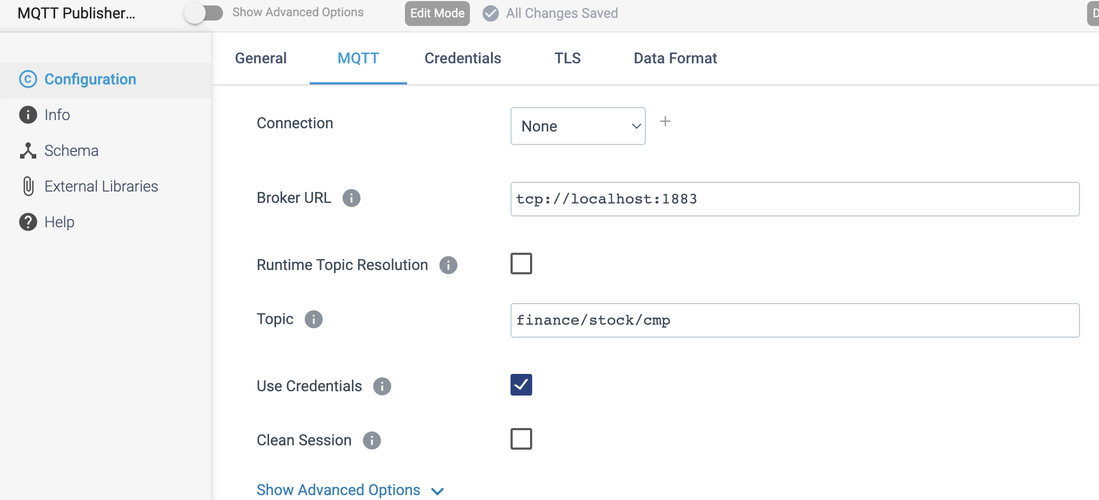

Step 2: Click on the **Credentials** tab to define the credentials.

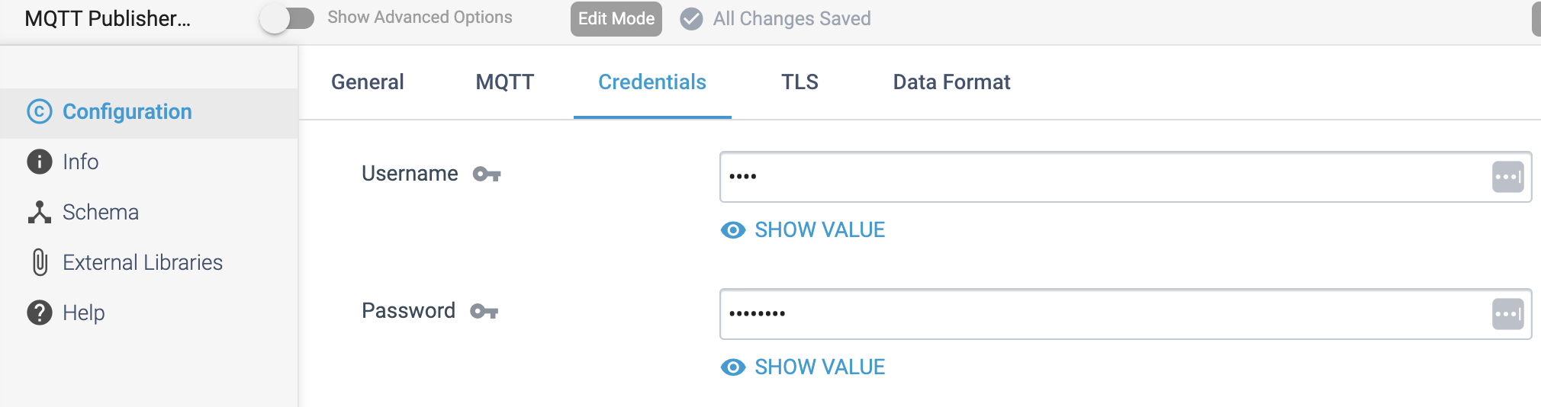

Step 3: Click on the **TLS** tab to configure SSL/TLS properties, including default transport protocols and cipher suites.

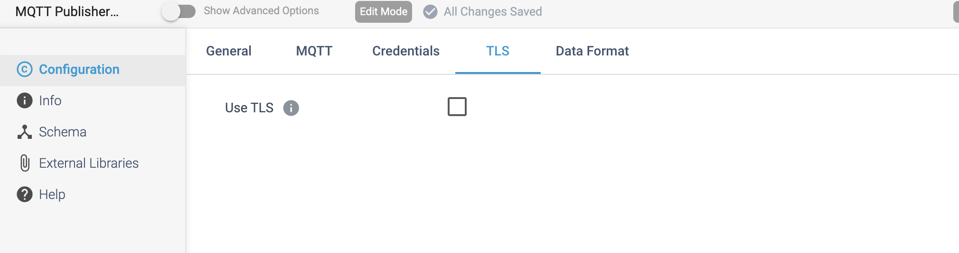

Step 4: Click on the **Data Format** tab to define the output format.

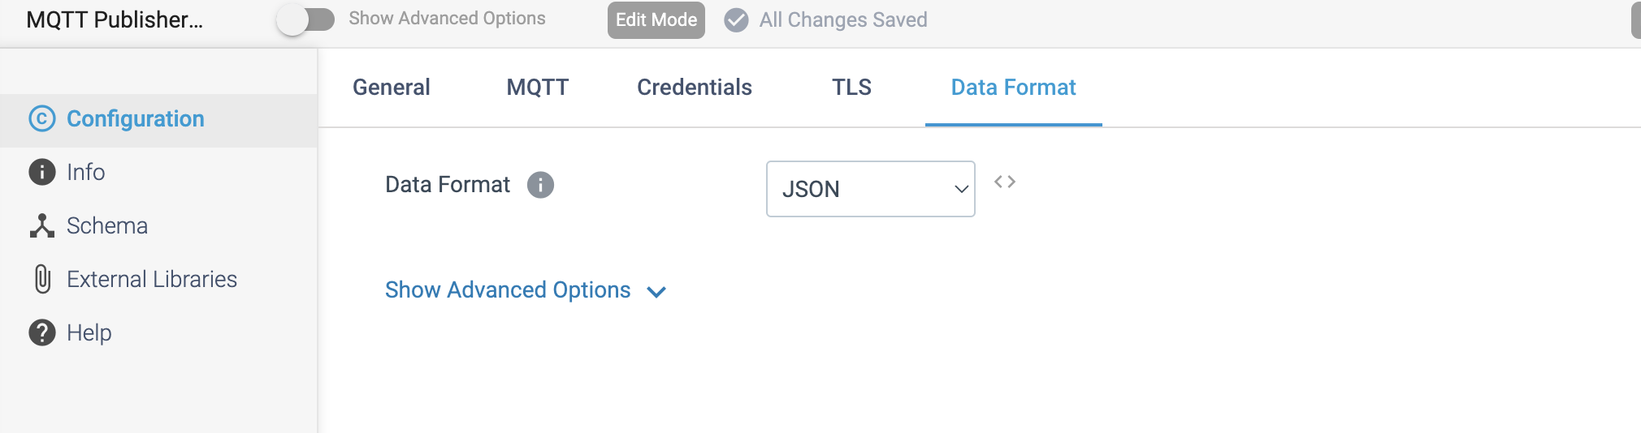

**DESTINATION NAME:** Google Pub Sub Publisher

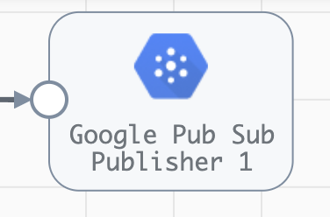

**Engine Type**: Data Collector

**Pipeline Name**: D_Ggle_Subscr_orgn_Pblshr_Dest_Pipeline_Cred

**Description**: The **Google Pub/Sub Publisher** destination publishes messages to a Google Pub/Subtopic.

We need to configure the **Google Pub/Sub Publisher** destination in a following way.

Step 1: click on the **Google Pub/Sub Publisher** destination to define the Google Pub/Sub topic ID to write messages to.

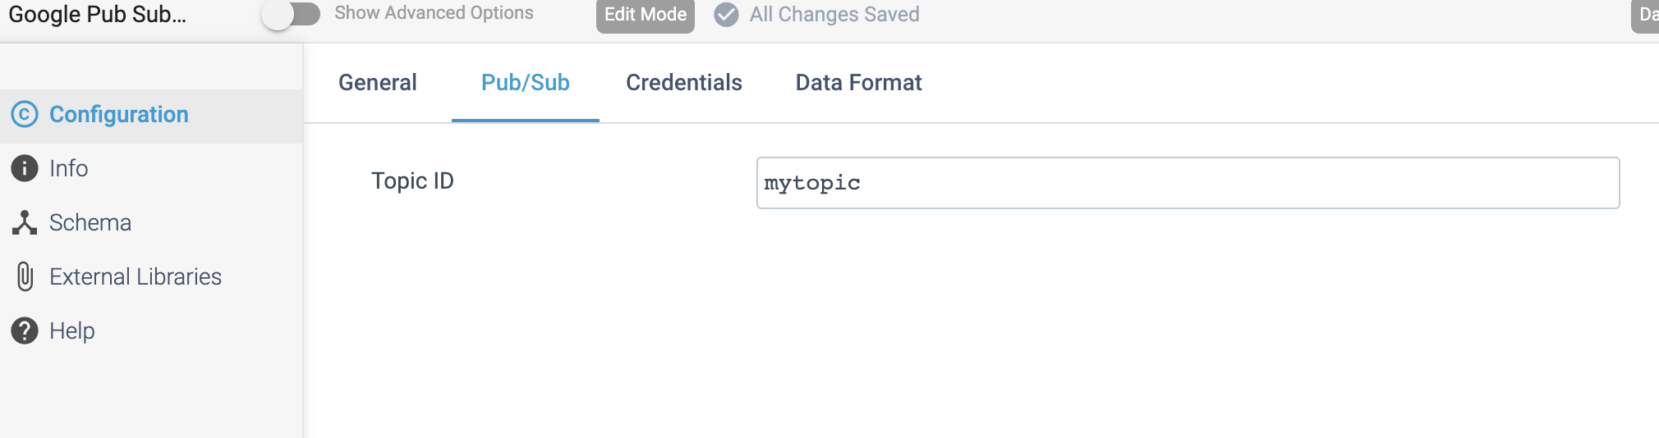

Step 2: Click on the **Credentials** tab to define the **project ID** and **credentials** to use when connecting to Google Pub/Sub.

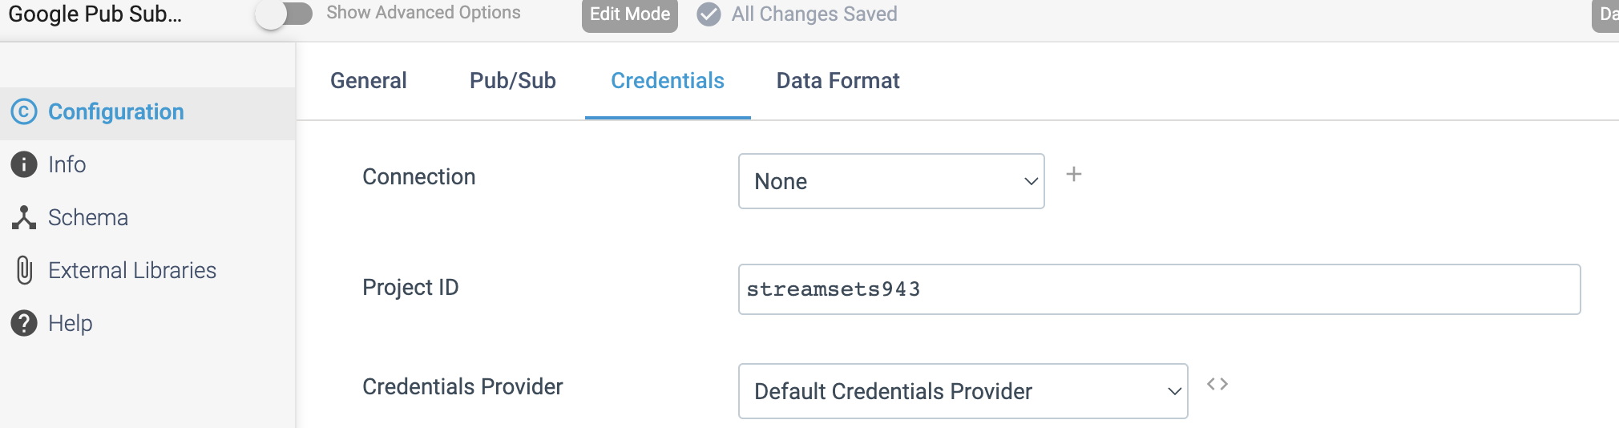

Step 3: Click on the **Data Format** tab to define the output format.

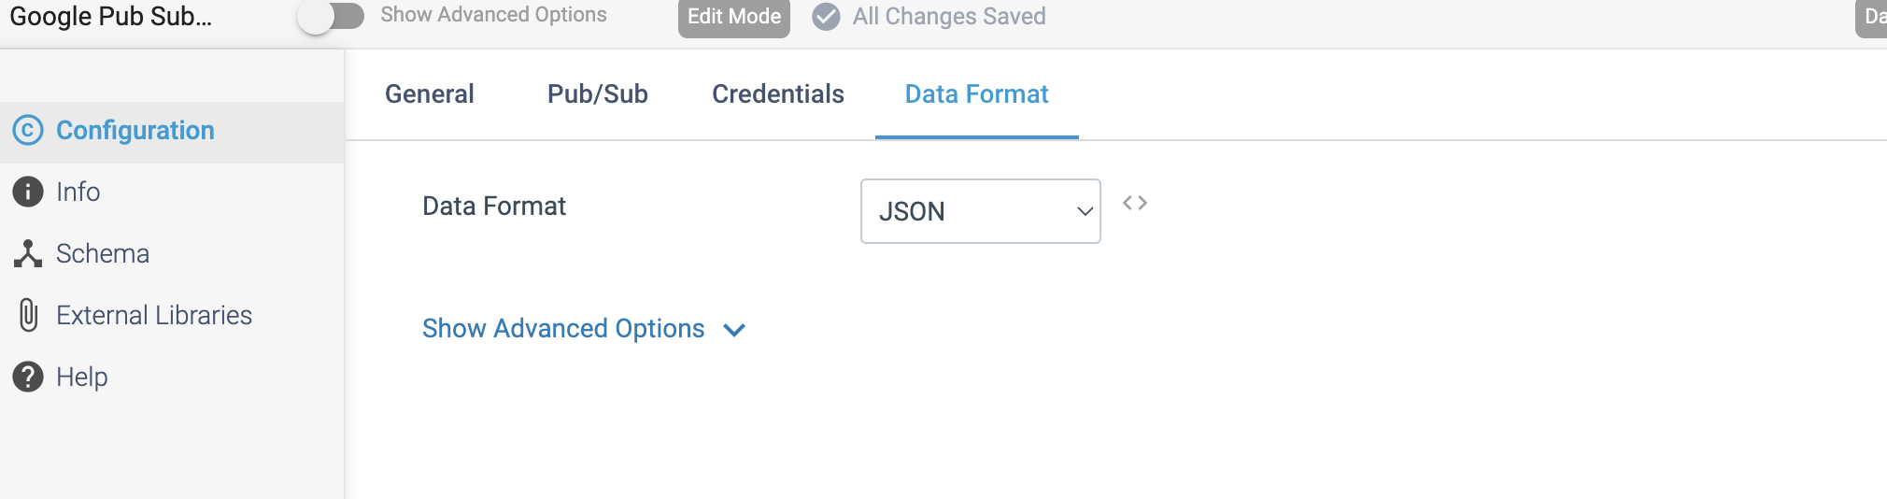

**DESTINATION NAME:** Google Cloud Storage

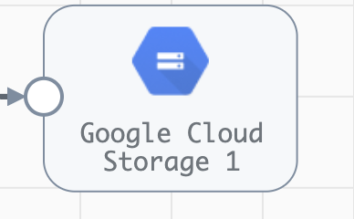

**Engine Type**: Data Collector

**Pipeline Name**: D_MYSQLlog_orgn_Ggle_Strge_Dest_Pipeline_CredStr

**Description**: The **Google Cloud Storage** destination writes data to objects in Google Cloud Storage.

We need to configure the **Google Cloud Storage** destination in a following way.

Step 1: Click on the **Google Cloud Storage** destination to configure the bucket and common prefix to define where to write objects. You can use a partition prefix to specify the partition to write to.

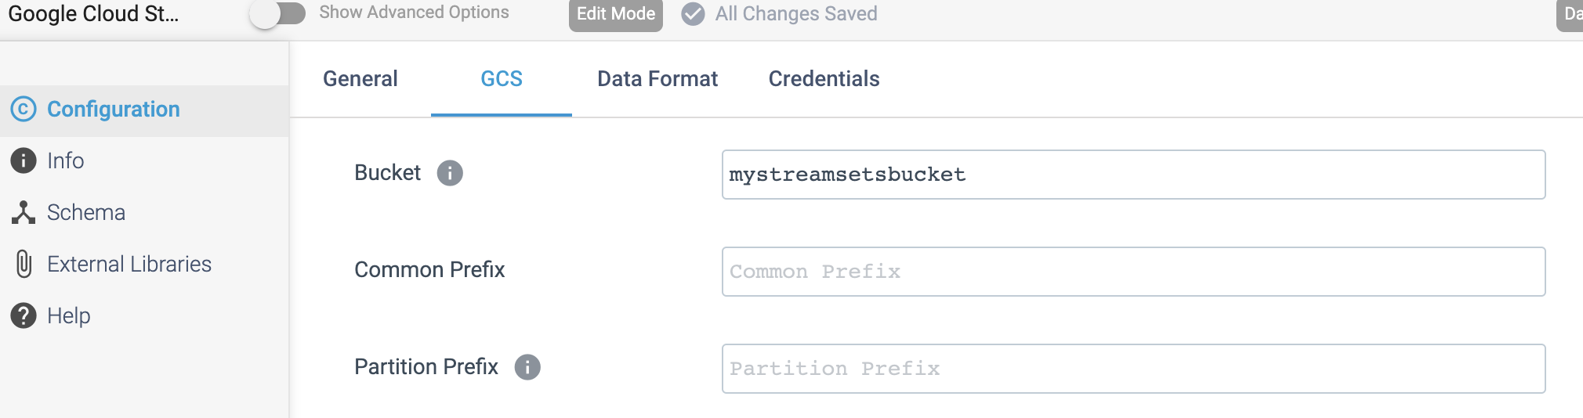

Step 2: Click on the **Data Format** tab to define the output format.

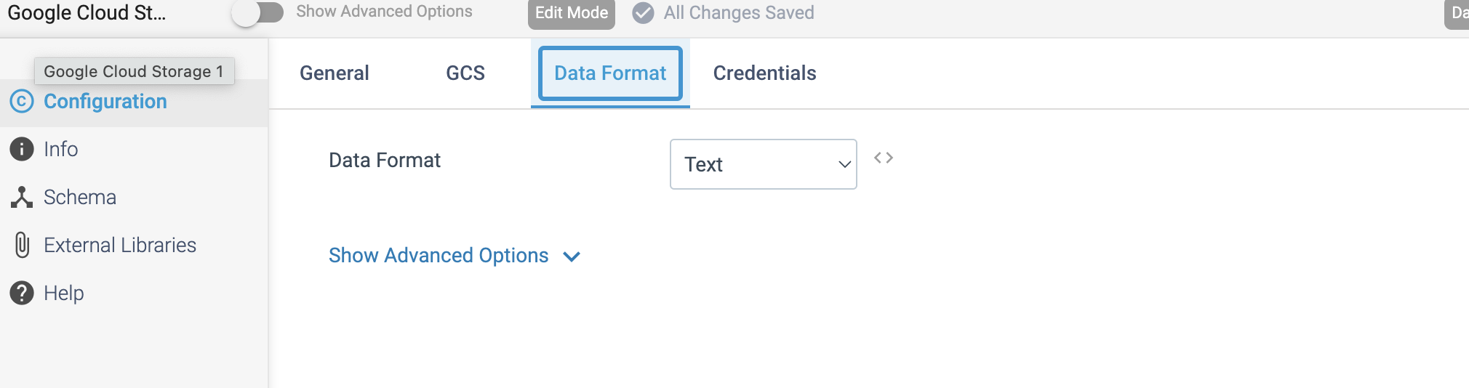

Step 3: Click on the **Credentials** tab to define the **project ID** and **credentials** to use when connecting to Google Cloud Storage.

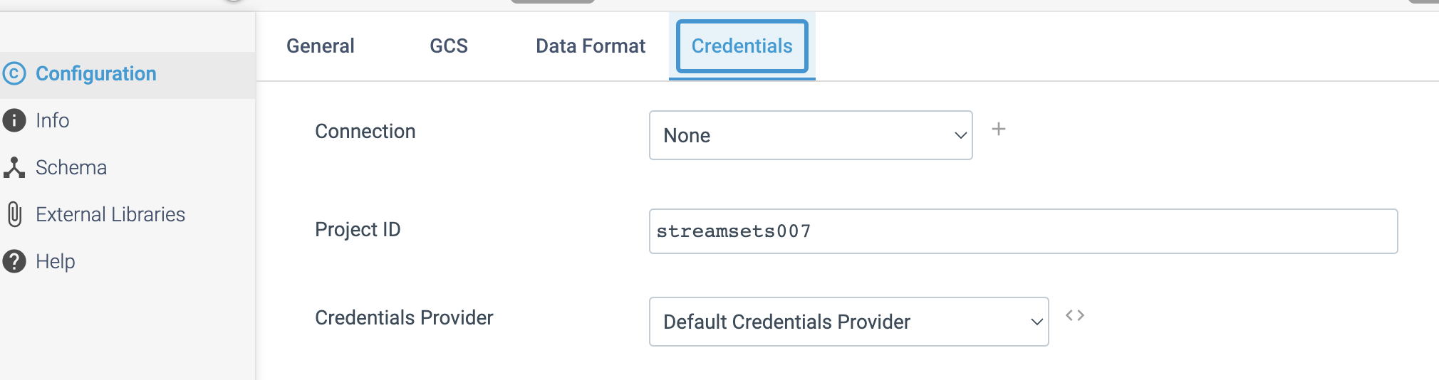

**DESTINATION NAME:** Google BigQuery

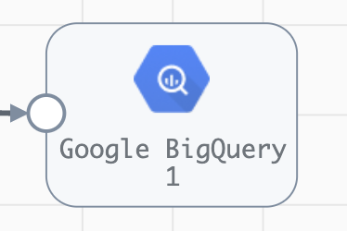

**Engine Type**: Data Collector

**Pipeline Name**: D_azre_DataLakeGen2_orgn_Dest_Pipeline_Cred

**Description**: The Google **BigQuery** destination loads new data or change data capture (CDC) data to **Google BigQuery.** The destination can compensate for data drift to support loading to new or existing datasets, tables, and columns.

We need to configure the **Google BigQuery** destination in a following way.

Step 1: Click on the **Google BigQuery** destination to specify authentication information for Google BigQuery.

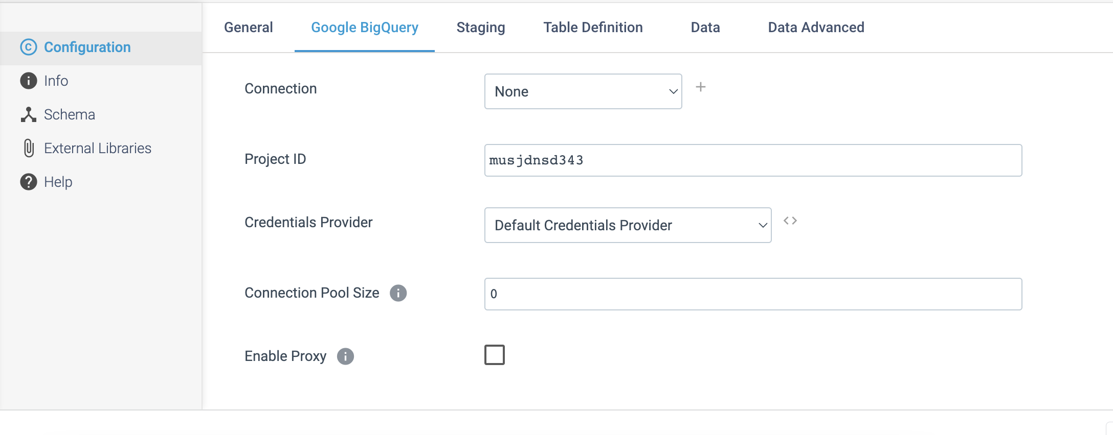

Step 2: Click on the **Staging** tab to specify authentication information for Google Cloud Storage staging area.

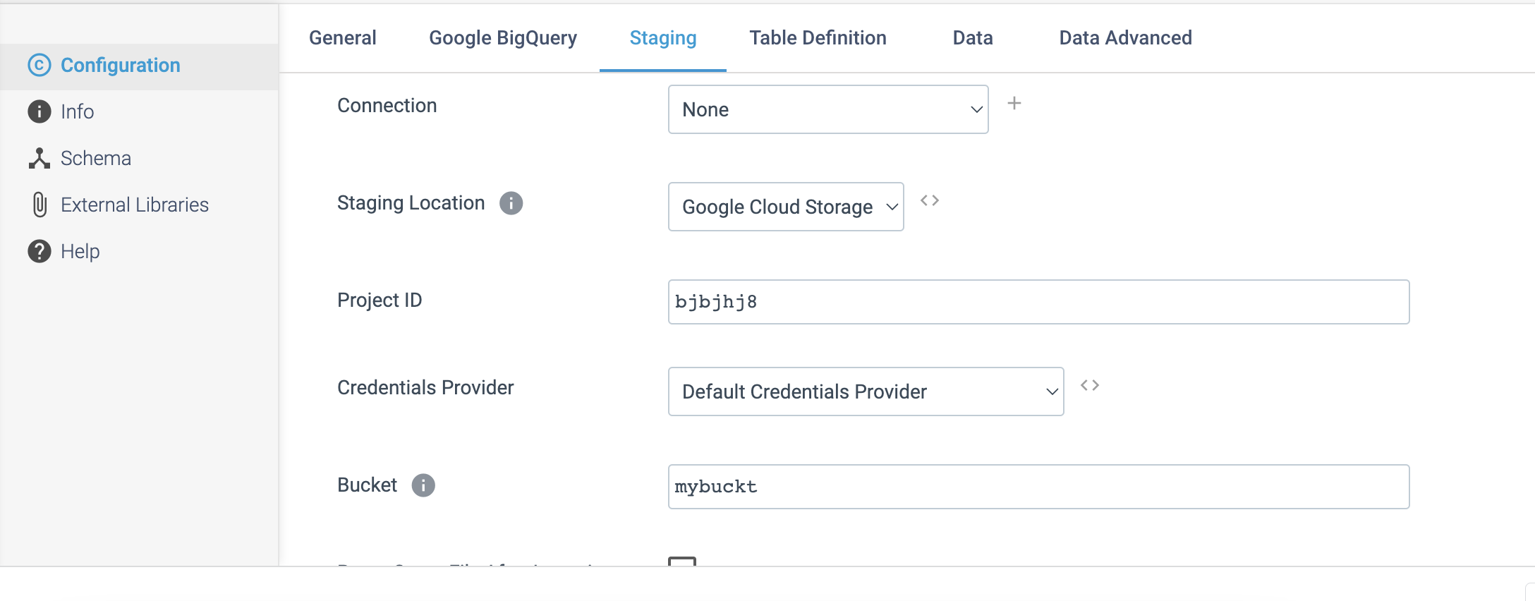

Step 3: Click on the **Table definition** tab to define the table properties.

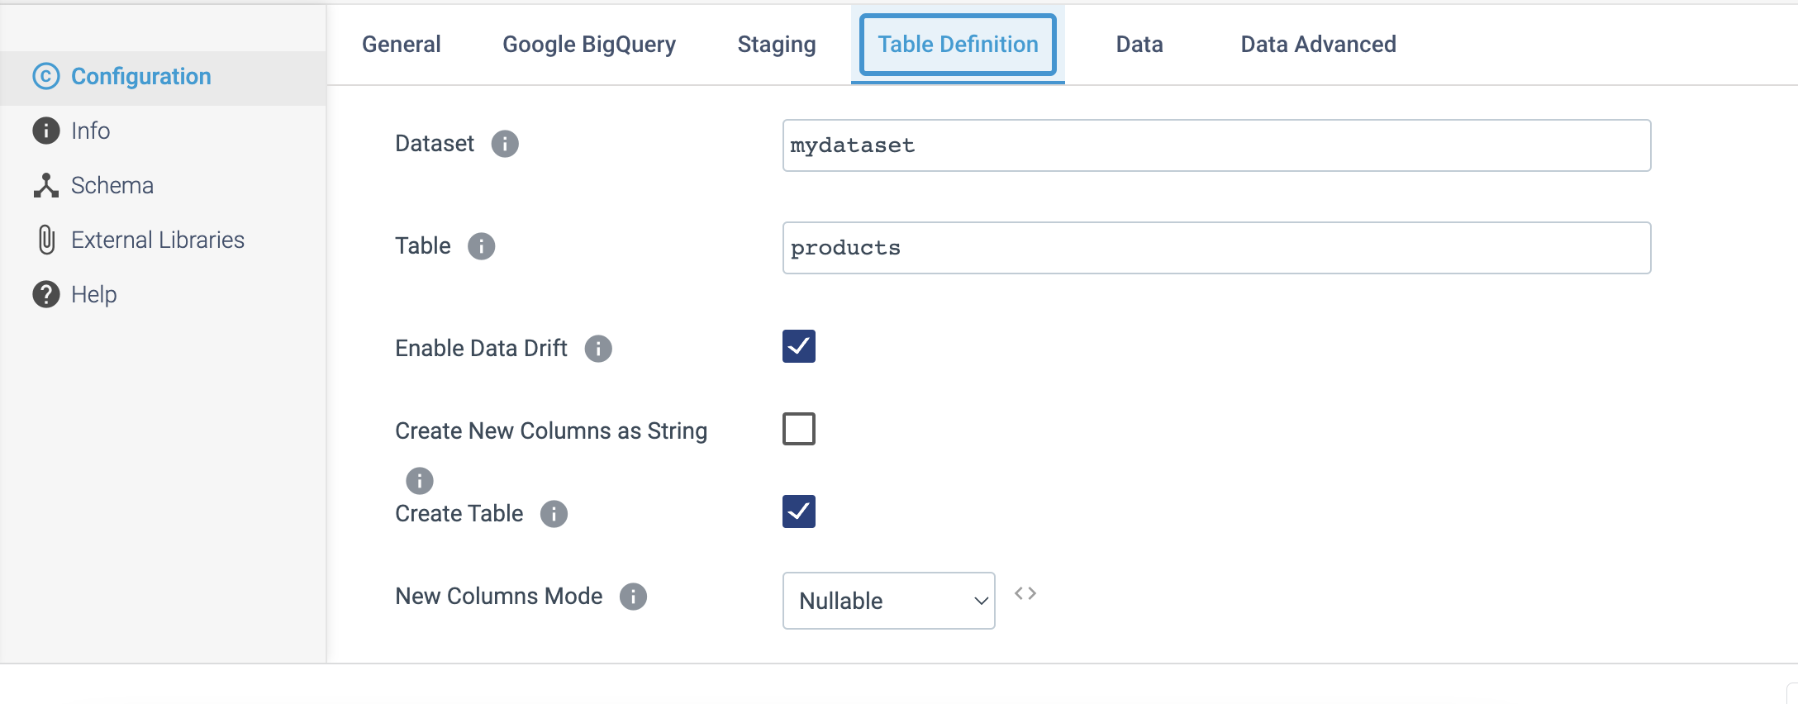

Step 4: Click on the **Data** tab to define the following details.

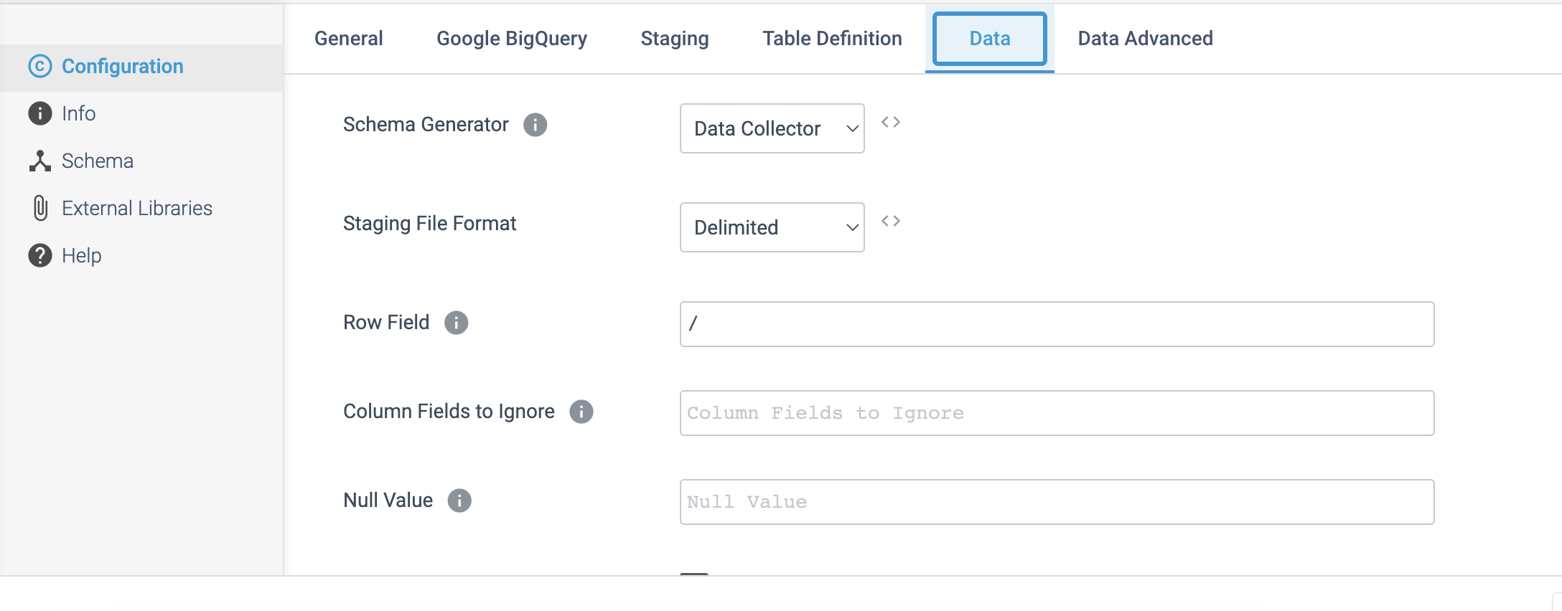

Step 5: Click on the **Data Advanced** tab to optionally define the following details.

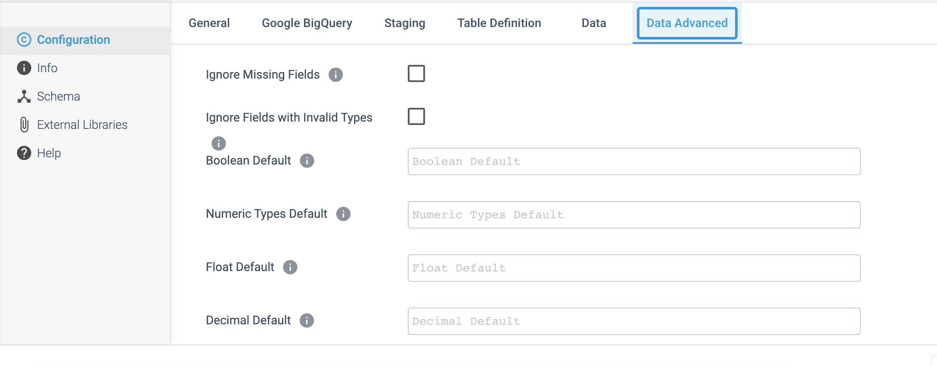

**DESTINATION NAME:** Google BigTable

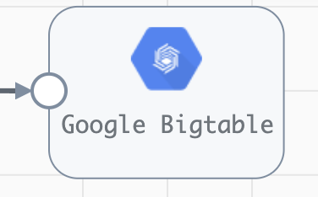

**Engine Type**: Data Collector

**Pipeline Name**: D_Ggle_strge_orgn_bigtble_Dest_Pipeline_Cred

**Description**: The **Google Bigtable** destination writes data to Google Cloud Bigtable.

We need to configure the **Google Bigtable** destination in a following way.

Step 1: Click on the **Google Bigtable** destination to define the instance ID, project ID, and the table that you want to write to.

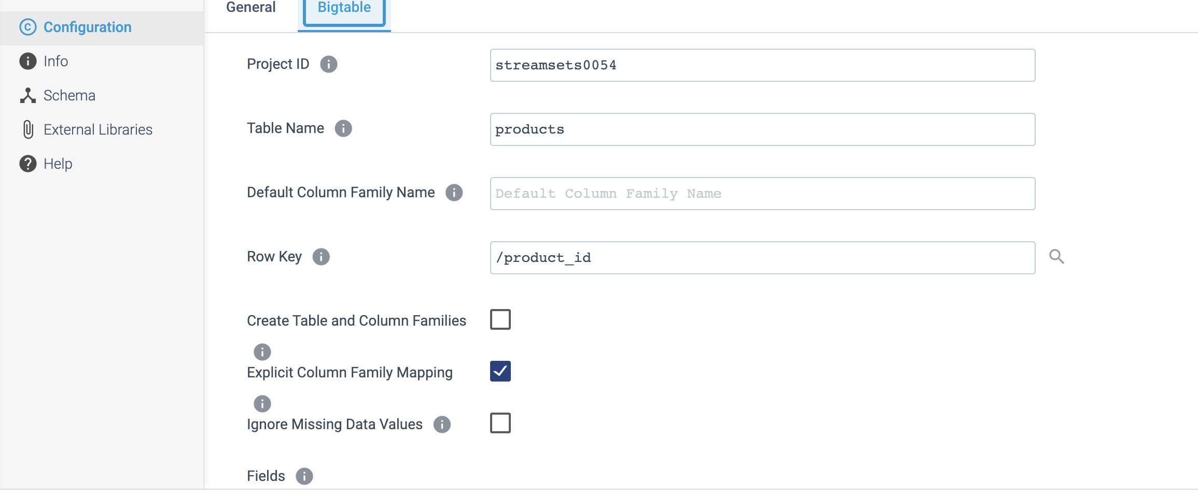

**DESTINATION NAME:** Hbase

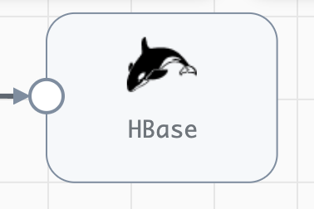

**Engine Type**: Data Collector

**Pipeline Name**: D_JDBC_Orgn_HBase_Dest_Pipeline_CredStr

**Description**: The **HBase** destination writes data to an HBase cluster. The destination can write data to an existing HBase table as text, binary data, or **JSON** strings. You can define the data format for each column written to **HBase**.

We need to configure the **HBase** destination in a following way.

Step 1: Click on the **HBase** destination to specify the HBase configuration properties, including the **ZooKeeper Quorum**, **parent znode**, and the existing **table name**. We specify the row key for the table, and then map fields from the pipeline to **HBase** columns.

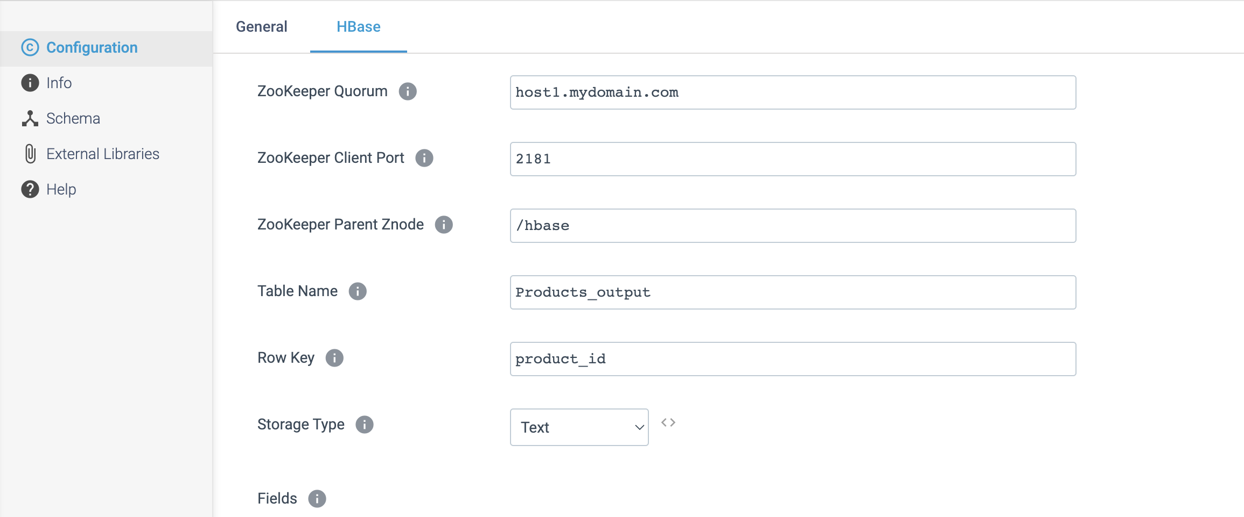

**DESTINATION NAME:** Hadoop FS

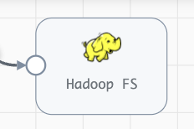

**Engine Type**: Data Collector

**Pipeline Name**: D_JDBC_Orgn_Dest_Pipeline_Cred_All

**Description**: The **Hadoop FS** destination writes data to Hadoop Distributed File System (HDFS). We can also use the destination to write to Azure Blob storage.

We need to configure the Hadoop FS in a following way.

Step 1: Click on the Hadoop FS destination to define the **connection** details.

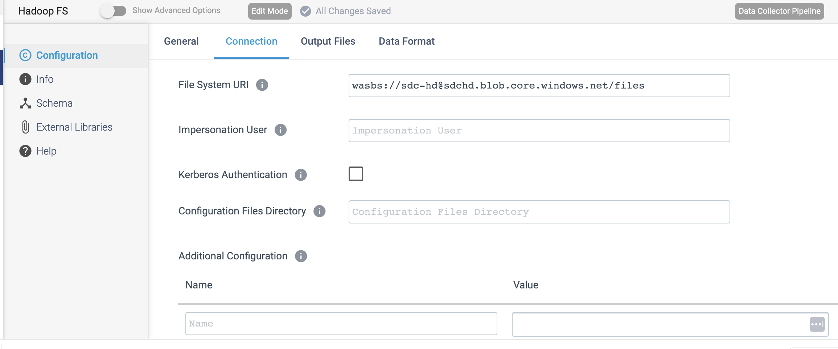

Step 2: Click on the **Output Files** tab to define a directory template and time basis to determine the output directories that the destination creates and the files where records are written.

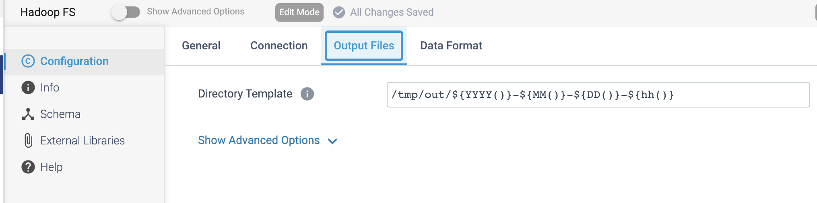

Step 3: Click on the **Data Format** tab to define the output format.

